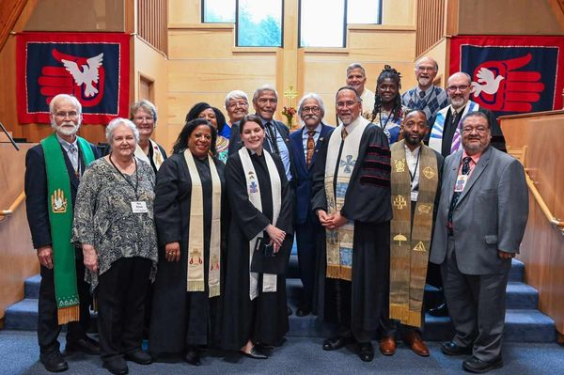

The Soboleff family, former and current pastors and PCUSA delegation

A time of healing from the 1963 racist closure of an Indigenous congregation, in Juneau, Alaska and the displacement of Rev. Dr. Walter Soboleff, their Pastor
“We have been waiting to hear this apology for 60 years.” Those were the words of Sasha Soboleff, son of the late Walter Soboleff, Sr. when the PCUSA, issued an “Apology and Reparations” for the racist actions of the Presbyterian Church in 1963.

A delegation of Presbyterian Church, USA officials and the family of Rev. Dr. Walter Soboleff gathered in Juneau, Alaska, October 6-9, 2023, to hear from the family of Rev. Soboleff, the Tlingit tribal community and descendants of Memorial Presbyterian Church, which was closed in 1963 and their Pastor reassigned to an itinerate preaching position among Alaska’s Presbyterian Native community.

The delegation representing the Presbyterian Church, USA included: Jermaine Ross-Allam, Director of the Center for the Repair of Historic Harms (PMA), Rev. Bronwen Boswell. Acting Stated Clerk of the General Assembly – Presbyterian Church (U.S.A), Rev. Diane Givens Moffett, President/Executive Director of the Presbyterian Mission Agency, Corey Schlosser-Hall, Deputy Executive Director of Visioning (PMA), Dianna Wright, Director of Ecumenical and Interreligious Relations (OGA), Rev. Irvin Porter, Associate-Native American Intercultural Congregational Support (REWIM), Laura Terasaki, Executive Presbyter – Northwest Coast Presbytery, Rev. Matt Paul, Pastor – 1st Presbyterian Church, Port Angeles, WA, Melody Smith, Assc. Director for Digital and Marketing (PMA), Richard Copley, Multimedia Producer, (PMA).

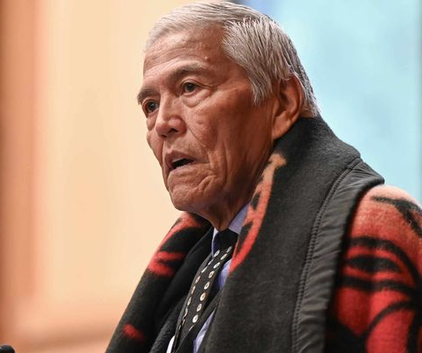

Speaking for the family of Rev. Dr. Walter Soboleff was his son, Sasha:

“It is with great honor, distinction, and wonderment that all of you have taken the time to provide some healing for our family, the immediate family, and the family of Memorial Church . . . Our ancestors have this story for times like this when dignitaries come to talk before a group the Creator puts moss and bright flowers underneath their feet so that they would be protected walking here and that’s what’s happened today . . . on behalf of my sister, my brother and my younger brother deceased, and all of you close relations, it took us fifty-some years to get here. Remember that and you can carry it with you beyond today with the warmth and the confirmation of the knowledge that we were created by [Tlingit word for Creator] and that we have a message and a legacy to live out and that’s to do as He first loved us, to love one another.”

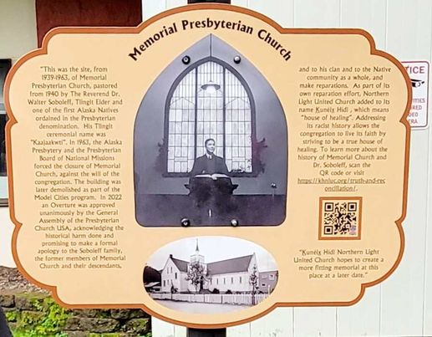

Events began on Oct 7th with the dedication of a memorial plaque at the site of the original Memorial Presbyterian Church which is now occupied by Juneau, Alaska Fire Hall at Fire Station #1 where an unveiling of the plaque commemorating the congregation (pictured above).

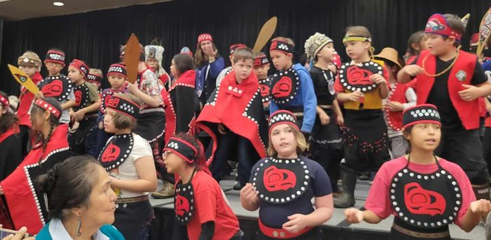

Members of Kunéix Hídi Northern Light United Church and Tlingit & Haida community leaders gathered with the Presbyterian Church, USA delegation for an Indigenous Peoples’ Day healing event recognizing denomination’s historic apology and reparations to both the Memorial Presbyterian Church descendants as well as the Tlingit & Haida communities. It began with a children’s dance group, (pictured above), then videos about Memorial Presbyterian Church’s 1963 closure, a presentation of reparation funds from the PCUSA for language preservation to Sealaska Heritage Institute and the Central Council of Tlingit and Haida.

Memorial Presbyterian Church was chartered in 1887 in Juneau, where restaurants and movie theatres practiced segregation often posting signs that read, “Indians and dogs not allowed.” Alaskan Natives could only shop one day of the week in the city into the mid-1940’s.

In 1962, the presbytery in Juneau decided to stop subsidizing Memorial, decided to close it through the Board of Foreign Missions then loaned $200,000 to the Caucasian congregation to build their new church a few blocks from Memorial.

A Native Ministries Committee, (some pictured above), was formed by Indigenous members of Northern Light and with the help of their pastor, Phil Campbell, researched and created the “Overture” sent to the General Assembly of the Presbyterian Church, USA, in 2022 which sought the Apology for the racist decision to close Memorial Presbyterian Church and reparations in the amount of $200,000 for the Native American, Native Alaskan Peoples Fund, to help repair dilapidated churches across the country, and $100,000 to Sealaska Heritage Institute for language preservation efforts, considering the boarding schools which Native American and Alaskan Native children were forced to attend as a tool of assimilation by the federal government and church denominations where their Indigenous languages were forbidden.

The Overture stated:
“The forced closure of this thriving, multiethnic, intercultural church was an egregious act of spiritual abuse committed in alignment with the prevailing White racist treatment of Alaska Natives, statewide, and of Native Americans, nationwide.”

The Overture was concurred by these 12 presbyteries: Baltimore, Dakota, Denver, Eastern Oklahoma, Northern Kansas, Olympia, Twin Cities Area, Inland Northwest, Santa Fe, Seattle, Cascades, Upper Ohio Valley, Yukon

The General Assembly action commits the Presbyterian Church, USA, to become engaged and accountable for:
“Interactions with churches of primarily people of color congregations so that difficult decisions about support and funding are made in a spirit that recognizes the importance and contributions of these congregations to the Presbyterian Church (USA), which outweigh superficial considerations of their membership numbers or perceived lack of financial resources.”

It also encourages Presbyterians to donate to the Native American Native Alaskan Peoples Fund whose sole purpose is the repair of the 98 Native American Presbyterian congregations nationally. It also calls for renewed commitments to dismantle systemic racism and increase the voices from people of color.

Our Brief Statement of Faith reminds us: “. . . The Spirit gives us courage to pray without ceasing, to witness among all peoples to Christ as Lord and Savior, to unmask idolatries in Church and culture, to hear the voices of peoples long silenced, and to work with others for justice, freedom, and peace.”
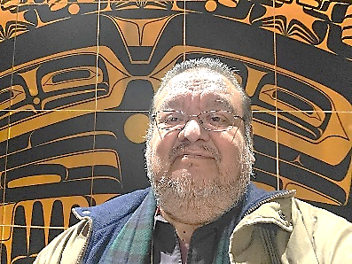
Irvin Porter, Associate, Native American Intercultural Congregational Support
Irv.porter@pcusa.org

