Eater’s Guide
to the
Farm Bill

Eater’s Guide
to the
Farm Bill

Table of Contents

The Farm Bill in Pictures 3

Food and Farming in the United States: The Situation 5

Principles for a Faithful Farm Bill 7

2018 Platform for the Farm Bill Overview 8
Questions for Candidates 9
Local 11
State 12
Federal 14

Appendix: 2018 Farm Bill Platform 17

Provided by the Presbyterian Hunger Program, PC(USA) – January 2018

The Farm Bill in Pictures

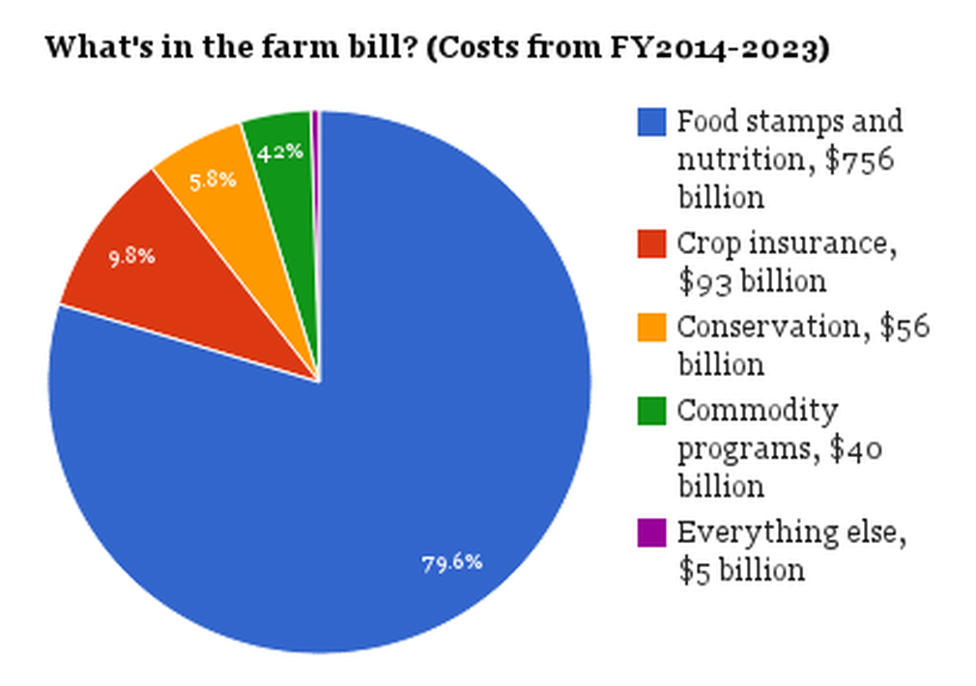

Congressional Research Service, 2013
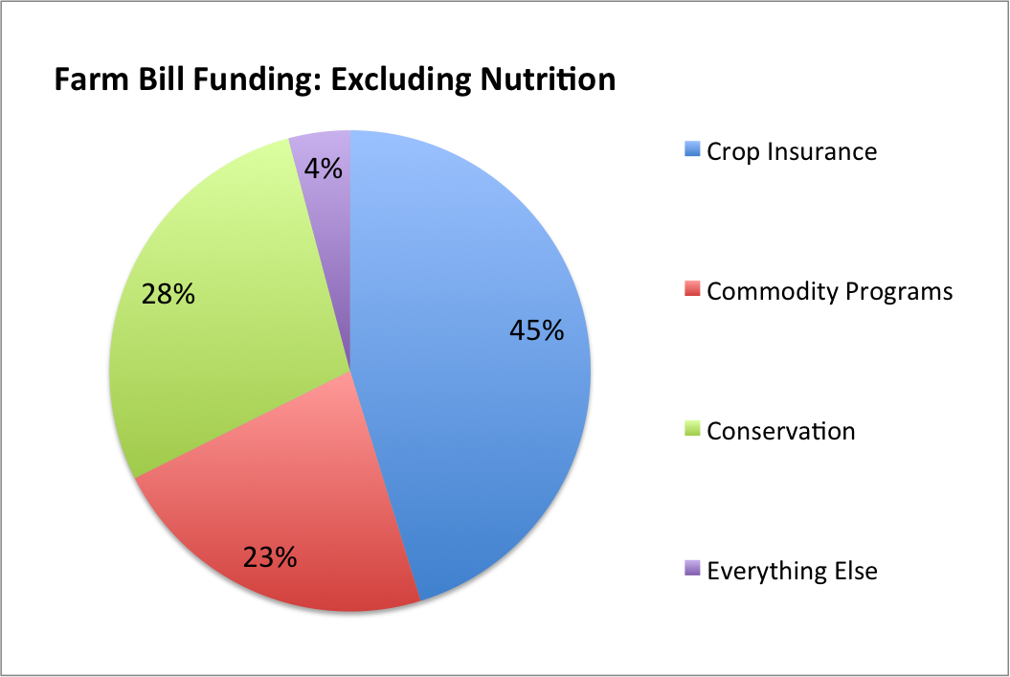
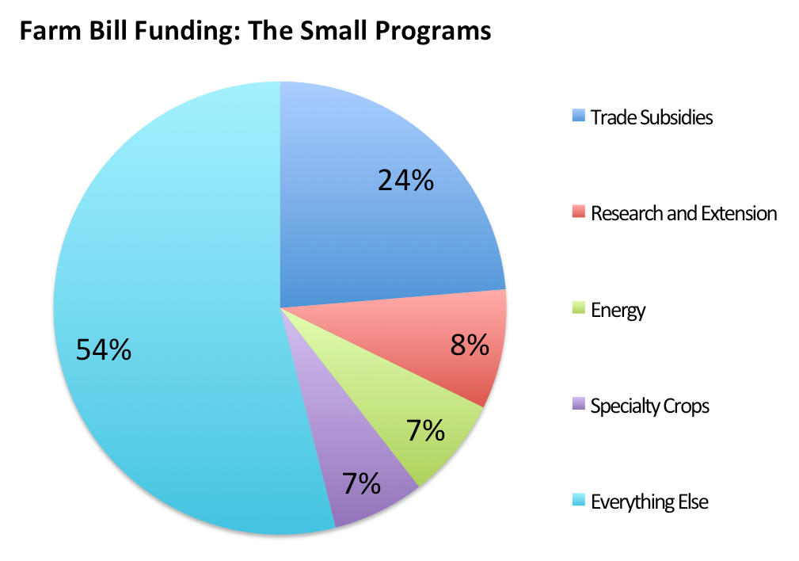
This chart shows the Small Programs in the Farm Bill, which comes from the purple 4% ‘Everything Else’ in the chart to the left. On the above chart, we see that the money spent on Specialty Crops (7%), which are the fruits, vegetables, dairy, protein, etc. is a tiny portion of the Farm Bill. (NSAC, 2015)
This chart shows the proportions of the 20% of the Farm Bill not used for SNAP and nutrition programs. (NSAC, 2015)

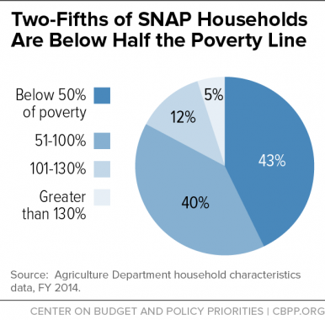
SNAP

Since a large proportion of the Farm Bill’s nutrition programs are for SNAP – Supplemental Nutrition Assistance Program, formerly known as Food Stamps, they merit a few charts.

Along with Temporary Assistance for Needy Families, SNAP is one of the primary pieces of the safety net. While the monthly SNAP benefits are minimal, they are critical for children, the elderly, disabled people, and families struggling with poverty.

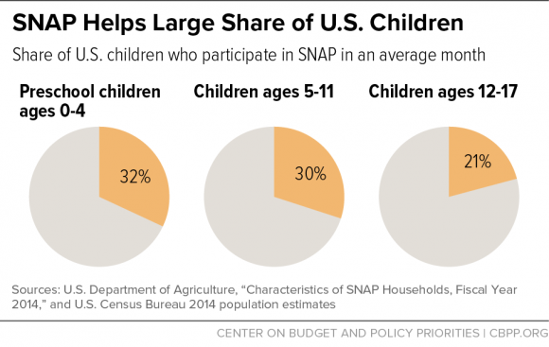

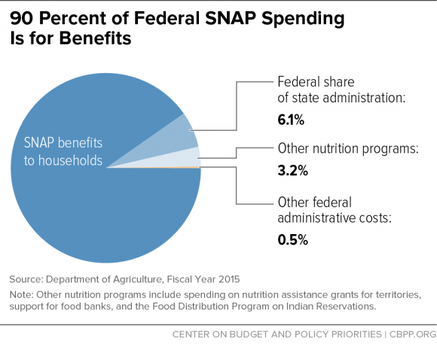

Food & Farming in the United States: The Situation

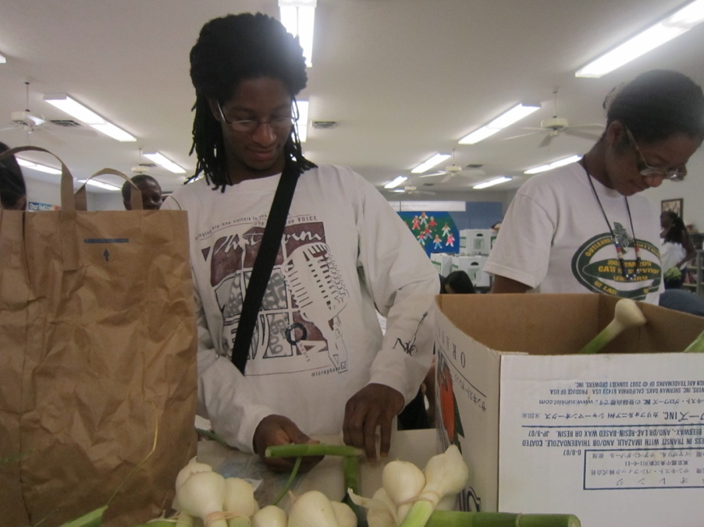
Many people do not have access to safe, nutritious, affordable food.
Many farmers can’t make a living.
Many regions of the country no longer produce the food they consume.
Large-scale industrial agriculture often pollutes our soil and water.
Decades of farm policy driven by agribusiness and supported by unchecked corporate consolidation has hurt, not supported family farmers. Meanwhile, farm and food policies have created food deserts, lowered farmer incomes, separated citizens from regional food sources, and otherwise damaged public health, the environment, and rural communities.
Jonathan Krigger, former PHP VISTA volunteer, and another volunteer prepare affordable produce shares for Fresh Stop Market in a Louisville ‘food desert’. Photo credit: New Roots
The Presbyterian Church (USA) has long had policies on food security, hunger, poverty, democratic processes, supporting rural communities, and caring for God’s creation. As people of faith, we are called to make our voices heard in public arenas, to advocate for the just and fair distribution of food, for a healthy environment for all people, and for policies created through transparent processes that take civic concerns seriously.
For many decades, independent farmers have been disadvantaged by an agricultural policy that favors the overproduction and deregulation of commodity crops like corn and soybeans. Overproduction often drives down the price, affecting farmer income and the fabric of rural communities. After having made many farmers dependent on these large cash crops, deregulation has left farmers vulnerable to wild swings in the price of corn, soybeans and wheat, lowering farmers’ earnings for most of the last 20 years.
Under current farm policy, farmers are not rewarded and supported in their vital work of feeding the nation, but rather, it is the large-scale agribusiness buyers — grain-trading companies, meatpackers, and food manufacturers that use soybeans and corn in processed foods — who profit from this system that promotes cheap commodity crops. Small- and mid-sized farms are at the mercy of market fluctuations, and a wave of agribusiness, food manufacturing, and supermarket mergers has made the problem worse.
Consolidation has allowed a handful of companies that buy crops and livestock to dictate the prices that farmers receive. The four largest companies in each industry slaughter nearly all the beef, process two-thirds of the pork, sell half the groceries and manufacture about half the milk in the United States. Farmers are squeezed by this increasingly uncompetitive marketplace and agrifood corporations, not farmers, reap the profits.
Meanwhile, farm policy also has continued to rely on exports to absorb excess supplies of bargain basement-priced crops, while failing to address the real problems at home, including high land prices, high debt, and weakened safety nets for farmers.
Good News
There is a growing movement of farmers and consumers working to rebuild local food systems and put more of the consumer food dollar directly in the hands of farmers. In addition to direct consumer support of local farmers, we also have the opportunity to fix food policy at the federal level.
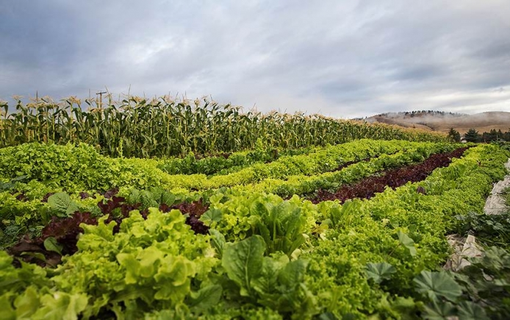
The Farm Bill, which is rewritten every five years, offers a critical opportunity to change federal farm and food policy. Instead of catering to a business mentality focused solely on a desire for cheap raw materials, we can demand that our country’s next Farm Bill ensure functional, fair markets so that farmers and farmworkers who grow our food can earn a decent living, promote environmental stewardship and rebuild the infrastructure we need for consumers to access sustainably grown, regionally produced food.

Farm with various crops in California. Photo from Pexels
Principles of a Faithful Farm Bill

From God’s initial command to care for creation to the prophets’ call for justice among governments and nations, people of faith in every age are called together to work for the common good. Inspired by our faith traditions’ commands to care for poor and vulnerable people, we join together to support policies that promote local food security, strengthen rural communities, support farmworkers, farmers and all who work in the food system, and care for the land as God’s creation.
Our nation’s food and farm policies as embodied in the Farm Bill impact people and communities from rural America to developing countries. In the current budget climate, the Farm Bill’s resources must be effectively targeted where need is greatest. Sustainable programs and policies that curb hunger and malnutrition, support vibrant agricultural economies must be prioritized.
As disciples of a loving God, we are called upon – each of us – to urge Congress to take the opportunity presented by the reauthorization of the Farm Bill to reduce hunger and poverty in the U.S. and around the world and encourage sustainable stewardship of soil, land, water, and air.

To this end, we support the following principles and subsequent platform for reform of the Farm Bill:
- Protect and strengthen programs that reduce hunger and improve nutrition in the United States.
- Promote investments, loan programs and policies that strengthen rural communities and combat rural poverty.
- Ensure that farmers in the U.S. and around the world receive fair prices so they can sustain their farms and their livelihoods.
- Ensure that crop insurance and other programs include payment limitations and rules giving equitable access to small- and medium-scale farmers.
- Strengthen policies and programs that promote conservation, reduce carbon emissions, and protect creation from environmental degradation.
- Protect the dignity, health, safety, and fair compensation of those responsible for working the land.
- Promote research and incentives related to clean, and renewable forms of energy that do not negatively impact food prices or the environment.
- Safeguard and improve international food aid in ways that encourage local food security and improve the nutritional quality of food aid.
- Advocate for policies that honor treaties and land claims by Indigenous Peoples, support farmers and food chain workers of color, and promote food sovereignty in the Global South.

2018 Platform for Farm Bill Reform

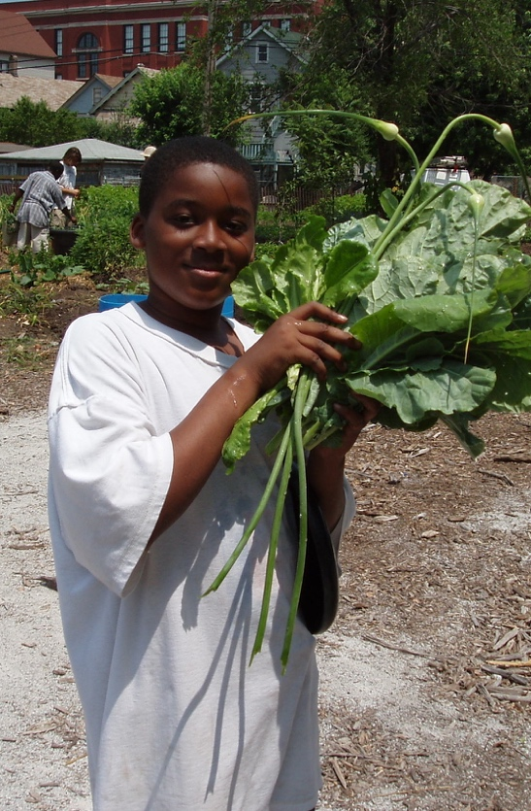
- Food security, rural support and sustainable regional food economies

- Access to resources and land for people of color, immigrants and farmworkers, and beginner farmers.
- Land, environment, and climate stewardship
- Food chain & farm workers, and at-risk farmers & producers
Young gardener at Angelic Organics garden in Chicago.
Photo credit: Angelic Organics
- Responsive international food aid that strengthens food sovereignty

Find platform specifics in the Appendix
and online at bit.ly/fb17five.
The following sets of questions are for use
with candidates and political representatives
at the local, state and national levels.

Questions for Candidates
on the 2018 Food and Farm Bill

We know that food and farming activists make an impact when they are able to impress upon policy-makers the importance of sustainable farming and community food systems. This guide provides questions you can ask candidates for elected office to understand their positions on the policies that impact farms and food systems. Questions for Candidates aims to get candidates and their communities thinking about farming, food security, urban agriculture, the environment and food.

Some candidates will become elected officials; the more the candidates learn about sustainable and just farming and food systems now, the more likely that they will support policies that foster these systems once elected. Public discourse about these issues is incredibly important to both increase awareness and to hold our elected officials accountable. Please use this guide to discuss food and farm system issues at public debates, forums and town hall meetings.
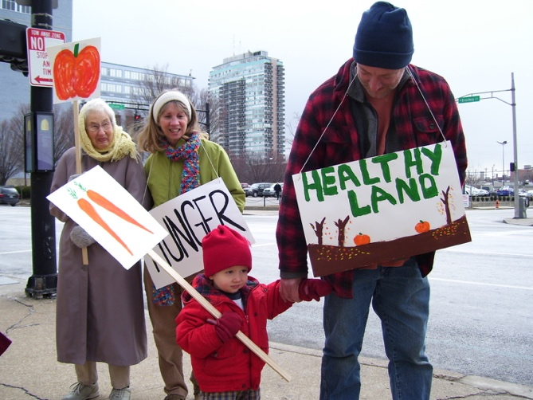
______________
Relationships matter
The better or stronger your relationship with a future policy-maker, the more likely you are to impact how that person thinks about the issues that matter to you. Keep in mind that you can work effectively with someone, regardless of the personal opinions either of you may hold. Although you are unlikely to agree on every issue, you can still build a positive relationship in the long run.

Get to know them and their staff:
The best way to get to know your candidates on a personal basis is to spend time with them. For incumbent state or federal lawmakers, arrange an in-district meeting when they are home. You can also write a letter, attend a town hall meeting, send an email, write a letter to the editor of your local paper: take action to let candidates know how you stand on issues. It is also important to get to know their campaign staff, especially at the state and federal level; staff opinions inform the policy positions of candidates.
Farmer Ivor Chodkowski, son Eliah, Rev. Jane Larsen-Wigger and Jean Edwards at past Farm Bill rally in front of KY Sen. McConnell’s Office. Photo credit: Andrew Kang Bartlett

Invite them often and early:
Candidates are often very busy. Be sure to invite them to every event that you hold and remind them of your invitation about a month before the event and again the week of the event.

Follow up with a thank you note:
Following up with a thank you note after a meeting or an event sets the stage for future interactions. A simple email message will usually do the job. Thanking a candidate for their time will go a long way towards building a stronger relationship and encouraging future discussions.

Learn about their interests:
Educate yourself about the interests of a candidate; this will help you to better understand why they may choose a certain position. Knowing background information about the candidate’s life and concerns will better inform your engagement efforts and help you to understand their motivations around certain issues. For example, it might help to talk about sustainable agriculture as a way to promote healthy ecosystems with one official, while another might better understand the benefits local agriculture can have on public health, while still another will be interested in sustainable agriculture’s role as an economic driver.
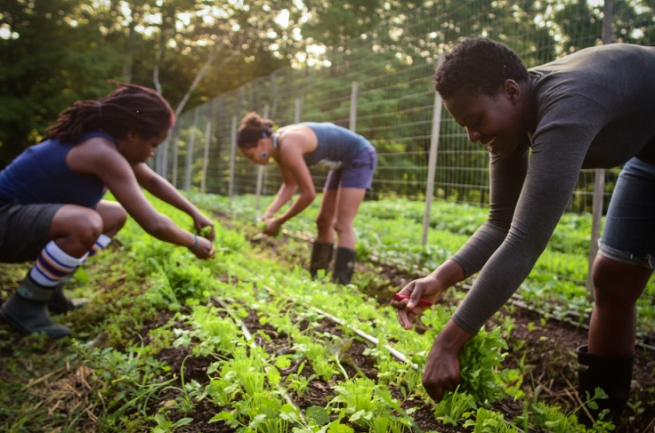

Educational Videos on the Farm Bill

Farm Bill 2014
http://bit.ly/fb2014al
What is the Farm Bill and why should you care? bit.ly/fbwhycare (2:43 minutes)

Farm Bill 101 – PDF from Food & Water Watch
bit.ly/farmbill101

Harvesting micro-greens at Soul Fire Farm, New York; photo credit Capers Rumph
QUESTIONS FOR LOCAL CANDIDATES
These questions may best be asked of candidates running for offices like Metro/City Council, Mayor, County Commissioner, Soil and Water Conservation District Supervisor, and School Board

- Many municipalities are adopting policies and passing laws to ensure that food available in public settings—cafeterias and vending machines in government office buildings, day care centers, schools, parks, and other venues—are healthful. What would you do to encourage healthy eating in our community?
- Health is a priority for people, and food grown from healthy soils not only protects the environment, but promotes well-being and prevents disease. For example, a team of scientists in the U.K. recently found that organic crops had 18 to 69 percent more antioxidants than conventional crops (British Journal of Nutrition, 2014) What would you do to promote farming practices that develop rich, healthy soil and reduce dependence on human-made inputs?
- Health disparities, evident in longevity and rates of diabetes and heart disease, between certain socioeconomic and racial communities are well documented in many cities across the nation. What policies and plans would you implement in order to decrease the gap in health outcomes among residents?
- Research in one state has shown that the direct sale (through farm stands, CSAs, farmers’ markets, etc.) of local agricultural products annually generates over $3.3 million dollars in revenue to farms and a total of $6 million in local economic impact. (Economic Impacts of Direct Produce Marketing, 2008). In addition to their positive impact on local economies, farmers’ markets are also a great vehicle for putting more locally grown food on the plates of local community members. What would you do to help establish or expand access to locally-grown food?
- In order to feed future generations, we must ensure that farmland is protected. Pressure to develop open land makes it difficult for farmers to keep their land in farming, and so, without protections, more farmland will be lost. What policies would you support to preserve farmland? What would you do to support trainings in farm transfer and succession planning?
- Forty percent of the food produced in the United States is wasted as a result of production, storage, and packaging losses, and retail and consumer waste (Natural Resources Defense Council, 2012). Do you support this and what other policies would you support to reduce food-related waste in our community?
QUESTIONS FOR STATE CANDIDATES

These questions may be asked of candidates for Governor, State Senate, State House of Representatives, and other state officials

- Are you committed to the dignity, fair compensation and safety in the workplace for all workers? Do you believe farm workers should be protected by the National Labor Relations Act like all other workers in the country?
- Do you believe consumers should have the right to know what is in their food so they can make decisions about what they and their families eat? Do you support GMO labeling?
- The organic agricultural sector is an area where we can see rapid expansion and economic growth. What policies do you support to foster the continued increase of the organic sector?
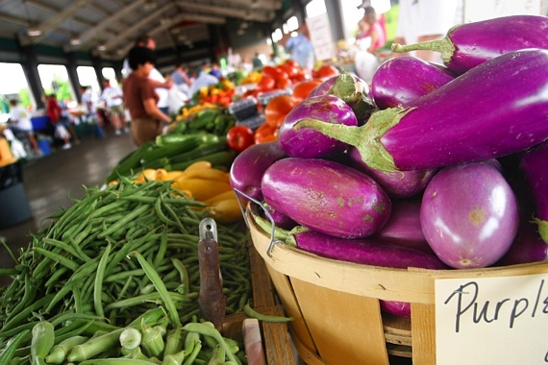
- Farming families have a hard time making ends meet, and seeds are expensive. Should farmers have the right to save seeds regardless of who sells them the seeds?
- Do you support incentives for farmers to reduce their energy and carbon footprint by focusing on soil fertility, low or no use of chemical fertilizers, and reduced reliance on fossil fuels? Specifically, what measures do you advocate?
Farmers’ Market in New Orleans.
Photo credit: Andrew Kang Bartlett

- What incentives do you favor to encourage procurement of locally-grown food by local markets, local and state governments, and institutions such as schools and hospitals?

- Federal nutrition programs such as WIC, SNAP, school lunch and breakfast programs, and the Summer Food Service Program are important food security resources in communities across the state. If some of the food used in these programs is sourced from local farms, the programs have a positive economic impact on local retailers and food producers. If elected, what will you do to ensure that these programs purchase from in-state farmers?

- Many state-level policies have been set to support the growth of larger-scale farms who are working to access wholesale, international markets. The needs and challenges faced by small-scale producers are different than those faced by large growers. What policies would you support to support the efforts of small-scale farms in the state?

- Forty percent of the food produced in the United States is wasted as a result of production, storage, packaging losses, and retail and consumer waste (Natural Resources Defense Council, 2012). Local and regional cold handling and storage systems reduce perishable food losses, and increase income for farmers and economic growth for the state. What policies would you support at the state level to rebuild local and regional processing, storage, and distribution infrastructures to decrease the amount of food waste in the food chain and support farmers?

- The herbicide Dicamba has damaged more than 3.6 million acres of soybean crops in 25 states. The state of Arkansas has banned the use of Dicamba herbicide. Would you support banning the use of Dicamba in our state?

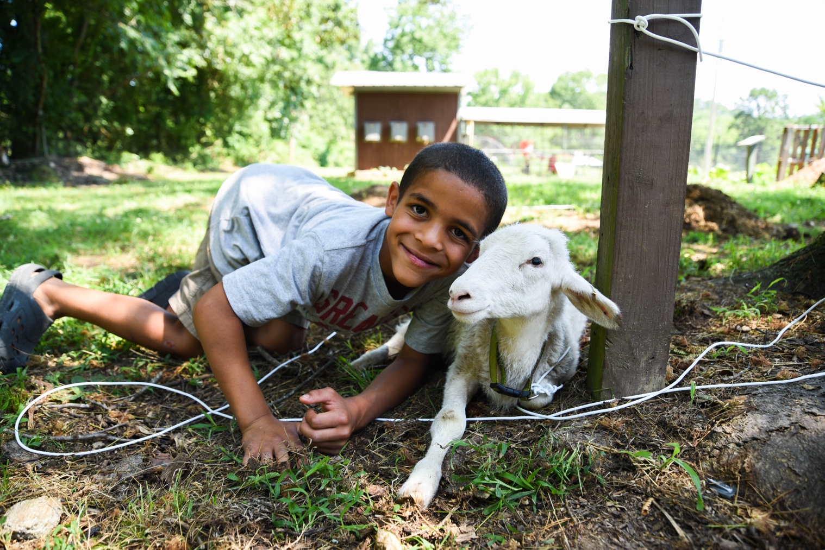
Camper and goat at Ferncliff Camp and Conference Center near Little Rock, Arkansas. Photo credit: David Gill
QUESTIONS FOR NATIONAL CANDIDATES
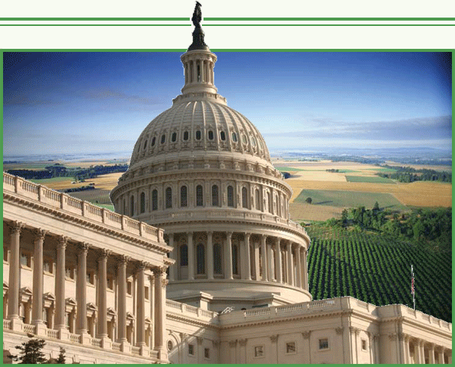
These questions may be asked of candidates to the US Congress whether they are running for a seat in the Senate or one in the House of Representatives

Food security and equity
- Almost 3/4s of a million of our fellow citizens, including more than 220,000 kids, did not always know where their next meal was coming from. SNAP benefits, funded as part of the Farm Bill, have kept this figure from rising even higher. Yet, some members of Congress have advocated reducing funding for SNAP or restricting access to benefits. Will you commit to supporting continued full funding for and access to SNAP?
- Do you believe consumers should have the right to know what is in their food so they can make decisions about what they and their families eat? Do you support GMO labeling?
- Are you committed to the dignity, fair compensation, and safety in the workplace for all workers? Do you believe farm workers should be protected by the National Labor Relations Act like all other workers in the country?

Support of Farming Families
- We’re fast approaching a crisis as farmers age and shrink in number; the average age of a farmer is 58. Access to affordable land is a major obstacle to beginning farmers and programs to support them are insufficient. What policies do you support to encourage small transitioning and beginning farmers?
- Are you in favor of increased funding for new and socially-disadvantaged farmers (low interest credit, training/tools, access to USDA programs)?
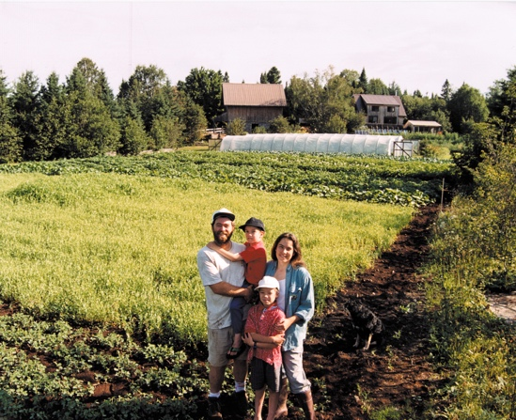
- In order to feed future generations, we must ensure that farmland is protected. Development pressure makes it difficult for farmers to keep their land in farming, and so, without protections, more farmland will be lost. What policies would you support to preserve farmland? How will you support trainings in farm transfer and succession planning?
- Do you support food safety training to equip beginning farmers on the requirements of the Food Safety Modernization Act?
- The organic agricultural sector is an area where we can see rapid expansion and economic growth. A substantial increase in funding for Sustainable Agriculture Research Education (SARE) would help worthy sustainable agriculture research projects get going and would support this growing sector. What policies do you support to foster organic agriculture?
Abazs family in Finland, Minnesota.
Photo credit: Round River Farm
- Forty percent of the food produced in the United States is wasted as a result of production, storage, packaging losses, and retail and consumer waste (NRDC, 2012). Local and regional cold handling and storage systems reduce perishable food losses, and increase income for farmers and economic growth for the state. What policies would you support at the state level to rebuild local and regional processing, storage, and distribution infrastructures to decrease the amount of food waste in the food chain and support farmers?
- What incentives do you favor of incentives to encourage procurement of locally-grown food by local markets, government, and institutions such as schools and hospitals?

Conservation and Environment
- Do you support incentives for farmers to reduce their energy and carbon footprint by focusing on soil fertility, low or no use of chemical fertilizers, and reduced reliance on fossil fuels?
- The USDA established regional hubs to deliver weather information to farmers, ranchers, and forest landowners to help them to adapt to increasing weather unpredictability caused by climate change. What policies will you support to address climate change – mitigation or adaptation – to protect our farms?
- Although less than five percent of Farm Bill funds have gone toward conservation programs, these have had multiple impacts on the environment. To name just a few benefits, the programs reduce topsoil loss, improve soil health, prevent habitat loss, protect water quality and access, and conserve wetlands. Will you commit to voting for a Farm Bill which fully funds or expands these programs: Conservation Reserve Program (CRP), the Environmental Quality Incentives Program (EQIP), Conservation Stewardship Program (CSP), Agricultural Conservation Easement Program (ACEP), and Regional Conservation Partnership Program (RCPP)?

Fair and Competitive Playing Field
- The best seeds have been selected by generations of farmers over millennia, and they are essential to life. Yet seeds are increasingly licensed and patented by private companies, and the diversity of seed varieties dramatically reduced. Should seeds be something that can be patented by private companies?
- Mergers of large corporations -- such as seed, pesticides, food processors and retailers, and other agrifood companies -- have become commonplace. In result, a very few enormous companies control large parts of the food and farm system. Do you favor stricter enforcement of antitrust and antimonopoly laws for agriculture and food companies? Are you in favor of greater transparency in the market in terms of contracts, and do you support the Farmers Fair Practice rule?
- In addition to the many mergers and market dominance of a small number of global livestock corporations, they increasingly control all stages of livestock production from birth to retail, which economists agree limits competition and pushes smaller family-scale producers out of business. How do propose to regulate vertical integration in livestock industries?
- Country-of-Origin Labeling (COOL) is a win-win for farmers and eaters. Without it, U.S. farmers have a harder time getting a fair price because corporate meat processors can import cheaper meat and pass it off as a domestic product. As a favor to large livestock corporations, the requirement to label meat with its country-of-origin was recently lifted. Do you support and would you fight for country-of-origin labeling?
- Crop insurance is subsidized by taxpayers and yet the benefits accrue primarily to the largest farm operations and result in numerous adverse consequences. Do you support reforms to end unlimited subsidies in order to slow farm consolidation? Will you sponsor or support measures to make crop insurance accessible to all types of farmers, and to link premium subsidies to stewardship practices that protect our land, water and health?

Appendix:
2018 Farm Bill Reform Platform

A) Food Security, Rural Support and Sustainable Regional Food Economies
Whereas: Inequality has become extreme and many people are falling through the cracks of our weakened safety net, especially in rural areas of the United States.
Therefore:
1) We advocate for strong governmental involvement in guaranteeing the right to food for all people as well as a basic standard of living. Regarding SNAP, food access, and support for regional food economies, we support:
- Sustained funding for SNAP
- Broader and increased use of EBT (Electronic Benefits Transfer)
- Increased funding for Farm to School, Community Food Projects, and other programs to strengthen local food economies.
- Addition of a federal Farm to Food Bank policy to allow sales of surplus produce
- A well-funded Value Added Producer Grants Program (VAPG)
- Full funding for the Farmers Market and Local Food Promotion Program (FMLFPP) and adjustments to ensure direct benefits for family farmers and ranchers.
2) We call for the government to reinstate a strategic and farmer-owned grain reserve system to protect family farmers from unstable price fluctuations and ensure resilience in the event of weather-related disasters.

B) Access to Resources and Land for people of color, immigrants and farmworkers, and beginner farmers.
Whereas: The dispossession of lands from Native Americans and our country’s history of slavery along with ongoing suppression of immigrants compels us to confess our complicity and failure to fully learn and pass along this history, and to call for reparations for past harms:
Therefore:
1) We advocate for policies which provide affordable access to land and resources for Native American, African-American, and other people of color farmers and ranchers, with special attention to small- and medium-scale producers.
2) We call for reparations of past discrimination as exemplified in the Pigford class action suits and an end to ongoing discriminatory lending practices at all levels of USDA.
3) We call for ample support and funding for land-link programs, technical assistance for transition and succession planning, and access to credit, crop insurance and other risk management, cooperative development support, training, and technical assistance, with a priority on providing these to low-resource and people of color farmers, livestock producers, and ranchers through increased funding of the 2501 Program.
4) We call for an end to land grabs and other land speculation by individuals, corporations, pension funds and governments, which raise land prices out of the reach of farmers, and often cause deforestation and ecologically destruction.
5) We call for stricter rules in the Environmental Quality Incentives Program (EQIP), which would limit inappropriate use of EQIP funds by large, polluting operations, and support adjustments to discourage overproduction and pollution of water resources.
6) We call for policies that support the economic resiliency of coastal communities, particularly for independent small and medium scale fishermen.

C) Land, Environment, and Climate Stewardship
Whereas: Changes in climate and weather patterns are already disrupting farming around the world, and these will only become intensified in coming years;
Whereas the dominant practices of chemical- and fossil fuel-intensive, single-cropping agriculture used around the world damage and erode the soil, often cause desertification, and poison land, water, air and people;
Whereas prior year disinvestment has drastically reduced public plant breeding programs which increase farm resiliency;
Whereas genetic engineering and seed ownership is not democratically controlled and research decisions are influenced by the corporations that profit in these areas:
Therefore:
1) We advocate for conservation incentives, in particular agroecological, regenerative approaches, that build up (sequester) carbon in the soil in the Comprehensive Conservation Title and in these critical programs, which deserve increased funding:
- Conservation Stewardship Program (CSP)
- Conservation Reserve Program (CRP)
- Environmental Quality Incentives Program (EQIP)
2) We call for increased funding for public sector breeding and research programs in land grant university system and USDA research facilities, which will reinvest in ecological public plant breeding programs that address climate change and extreme weather patterns so farmers are prepared with diverse, adaptable seed stocks and agroecological approaches.

3) We call for stronger review of proposed genetically-engineered crops, seafood, and livestock prior to approval, and GE labeling laws at state, national and international levels, and for fair and open access to and ownership of heritage, hybrid and conventional (non-genetically modified) seeds; ecology-based biodiversity of seeds, crops, livestock and seafood.

D) Food Chain & Farm Workers, and At-Risk Farmers & Producers

Whereas: Farmers, Farm Workers and other Food Chain Workers are threatened with detention and deportation, human trafficking, sub-poverty wages, wage theft, lacking and unenforced labor laws, and dangerous conditions, legislative and corporate advocacy in support of these workers is a priority;
Whereas small- and medium-scale farmers and producers and food chain workers are disadvantaged by current policies and corporate practices:
Therefore:
1) We advocate in support of Dairy Farmers, Contract Poultry & Livestock Producers, and Fisherfolk by supporting policies which:
- Support dairy farmers and other producers by opposing corporate manipulation of prices and contract abuse.
- Resist the monopolization of corporations in this sector and oppose abuse of contract producers. Specifically, by:
– Opposing amendments to the Agricultural Fair Practices Act that would undermine the ability of farmers to negotiate fair contracts with processors.
– Opposing amendments to the Packers and Stockyards Act that would undermine enforcement authority for GIPSA over all livestock operations.
– Advocating for the economic, social and ecological sustainability of small and medium-sized fishermen and their communities.
2) We oppose increasing the loan cap limits for Farm Service Agency (FSA) Direct Operating Loans (DOL), Guaranteed Operating Loans (GOL), and Guaranteed Farm Ownership Loans; doing so is unnecessary and would primarily benefit large Confined Animal Feeding Operations (CAFOs).

E) Responsive International Food Aid that Strengthens Food Sovereignty

Whereas: The US is the world’s biggest food donor and responds to food emergencies and humanitarian crises, but the program is wasteful and slow because of rules requiring that US commodities be purchased and sent on US ships;
Whereas: A flood of food aid, that often arrives after the crisis, may cause a food glut, price depression, and the bankrupting of local farmers:

Therefore:

1) Funding should be maintained or increased for international food aid, and reforms to improve responsiveness and effectiveness should be enacted.

- Funding for local and regional procurement (LRP) should be dramatically increased in our foreign food aid programs.
- The response times to famine, drought and natural disasters should be improved by opening additional overseas facilities to strategically pre-position food aid.
- Rather than wasteful and market distorting monetization program, NGO partners implementing Food for Peace Title II programs should be allowed to use all Food for Peace funds on non-commodity expenses.

Sign up for the PC(USA) Office of Public Witness Email Alerts here at bit.ly/18advocate to join with other people of conscience in advocating for these important policies.
This platform is based on a history PC(USA) General Assembly policies in support of family farmers, farm workers, and a just and sustainable food and farm system. Key resolutions include:
- We Are What We Eat (2002)
- Food Sovereignty for All (2012)
- Endorsing “A Fifty Year Farm Bill” (2014)
- Advocacy Against Factory Farming (2016)

The Presbyterian Hunger Program ushered the Eater’s Guide to the Farm Bill into existence with the invaluable assistance, insights, and work of the Food in Neighborhoods Community Coalition in Louisville, Kentucky and farmers of Field Day Family Farm. Special thanks to the Kentucky farmers who filled out the Farmer Survey.

This publication and any parts can be freely used with attribution to the Presbyterian Hunger Program (PCUSA), 2018

