Snapshots of the U.S. Food & Farm System: Pandemic Edition
Understanding our food and how it gets to us is no simple task.
This overview is a snapshot of the situation of workers and dynamics in our country’s food and farm system. The goal was to outline the current situation in the pandemic and possible solutions for each part of the food chain. It is a group project crowdsourced from several US Food Sovereignty Alliance participants and Louisville food activists. Hopefully the overview will help us understand the system and devise ways to improve it. We start from food producers and make our way around to consumers and hungry people.
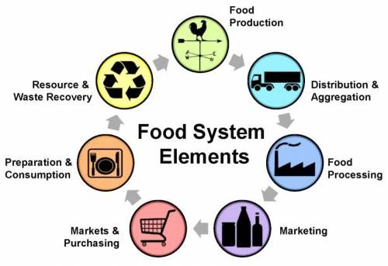

CONTENTS: Food Production | Food Chain Workers | Sales | Consumers | Food Insecure

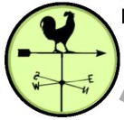

Food Production

Farm Workers

Situation
- Considered essential workers”, but treated as expendable — poor pay, dangerous work, lack of info in languages spoken, risking infection and death from Covid-19, no paid sick leave. (Related news)
- Shortage of workers due to Administration’s anti-immigrant policies, ICE raids, and prevailing low pay and poor working conditions, causing labor shortage on farms and agriculture-related businesses.
- President has threatened to reduce wages of farmworkers.
- Government trying to increase numbers of H2A farmworkers to meet the demand for labor, but leaving workers vulnerable to exploitation and abuse, and with no path to citizenship.
- Continued ICE raids in farmworker and other immigrant communities.

Solutions
- Demands for worker rights, hazard pay /living wage, safety protections in languages used, virus testing and affordable medical care, ample and safe housing.
- Immigration reform and improvement in wages and conditions.
- Increase wages. Provide financial support for smaller and independent producers to pay a living wage.
- Stop H2A workers system or others pushing for a variety of improvements, including better protection of workers and flexibility to switch employers, with direct hiring without using recruiters who charge the workers, and a path to citizenship.
(See bottom of Slaughterhouse for ways to support farm and other food workers)

Food Production

Farmers, Ranchers, Producers & Fishermen

SMALL & MID-SCALE

Situation
- Greater consumer demand on small and medium-scale farmers, including direct market dairy and livestock: most CSAs are wait-listed, many farmers markets are running; farmers already doing or able to switch to online sales and pick-ups doing great, but some farmers can’t. (Related article)
- 92% of farms grossing under $350,000 depend on off-farm earnings and rely on that job for health insurance. That income also subsidizes farm operations, so unemployment can jeopardize the farm.
- Disruptions caused by the pandemic are most challenging for small-scale, low-resource farmers, producers and ranchers, and the potential for bankruptcy and loss of their farms is great.

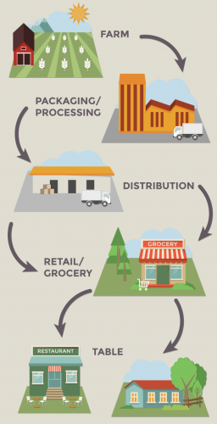
Solutions
- For farms on all scales, redesigned parity pricing with price supports, supply management and required conservation practices.
- Ensure all farmers, ranchers, and fisherpeople are included in any broader stimulus or farm relief package, with specific prioritization of small and mid-sized operations, limited resource producers, and farms operated by farmers of color and tribal nations.
- Secure and protect land access, particularly for producers of color. (Related article)
- Put teeth into local zoning ordinances and regional planning documents to incentivize and effectively preserve arable lands in perpetuity for agroecological agricultural production.
- Equalize and expand access to crop insurance, technical assistance, low interest credit, and technical assistance.
- Place moratorium on farm land foreclosures.

Food Production

Farmers, Ranchers, Producers & Fishermen

LARGE SCALE

Situation
- The pandemic has revealed the overall weakness and vulnerability of the dominant food and farm system and its supply chains.
- Nevertheless, the strength and capital of agri-food corporations and large-scale farms gives them tremendous advantages over smaller-scale operations.
- They have been able to access the bulk of CARES Act PPP and USDA emergency funds, exhausting the funds before smaller operations could access them.
LIVESTOCK: 1. Industrial livestock production causes habitat loss and concentrated, limited genetics of livestock increases chances of virus outbreaks, risks and spread. (Related article)
2. Dependence on antibiotics to speed growth and prevent disease rampant because of confined spaces.
DAIRY: 1. Surplus resulting from reduced milk distribution at schools and pizzerias; some farms going under. (Related article)

Solutions
- Systemic changes are needed, such as:
  - Fair pricing legislation, coupled with supply management.
  - Fair agricultural contracts, farmer/grower/rancher rights, and competitive markets through USDA Farmer Fair Practice Rules.
  - Passage of the PRIME Act to allow intrastate sales of meat from state-inspected facilities.
  - Through executive order or state legislation, USDA rules on who "owns" livestock could be re-interpreted to allow for consumers to buy shares in an animal or a herd as has been done in Wyoming.
  - Prohibit crisis profiteering and corporate consolidation with an immediate moratorium on acquisitions and mergers and enforce antitrust laws.
  - Ensure that any farms that receive a bailout implement measureable stewardship practices. (Related recommendations and see also Green New Deal for Agriculture)
DAIRY Solutions: 1. Some dairy farmers are fertilizing farmland with surplus milk; others are donating it when possible.

Food Production

Farmers, Ranchers, Producers & Fishermen

FISHERMEN

Situation
- Covid-19 has had a devastating impact on America’s seafood industry, particularly independent fish harvesters and thousands of small and mid-sized seafood businesses including processors, aggregators, distributors, and other shore-based facilities.
- In the CARES Act, $300 million in disaster assistance was allocated to the seafood industry, but it is not enough and a coalition led by the Northwest Atlantic Marine Alliance is requesting additional assistance.

Solutions
- Emergency funding of $1.5 billion for fishermen and seafood businesses, with at least 50% for small and medium-scale operations.
- Payroll protection and debt forgiveness.
- Immediate expansion of community-driven shore-side infrastructure to strengthen local supply chains.
- Medical care and testing.
- Inclusion of fishermen in the USDA Coronavirus Food Assistance Program.

Food Chain Workers

GENERAL

Situation
- Deemed essential but still some of the poorest paid and most dangerous work done disproportionately by BIPOC. Very few are receiving hazard pay despite the fact that they risk their lives to provide the rest of the population with food.
- Immigrants, many of whom are undocumented, are excluded from protections by precarious status and are excluded from stimulus checks, food stamps and other assistance. Public Charge Rule punishes those who try to receive public assistance.
- Few food chain workers receive paid sick leave, so many must work even when they are sick. (See ‘Slaughterhouse‘ for situation of and solutions for food workers)

Solutions
- Provide free testing and healthcare coverage for all workers regardless of immigration status, including H2A and migrant workers
- Ensure that all workers receive the supplemental income they need to survive, regardless of immigration or employment status. Immediate moratorium on the Public Charge Rule and immigration enforcement.
- Organize unions and worker cooperatives to offer better security & working conditions. (Related article)

Food Chain Workers

TRUCK DRIVERS & OTHER TRANSPORT

Situation
- Consumer delivery services offer low wages & low protections for workers.

Solutions
- Guarantee safe workplaces with PPE, hand-washing breaks, and required space for “social distancing.”
- Provide time and a half hazard pay; make overtime voluntary and guarantee overtime pay.

Food Chain Workers

PROCESSING

Situation
- Considered essential workers, but treated as expendable; poor pay, dangerous work, lack of info in languages spoken, risking infection and death from Covid-19, no paid sick leave.
- Shortage of workers due to Administration’s anti-immigrant policies causing labor shortage

Solutions
- Guarantee safe workplaces with PPE, hand-washing breaks, and required space for “social distancing.”
- Provide time and a half hazard pay; make overtime voluntary and guarantee overtime pay.

Food Chain Workers

MEAT

Situation
- Meat processing, especially but not exclusively pork, has been hit hard by Covid-19 with a number of facilities closing. The resulting slow-down has necessitated the culling of animals.
- # of people who have contracted COVID-19 from outbreaks at these facilities has topped 10,000; a single Smithfield meat plant is responsible for more than half of S. Dakota’s COVID-19 cases.
- USDA uses COVID-19 crisis as excuse to increase line speed at chicken factory (article).
- Pork exports to China quadrupled as US experiencing some shortages; USDA predicts meat processing capacity will reach 85% by end of this week. (5/10/20)

Solutions
- Wages should be made living wages, line speeds should be slowed, and better safety measures taken now and permanently.
- Paid sick leave is critical and workers with higher risk factors must be allowed to stay healthy at home and not lose their jobs.

Food Chain Workers

GRAINS & PRODUCE

Situation
- Labor shortages sometimes disrupt production and processing. (see farmworkers section)
- Over-dependence on regional processing, distribution and long-distance shipping makes supply more vulnerable to disruption and less adaptive.

Solutions
- Increase local production while restoring local processing and distribution infrastructure.
- Provide support and capital to establish local and regional milling.

Sales

WHOLESALE

Situation
- Some supply chains have been disrupted to varying degrees, primarily those impacted by reduced demand from restaurants, hotels, airlines and schools.
- Meat is the sector most severely impacted by the closing or decreased capacity of processing facilities, causing some shortages and necessitating the culling of animals growing too big for processing.
- Dairy is in a similar situation with some producers throwing away large amounts of milk.

Sales

RETAIL

Situation
- Supplies are short because demand is up 10-30%; Grocery distributors are “smoothing” orders so stores get less than they order, but is more evenly distributed.
FAST FOOD: 1. Chains with capital reserves are surviving shutdowns better than independent restaurants. 2. Workers must continue working despite the health dangers, low pay, and lack of paid sick leave.

Solutions
Redirect restaurant suppliers to grocery outlets; Increase repacking and in-store resets.

Sales

RESTAURANTS

Situation
- Supply chains are different from retail grocery; Some food in wholesale/ restaurant supply chains has nowhere to go if restaurants close or scale back
- Restaurants have inventory spoiling in their coolers.
- Some restaurant workers are not receiving adequate unemployment payments.

Solutions
- Restaurants could be collecting relief money to pay some employees to prepare meals.
- Meals could go to schools, institutions, other outlets doing food relief, or distributed from their own premises (Importance of restaurants)

Consumers

GENERAL

Situation
- The rush on seeds, compost and local veg box delivery schemes that followed lockdown was a sign of public anxiety about the reliability of their food supply. For some, the threat was more psychological than real, as supermarket supplies are now returning to normal. The loss of paid work and the requirement to self-isolate, has brought challenges to afford and obtain food.
- U.S. unemployment has reached 33.3 million and most people will need a minimum of six months to a year or more to recover from Covid and related economic downturn, if they are able to find jobs. So, the dramatic increased demand for emergency food assistance will continue.
- Dissatisfaction with the food system makes the moment ripe for a new narrative and systemic change.

Solutions
- Provide guaranteed monthly payments to all low- and middle-income residents so they can afford healthy food.
- Increase unemployment payments and extend the period people can receive funds.
- Food-farm movements must continue to and increase joint strategizing and action to take advantage of the increased attention on food to make permanent policy and structural shifts toward more equitable, just and sustainable food systems.

Food Insecure People

FOOD BANKS & FOOD PANTRIES

Situation
- With a high poverty rate and now 15% of the workforce unemployed (5/8/20), the need for emergency hunger relief is extreme. By end of April, Brookings Inst. reported 40% of households with mothers with children 12 and under, were food insecure.
- Higher demand for food (98% of Feeding America’s 200 food banks) and higher operating costs. The 60,000 Feeding America food pantries pushing demand on food banks and other sources.
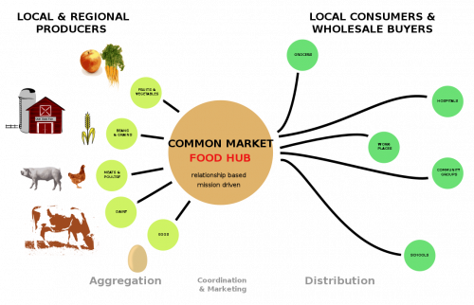
- Food surpluses from restaurants, hotels and resort drying up; most food banks seeing reduced inventory, sometimes dramatic; fewer volunteers since many were high-risk elders. At the same time, many farmers are forced to dispose of surplus food, especially dairy and livestock. (See ‘A disastrous situation’)

This diagram illustrates how a more localized food-farm system works; one that is more resilient and adaptive than the more disruption-prone, centralized food supply chains of the industrial food-farm system.

Solutions
- Expand, increase, and protect food and nutrition programs like SNAP and Women, Infants and Children (WIC), with no discriminatory barriers, and offer delivery where needed. (Related article)
- Include all seniors in Meals on Wheels programs.
- Strengthen and expand Double Up Food Bucks.
- Establish an Emergency Tribal Food Assistance Fund and enhance the Food Distribution Program on Indian Reservations (FDPIR), and allow dual participation in SNAP and FDPIR.
- USDA to support regional farmers to supply food directly to food banks, schools, and other emergency food suppliers.
- Mobilization of healthy furloughed/unemployed people, military and reserves, with adequate protections to staff food pantries.

Food Insecure People

FROM FARM TO PEOPLE

Situation
- Farmers, producers and food businesses with existing direct markets and those that can quickly shift to direct marketing are demonstrating flexibility and creativity to meet the demand for food.
- Yet they are not able to meet the huge demand for food, which depends on ability to purchase seeds, equipment, vehicles, cold storage, as well as access to nearby processing for dairy, grains and meat.
- The decimation of medium-sized farmers and in particular grain farmers limits the degree that local-regional farms can supply nearby populations.

Solutions
- Enable small and medium-scale producers to provide food for communities; key to this is prioritizing them (and especially limited resource producers, and farms operated by farmers of color and tribal nations) in stimulus and farm Covid-19 relief packages.
- Provide funds for purchase of small-scale equipment including farm equipment, refrigeration, trucking, and delivery systems.
- Ensure community food supply systems by investing in infrastructure for worker and neighborhood-owned food enterprises.

Food Insecure People

MUTUAL AID

Situation
- Many communities and cities are organizing mutual aid networks and systems and most include food.
- There are some existing apps, such as MyNabes and one open source app that is almost ready, and many folks are using google forms and sheets.

Solutions
- Local areas often have the food, resources and know-how needed to respond to crises and mutual aid networks make the necessary connections.
- Find Mutual Aid near you (map)
- Great examples and resources from MA.
- Sample mutual aid form.
- Neighborhood subscription uPick micro farms (model from Jacksonville)

  - farmers grow food in 1000 sq.ft. micro farms; label all harvest-ready crops with signs (with how-to-harvest instructions).
  - neighbors subscribe, paying monthly & come uPick whatever and whenever they want.

* The HEAL Food Alliance, in collaboration with other food and farm coalitions, came up with an excellent Food Workers and Farmers Platform with immediate policy asks and a number of the solutions above were come from that platform.

RELATED ARTICLES:
- Slaughterhouse: Meat processing workers risk Covid-19 infection
- Getting at the roots so we can harvest the fruit
- Local Food Surges in U.S. during Pandemic
- Food in a Pandemic: Curated Cream of the Crop
- Food Banks are Supporting Communities in COVID-19

