Become a Hunger Action Congregation

Actually, you may already be one!

The Presbyterian Hunger Program, PC(USA), is celebrating the faithful work of Presbyterians responding to the biblical call to alleviate hunger and end its causes.
We wish to acknowledge the work you are doing to end hunger, and to be mutually inspired to deepen and broaden our ministries.

Yours is a Hunger Action Congregation if you are doing an activity in one or more of these areas. For congregations that are doing one or more activity in all six areas, you can be a Certified Hunger Action Congregation. All of the Hunger Action Congregations will be celebrated on October 16, World Food Day.
- Hunger Alleviation: providing and/or sharing food in a dignified way with an eye to long-term structural solutions
- Development assistance: addressing the root causes of hunger and poverty through equitable and sustainable development
- Hunger Education: learning about systemic causes of hunger, leading towards faithful action that is informed and directed by directly affected people and partners
- Lifestyle Integrity: adopting sustainable personal and corporate lifestyles to restore justice and protect all of God’s creation
- Corporate and Public Policy Witness: advocating and campaigning for changes in policies and practices to end hunger and its causes, promote self-development, and care for creation
- Worship: incorporating prayer, education, and preaching about ending hunger and its causes into worship
We invite you to covenant with us to help end hunger. The instructions and online Hunger Action Congregation form are at bit.ly/hungeractionform.

For this year’s initial launch, we have a modest goal of 25 congregations
by the deadline of September 15, but let’s go for one hundred!

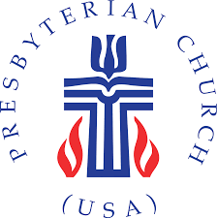
Contact php@pcusa.org or 502-569-5832 with any questions.
\

