—Jesus, in Matthew 25:35
—Jesus, in Matthew 25:35
“you gave me food…
you gave me drink…
you welcomed me…”
“you gave me food…
you gave me drink…
you welcomed me…”

Congregations around the country are responding to the biblical call to alleviate hunger and end its causes. The Presbyterian Hunger Program would like to hear from, encourage, and recognize these ministries.

Our church can covenant to become a Hunger Action Congregation if we are doing an activity in one or more of the following areas. When we are doing activities in all six areas, we can become a Certified Hunger Action Congregation.

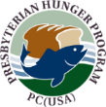
1 — Hunger Alleviation
2 — Development Assistance
3 — Hunger Education
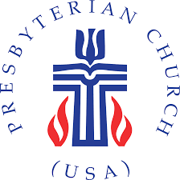
4 — Lifestyle Integrity
5 — Corporate and Public Policy Witness
6 — Worship

All Hunger Action Congregations who have completed the covenant will be celebrated on World Food Day—October 16.

The Hunger Action Congregation application is online at
www.bit.ly/hungeractionform.

Questions? Want to join our Hunger Action Team to apply and to help communicate about our hunger-related ministries?
Contact:

Congregations around the country are responding to the biblical call to alleviate hunger and end its causes. The Presbyterian Hunger Program would like to hear from, encourage, and recognize these ministries.

Our church can covenant to become a Hunger Action Congregation if we are doing an activity in one or more of the following areas. When we are doing activities in all six areas, we can become a Certified Hunger Action Congregation.

1 — Hunger Alleviation
2 — Development Assistance
3 — Hunger Education
4 — Lifestyle Integrity
5 — Corporate and Public Policy Witness
6 — Worship

All Hunger Action Congregations who have completed the covenant will be celebrated on World Food Day—October 16.

The Hunger Action Congregation application is online at
www.bit.ly/hungeractionform.

Questions? Want to join our Hunger Action Team to apply and to help communicate about our hunger-related ministries?
Contact:

