Eater’s Guide

to the
Farm Bill

2023 Edition

Eater’s Guide
to the
Farm Bill
2023 Edition

Table of Contents

Why We Eaters Should Care 3
The Farm Bill in Pictures 4

Food and Farming in the United States: The Situation 7

Principles for a Fair Farm Bill 9

2023 Farm Bill Platform for Reform 11
Questions for Candidates 16
Local 18
State 20
Federal 22

Created by the
Food in Neighborhoods Community Coalition
October 2022

Why We Eaters Should Care

The Farm Bill is a hard-working bill that covers everything from crop insurance to community food projects, from Meals on Wheels and SNAP (food stamps), to energy, conservation, and international food aid.

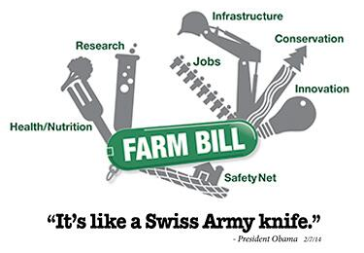

If you eat food or know anyone who eats food, then this bill directly impacts every part of your meal from where and how your food is grown; how it is cleaned or processed; how much it costs; and any money you may receive to help pay for your food.

Farm Bill in Pictures
The Farm Bill in Pictures

A glimpse of the Farm Bill, which ends in September 2023:
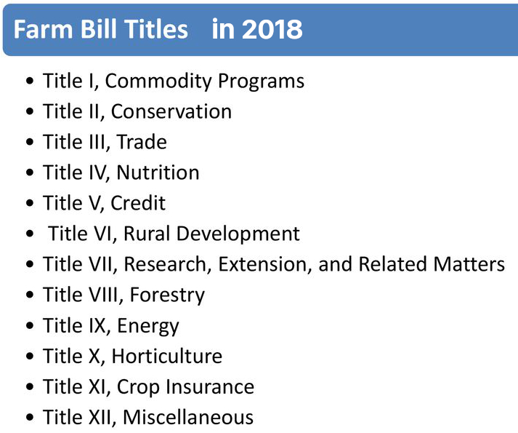
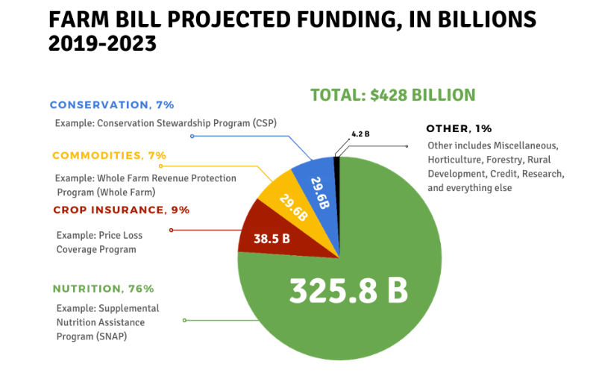

SNAP
Since a large proportion of the Farm Bill’s nutrition programs are for SNAP (Supplemental Nutrition Assistance Program, formerly known as Food Stamps), they merit a few charts. Along with Temporary Assistance for Needy Families, SNAP is one of the primary pieces of the safety net. While the monthly SNAP benefits are minimal, they are critical for children, the elderly, disabled people, and families struggling with poverty.
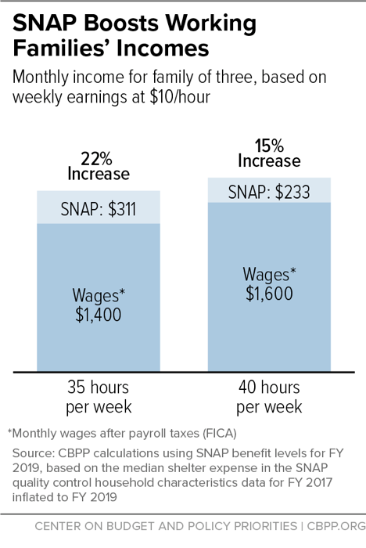
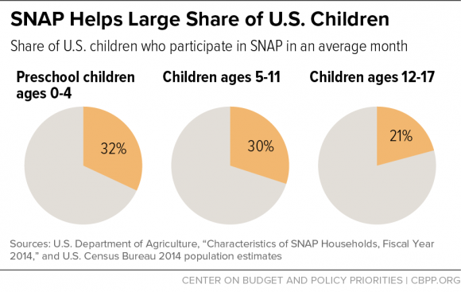
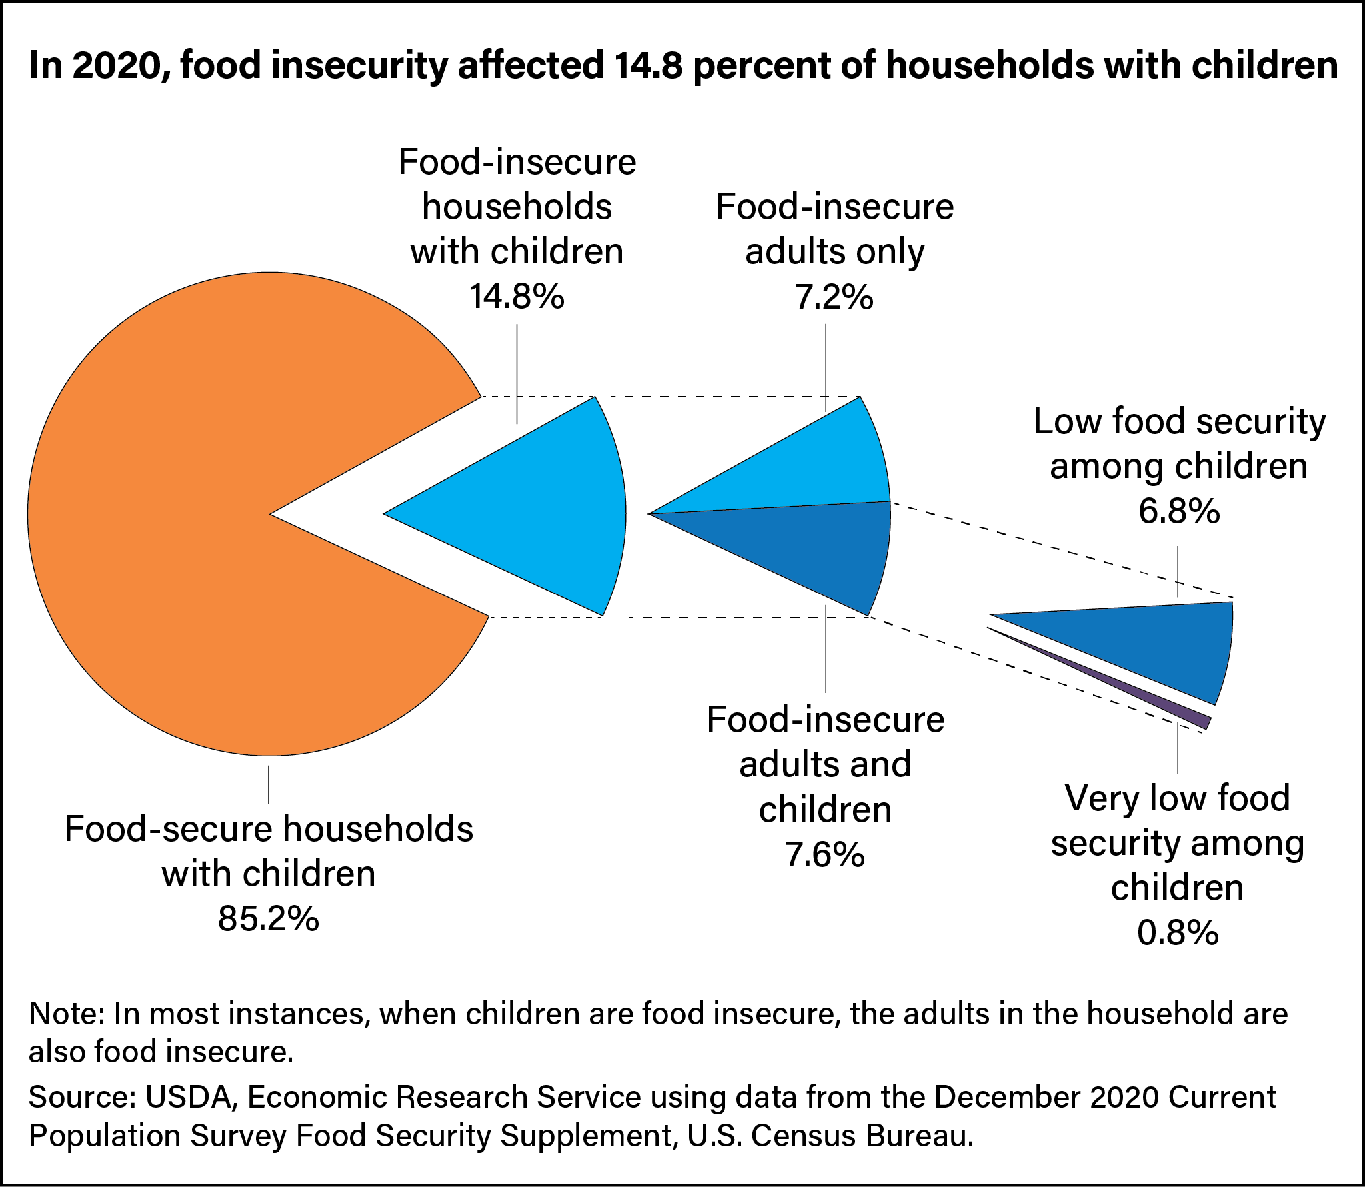

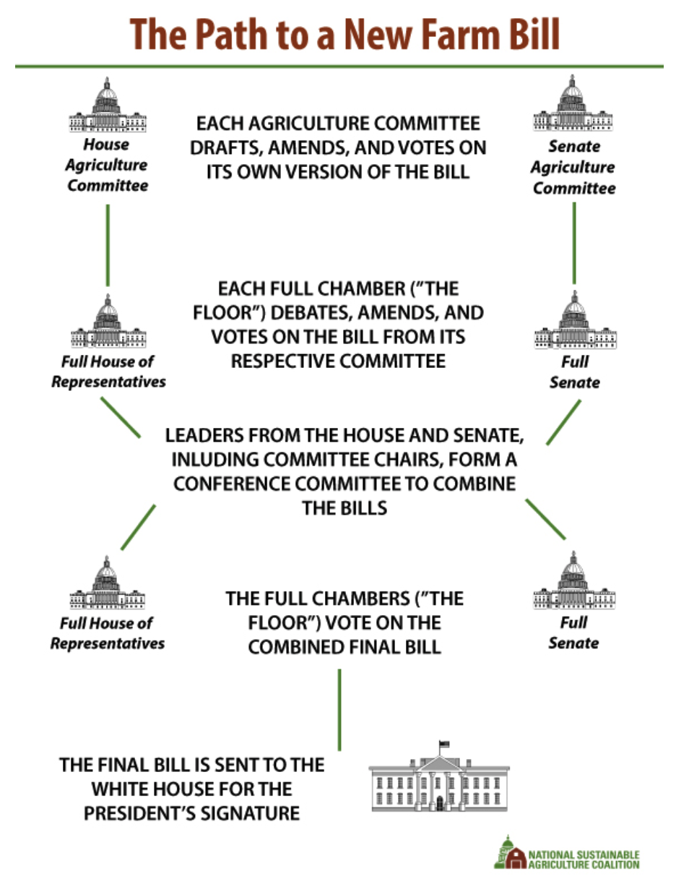

Food & Farming in the United States: The Situation

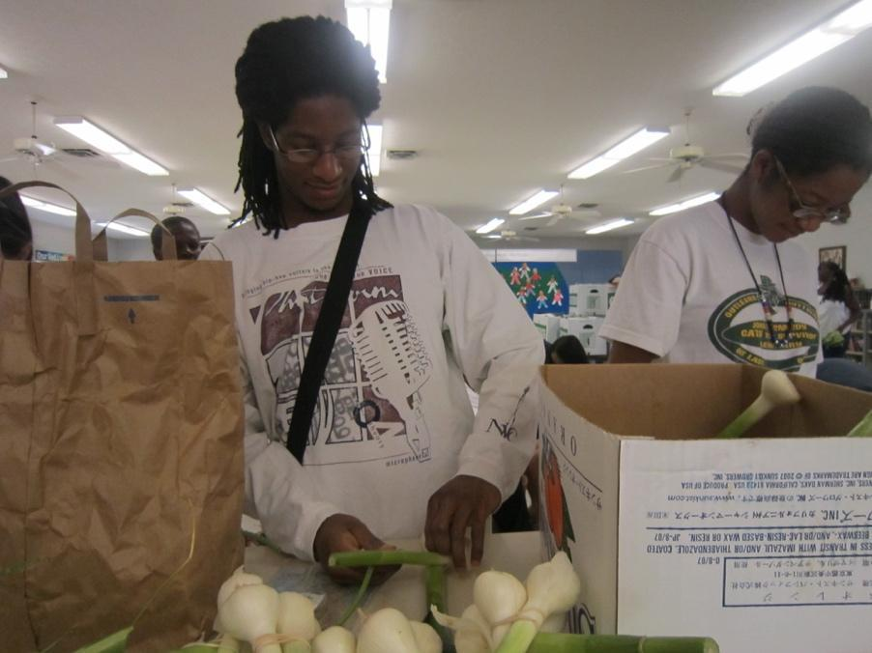
Many people do not have access to safe, nutritious, affordable food.
Many farmers, producers, fishers and ranchers can’t make a living.
Most regions in the U.S. no longer produce the food they consume.
Large-scale industrial agriculture often pollutes our soil, water and air and contributes greatly to climate change.
Farm policy has been crafted by and for agribusiness, supporting unchecked corporate consolidation that has hurt family farmers rather than help them.
These same policies have lowered farmer incomes, separated citizens from regional food sources, and wreaked havoc on public health, the environment, and rural communities. Meanwhile, consolidation of supermarket chains has reduced the number of grocery stores in urban and rural communities. Since 2020, the COVID pandemic has revealed the vulnerabilities of our long-distance food system.
Jonathan Krigger, former PHP VISTA volunteer, and another volunteer prepare affordable produce shares for Fresh Stop Market in a food apartheid neighborhood in Louisville.
Photo credit: New Roots
For decades, independent farmers have been disadvantaged by farm policies that favor commodity crops like corn and soybeans. Overproduction drives down crop prices, affecting farmer income and, in turn, the prosperity of rural communities.
In current farm policy it is large-scale agribusiness buyers — monopolistic grain-trading companies, meatpackers, and manufacturers that use soybeans and corn in processed foods and fuels — who reap huge profits from this system that promotes cheap commodity crops. Small and mid-sized farms and farmers are at the mercy of market fluctuations, and often find themselves competing with multinational agribusinesses.
Compounding this problem is the consolidation of agribusinesses. Consolidation has allowed a handful of companies that buy crops, dairy, seafood and livestock to dictate the prices that farmers receive. The four largest companies in each industry slaughter nearly all the cattle, process two-thirds of the pork, sell half the groceries, and market about half the milk in the United States. Farmers are squeezed by this increasingly uncompetitive marketplace and the giant agrifood corporations reap the profits.
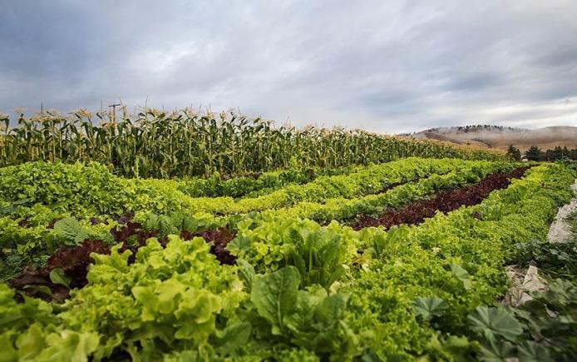
Meanwhile, farm policy also has continued to rely on exports to absorb excess supplies of bargain basement-priced crops, while failing to address the real problems at home, including high land prices, high debt, and weakened safety nets for farmers and consumers alike. The export of highly subsidized commodity crops, e.g. cotton and corn, harms small farmers in poor countries who cannot compete with the products of industrialized monocropping.
Good News
There is a growing movement of farmers and eaters working to rebuild local food systems and put more of the consumer food dollar directly in the hands of small and medium-scale farmers. In addition to direct consumer support of local farmers, we also have the opportunity to fix food policy at the federal level.
The Farm Bill, which is rewritten every five years, offers a critical opportunity to change federal farm and food policy. Instead of catering to a business mentality focused solely on profit and a desire for cheap raw materials, we can demand that our country’s next Farm Bill ensure functional and fair markets so that farmers and farmworkers who grow our food can earn a decent living, promote environmental stewardship, and rebuild the infrastructure we need for all people to access sustainably grown, regionally produced food.

Principles of a Fair Farm Bill

Our nation’s food and farm policies as embodied in the Farm Bill impact people and communities from rural America to urban neighborhoods to small farmers across the globe. In the current budget climate, the Farm Bill’s resources must be effectively targeted where need is greatest. Sustainable programs and policies that curb hunger and malnutrition and support vibrant agricultural economies must be prioritized.
As citizens, we are called upon – each of us – to urge Congress to take the opportunity presented by the reauthorization of the Farm Bill to reduce hunger and poverty in the U.S. and around the world and encourage sustainable stewardship of soil, land, water, and air. To this end, we support the following principles and subsequent platform for reform of the Farm Bill:
- Protect and strengthen programs that reduce hunger and improve nutrition in the United States.
- Promote investments, loan programs and policies that strengthen rural communities and combat rural poverty.
- Ensure that farmers in the U.S. and around the world receive fair prices so they can sustain their farms and their livelihoods.
- Ensure that crop insurance and other programs include payment limitations and rules giving equitable access to small- and medium-scale farmers.
- Strengthen policies and programs that promote conservation, reduce carbon emissions, and protect creation from environmental degradation.
- Protect the dignity, health, safety, and fair compensation of those responsible for working the land.

- Promote research and incentives related to clean, and renewable forms of energy that do not negatively impact food prices or the environment.
- Safeguard and improve international food aid in ways that encourage local food security and improve the nutritional quality of food aid.
- Advocate for policies that honor treaties and land claims by Indigenous Peoples, support farmers and food chain workers of color, and promote food sovereignty everywhere.

2023 Platform for Farm Bill Reform

- Strengthen food security and regional food systems

- Equitable access to resources and land
- Land, environment, and climate justice
- Protect food chain workers, producers and farmers
- Strengthen food sovereignty everywhere

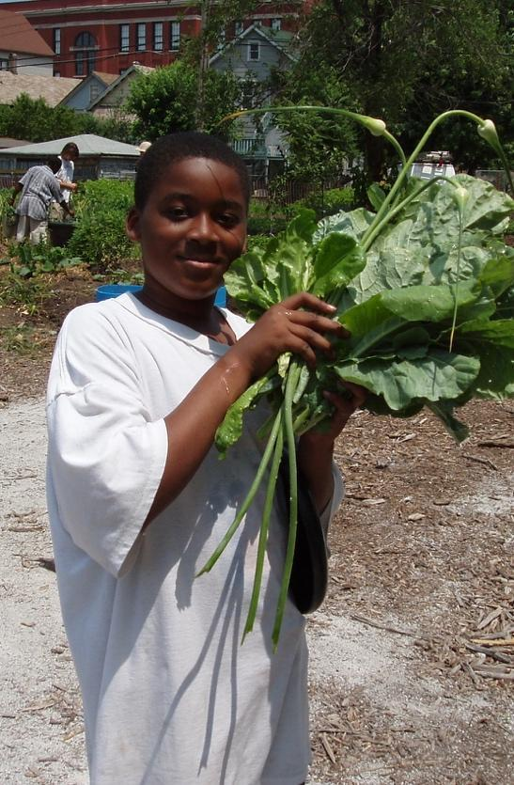
1) Strengthen food security and regional food systems

Inequality has become extreme and many people are falling through the cracks of our weakened safety net, especially in rural areas of the United States. Therefore:
ONE, we advocate for strong governmental involvement in guaranteeing the right to food for all people as well as a basic standard of living. Regarding SNAP, food access, and support for regional food economies, we support:
- Increased SNAP funding and eligibility.
- Increased funding for Farm to School, Community Food Projects, Gus Schumacher Nutrition Incentive Program.
- Increased funding for the federal Farm to Food Bank Projects.
Young gardener at Angelic Organics garden in Chicago.
Photo credit: Angelic Organics
- Expansion and full funding for the Local Agricultural Marketing Programs, which includes the Farmers Market Promotion Program, Local Food Promotion Program, and the Regional Food System Partnerships Program.
TWO, we call for the government to reinstate a strategic and farmer-owned grain reserve system to protect family farmers from unstable price fluctuations and ensure resilience in the event of weather-related disasters.
2) Equitable access to resources and land
The dispossession of lands from Native Americans and our country’s history of slavery along with ongoing suppression of immigrants compels us to confess our complicity and failure to fully learn and pass along this history, and to call for reparations for past harms. Therefore:
ONE, we advocate for policies which provide affordable access to land and resources for Native American, Black and other people of color farmers, producers, fishers, and ranchers, with special attention on small and medium scale producers.
TWO, we call for reparations of past discrimination as exemplified in the Pigford class action suits and an end to ongoing discriminatory lending practices at all levels of the USDA.
THREE, we call for ample support and funding for land link programs, technical assistance for transition and succession planning, and access to credit, crop insurance and other risk management, cooperative development support, training, and technical assistance, with a priority on providing these to low-resource and people of color farmers, producers, fishers, and ranchers through increased funding of the 2501 Program.
FOUR, we call for an end to land grabs and other land speculation by individuals, corporations, pension funds and governments, which raise land prices out of the reach of farmers, and often cause deforestation and ecological destruction.
FIVE, we call for stricter rules in the Environmental Quality Incentives Program (EQIP), which would limit inappropriate use of EQIP funds by large, polluting operations, and support adjustments to discourage overproduction and the polluting of water resources.
SIX, we call for policies that support the economic resiliency of coastal communities, particularly for independent small and medium scale fishers and shrimpers.
3) Land, environment, and climate justice
Changes in climate and weather patterns are already disrupting farming around the world, and these will only become intensified in coming years. The dominant practices of chemical- and fossil fuel-intensive, mono-crop agriculture used around the world damages the soil, often causes desertification, and poisons the land, water, air and people. Investing in patented seed technologies has drastically reduced farm resilience as many farmers cannot legally save seeds. The business focus of mono-crop production continues to erase traditional practices of sustainable land management and is decreasing our global crop diversity. Therefore:
ONE, we advocate for conservation incentives, in particular agroecological, regenerative approaches that build up (sequester) carbon in the soil in Conservation Title and in these critical programs, which deserve increased funding:
- Conservation Stewardship Program (CSP)
- Conservation Reserve Program (CRP)
- Environmental Quality Incentives Program (EQIP)
TWO, we call for increased funding for public sector breeding and research programs in land grant university systems and USDA research facilities, which will reinvest in ecological public plant breeding programs that address climate change and extreme weather patterns so farmers are prepared with diverse, adaptable seed stocks and agroecological approaches.

THREE, we call for stronger review of proposed genetically engineered crops, seafood, and livestock prior to approval, and GE labeling laws at state, national and international levels, and for fair and open access to and ownership of heritage, hybrid and conventional (non-genetically modified) seeds; ecology-based biodiversity of seeds, crops, livestock and seafood.

4) Protect food chain workers, producers, and farmers
Farmers, farm workers and other food chain workers are threatened with detention and deportation, human trafficking, sub-poverty wages, wage theft, lacking and unenforced labor laws, and dangerous conditions. Legislative and corporate advocacy in support of these workers is a priority. We seek legislation and corporate action that supports the dignity and safe working conditions of small- and medium-scale farmers, producers, and food chain workers. Therefore:
ONE, we advocate in support of Dairy Farmers, Contract Poultry & Livestock Producers, and Fishers with the following:
- Support dairy farmers and other producers by opposing corporate manipulation of prices and contract abuse.
- Resist the monopolization of corporations in this sector and oppose abuse of contract producers. Specifically, by:
– Opposing amendments to the Agricultural Fair Practices Act that would undermine the ability of farmers to negotiate fair contracts with processors.
– Opposing amendments to the Packers and Stockyards Act that would undermine enforcement authority for Grain Inspection, Packers and Stockyards Administration (GIPSA) over all livestock operations.
– Advocating for the economic, social and ecological sustainability of small and medium-sized fishermen and their communities.
TWO, we oppose increasing the loan cap limits for Farm Service Agency (FSA) Direct Operating Loans (DOL), Guaranteed Operating Loans (GOL), and Guaranteed Farm Ownership Loans; doing so is unnecessary and would primarily benefit large Confined Animal Feeding Operations (CAFOs).
5) Strengthen food sovereignty everywhere

The US is the world’s biggest food donor and responds to food emergencies and humanitarian crises, but the program is wasteful and slow because of rules requiring that US commodities be purchased and sent on US ships. The subsequent flood of food aid months after a disaster may cause a food glut, price depression, and the bankrupting of local farmers. Therefore,

ONE, funding should be maintained or increased for international food aid, and reforms to improve responsiveness and effectiveness should be enacted.

- Funding for local and regional procurement (LRP) should be dramatically increased in our foreign food aid programs.
- The response times to famine, drought and natural disasters should be improved by opening additional overseas facilities to strategically pre-position food aid.
- Rather than wasteful and market distorting monetization programs, NGO partners implementing Food for Peace Title II programs should be allowed to use all Food for Peace funds on non-commodity expenses.

Raise Your Voice!

The 2023 Farm Bill is our next chance to help shape the trajectory of food and agriculture for the next five years and beyond. This national legislation impacts the food you eat every day, so it's time for you to share your voice in support of a Farm BIll that prioritizes equity for farmers, farm workers, and the land from which our food comes.

We challenge you to talk to your elected officials and share with them your views of what an equitable and resilient food system can look like. WHY? Because the programs affect every aspect of our food system and funding from this federal bill is primarily distributed through state and local agencies under the direction of our state and local elected officials.

Your opinion matters!

If you’re ready to act, check out the following Questions for Candidates section for ideas on how to start the conversation.

Questions for Candidates

We know that people who care about food and farming in our state can make an impact when they are able to impress upon policymakers the importance of sustainable farming and community food systems. This guide provides questions you should ask candidates – as well as elected lawmakers – to understand their positions on the policies that impact farms and food systems. Questions for Candidates aims to get candidates, elected lawmakers, and their communities thinking about farming, food security, urban agriculture, the environment and food.

Candidates may become elected officials and the more they can learn about sustainable and just farming and food systems now, the more likely that they will support policies that foster these systems once elected. Public discourse about these issues is incredibly important to both increase awareness and to hold our elected officials accountable. Please use this guide to discuss food and farm system issues at public debates, forums and town hall meetings.
______________
Relationships matter
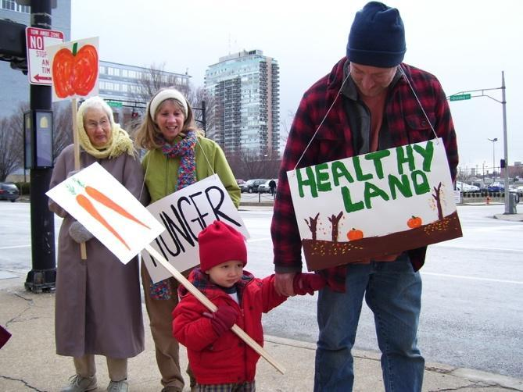
The better or stronger your relationship with a future policymaker, the more likely you are to impact how that person thinks about the issues that matter to you. Keep in mind that you can work effectively with someone, regardless of the personal opinions either of you may hold. Although you are unlikely to agree on every issue, you can still build a positive relationship in the long run.

Get to know them and their staff:
The best way to get to know your candidates on a personal basis is to spend time with them. For incumbent state or federal lawmakers, arrange an in-district meeting when they are home. You can also write a letter, attend a town hall meeting, send an email, write a letter to the editor of your local paper: take action to let candidates know how you stand on issues. It is also important to get to know their campaign staff, especially at the state and federal level; staff opinions inform the policy positions of candidates.
Farmer Ivor Chodkowski, son Eliah, Rev. Jane Larsen-Wigger and Jean Edwards at past Farm Bill rally in front of KY Sen. McConnell’s Office.
Photo credit: Andrew Kang Bartlett

Invite them often and early:
Candidates are often very busy. Be sure to invite them to every event that you hold and remind them of your invitation about a month before the event and again the week of the event.

Follow up with a thank you note:
Following up with a thank you note after a meeting or an event sets the stage for future interactions. A simple email message will usually do the job. Thanking a candidate for their time will go a long way towards building a stronger relationship and encouraging future discussions.
Learn about their interests:
Educate yourself about the interests of a candidate; this will help you to better understand why she may choose a certain position. Knowing background information about the candidate’s life and concerns will better inform your engagement efforts and help you to understand her motivations around certain issues. For example, it might help to talk about sustainable agriculture as a way to promote healthy ecosystems with one official, while another might better understand the benefits local agriculture can have on public health, while still another will be interested in sustainable agriculture’s role as an economic driver.

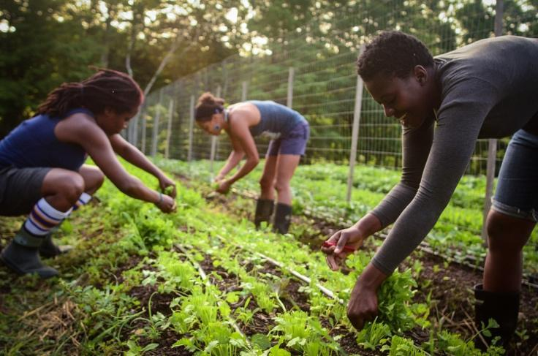

Soul Fire Farm in Grafton, New York

QUESTIONS FOR LOCAL CANDIDATES
The Farm Bill is national legislation that is enacted by state and local elected officials. Local officials often have lots of decision-making power over how the farm bill dollars are spent on local programs, so learning about the priorities of these officials is important for shaping the type of community you want to see. Even if your question does not translate precisely to Farm Bill language, it helps to know as much as possible about the concerns and priorities of elected officials. These questions may best be asked of candidates running for offices like Metro/City Council, Mayor, County Commissioner, Soil and Water Conservation District Supervisor, and School Board.

- Many municipalities are adopting policies and passing laws to ensure that food available in public settings—cafeterias and vending machines in government office buildings, day care centers, schools, parks, and other venues—are healthy. What would you do to encourage healthy eating in our community?
- Health is a priority for people, and food grown from healthy soils not only protects the environment but promotes good health and prevents disease. For example, a team of scientists in the U.K. recently found that organic crops had 18 to 69 percent more antioxidants than conventional crops. What would you do to promote farming practices that develop rich, healthy soil?
- Health disparities between certain socioeconomic and racial communities, evident in decreased longevity and rates of diabetes and heart disease, are well documented in our state and across the nation. What policies or initiatives would you implement in order to decrease the gap in health attainment among residents?
- Research in one state has shown that the direct sale (through farm stands, CSAs, farmers’ markets, etc.) of local agricultural products annually generates over $3.3 million dollars in revenue to farms and a total of $6 million in local economic impact. In addition to their positive impact on local economies, direct sales put more locally grown food on the plates of local community members. What would you do to establish or expand access to locally grown food?

- Institutional purchases are also an excellent way to direct dollars to local growers. What steps would you support to ensure that local entities (e.g. schools, hospitals, the zoo, and Metro offices, parks and events) support our farmers?
- In order to feed future generations, we must ensure that farmland is protected. Development pressure makes it difficult for farmers to keep their land in farming, and so, without protections, more farmland and family farmers will be lost. What policies would you support to preserve farmland and greenspace? How would you support beginning and existing farmers?
- Many of our cities have seen rising demand for garden spaces. Community activists have urged Metro to revise its procedures related to vacant lands to make it easier for would- be gardeners and farmers to secure plots. What policies would you support in respect to urban agriculture?

- Forty percent of the food produced in the United States is wasted due to losses during production, storage, and packaging, and through retail and consumer waste. What policies would you support to reduce food-related waste in our community?
QUESTIONS FOR STATE CANDIDATES

The Farm Bill is national legislation that is enacted by state and local elected officials. Much of the farm bill funding is distributed to state-level offices and then further distributed out to smaller communities. State officials often have lots of decision-making power over how the farm bill dollars are distributed to local programs, so learning about the priorities of these officials is important for shaping where and how the farm bill funds are distributed. These questions may be asked of candidates for Governor, State Senate, State House of Representatives, and other state officials.

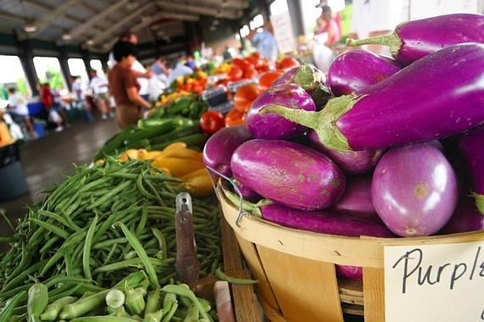
- Farming families have a hard time making ends meet, and seeds are expensive. Should farmers have the right to save seeds regardless of who sells them the seeds?

- What measures would you support to encourage local procurement by state agencies and offices, particularly parks and prisons?

- Across our state there are thousands of small-scale farms, defined as having annual farm sales of less than $250,000. Many state-level policies have been set to support the growth of larger-scale farms which focus on wholesale national and international markets. The needs and challenges faced by small-scale producers are different from those faced by large-scale producers. What policies would you get behind or develop to support the efforts of small-scale farms in the state?
- Federal nutrition programs such as WIC, SNAP, school lunch and breakfast programs, and the Summer Food Service Program are important food security resources in communities across our state. When these programs source food from local farms they have a positive economic impact on both retailers and food producers. What will you do to ensure these programs increase purchases from local and regional farmers?
- Do you support providing incentives for farmers to reduce their energy and carbon footprints by focusing on soil fertility, low or no use of chemicals, and reduced reliance on fossil fuels? Specifically, what measures would you promote?

- The organic agricultural sector is an area where we can see rapid expansion and economic growth. What policies do you support to foster the continued increase of the organic sector?
- Forty percent of the food produced in the United States is wasted from losses during production, storage, packaging, and through retail and consumer waste. Local and regional cold handling and storage systems reduce perishable food losses, and they increase income for farmers and economic growth for the state. What policies would you support at the state level to rebuild local and regional processing, storage, and distribution infrastructures to decrease the amount of food waste in the food chain and support farmers?
- How much information do you think consumers should have about the content of the food they purchase? What kind of product labeling do you support? Specifically, what are your views on GMO labeling?

- The herbicide Dicamba has damaged more than a million acres of crops across 27 states as a result of 3,400 drift incidents in 2021 alone. Dicamba use has been restricted in Iowa and Minnesota, and Arkansas and Missouri have both banned the use of the herbicide. Would you support banning the use of Dicamba in our state?

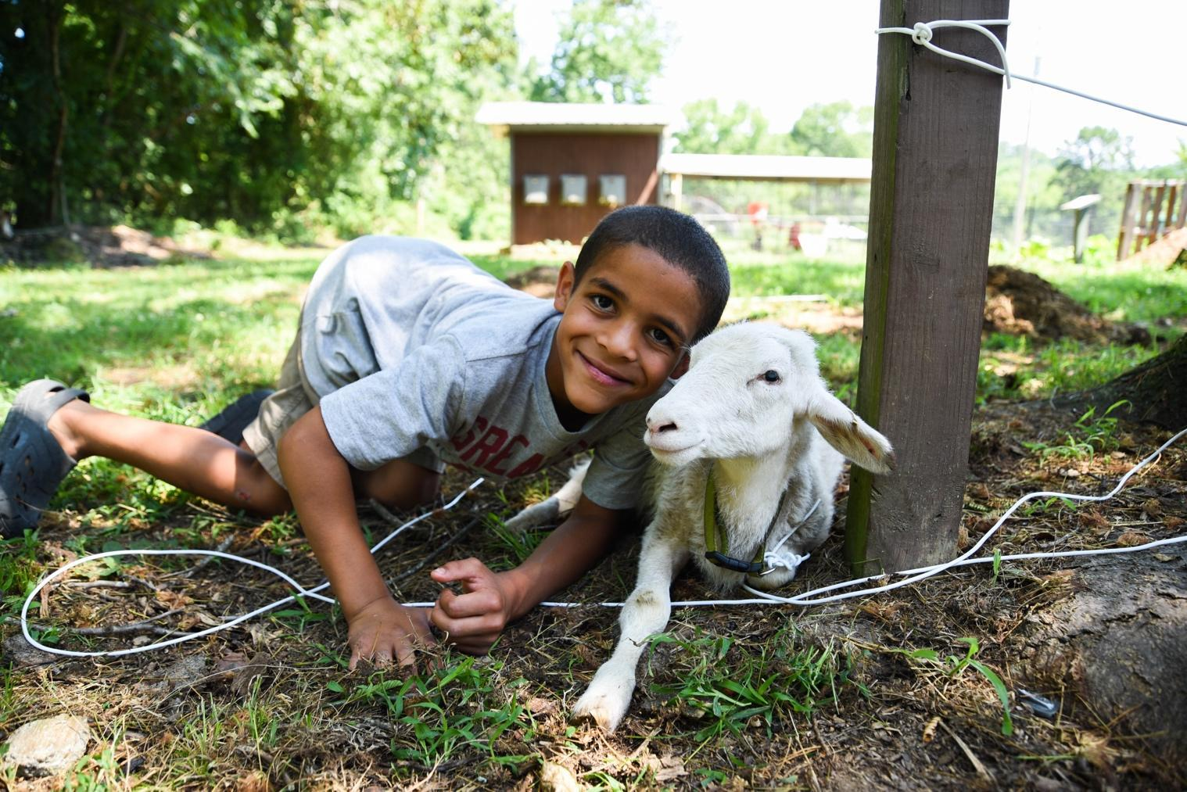

Camper and goat at Ferncliff Camp and Conference Center near
Little Rock, Arkansas. Photo credit: David Gill

QUESTIONS FOR NATIONAL CANDIDATES
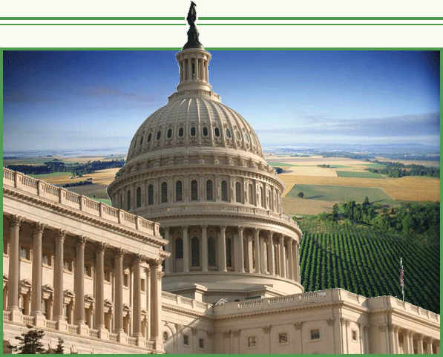
Our nationally elected officials are the ones who write and vote on the farm bill. However, even if our Congresspeople are not on Agriculture Committees, they will all vote on the Farm Bill. These questions may be asked of candidates and current members of Congress.

Support of Farming Families
- We’re fast approaching a crisis as farmers age and shrink in number; the average age of a farmer is almost 60. Access to affordable land is a major obstacle to beginning farmers and programs to support them are insufficient. What policies do you support to encourage small and beginning farmers?
- Are you in favor of increased support for new and socially-disadvantaged farmers and, if so, what policies would you get behind or develop to support them?
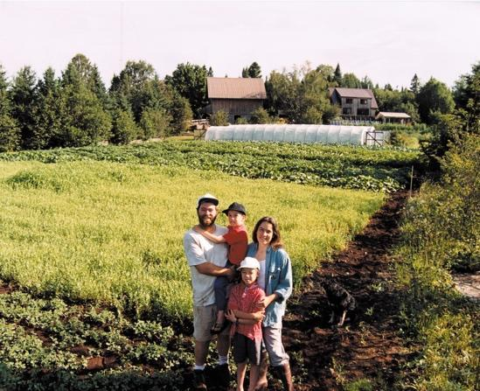
- In order to feed future generations, we must ensure that farmland is protected. Development pressure makes it difficult for farmers to keep their land in farming, and so, without protections, more farmland will be lost. What policies would you support to preserve farmland? Do you support expanded funding and training for land access, farm transfer and succession planning?
- Do you support food safety training to equip beginning farmers on the requirements of the Food Safety Modernization Act?
Abazs family in Finland, Minnesota.
Photo credit: Round River Farm
- The organic agricultural sector is an area where we can see rapid expansion and economic growth. A substantial increase in funding for Sustainable Agriculture Research Education (SARE) would help worthy sustainable agriculture research projects get going and would support this growing sector. What policies do you support to foster organic or low-input agriculture? Would you support increasing the funding for research on organic and regenerative agriculture?
- Forty percent of the food produced in the United States is wasted as a result of losses during production, storage, and packaging, and through retail and consumer waste. Local and regional cold handling and storage systems reduce perishable food losses, and increase income for farmers and economic growth for states. What policies would you support at the state level to rebuild local and regional processing, storage, and distribution infrastructures to decrease the amount of food waste in the food chain and support farmers?
- Are you in favor of incentives to encourage procurement of locally grown food by markets, government, and institutions such as schools and hospitals?

Food Security and Equity
- Food insecurity among children is a serious policy issue in the United States, with 17 percent of children (12.5 million kids) residing in food insecure households in 2017. SNAP benefits, funded as part of the Farm Bill, have kept this figure from rising even higher. SNAP may not be perfect, but it allows people to significantly extend their monthly food budget. Yet, some members of Congress have advocated reducing funding for SNAP or restricting access to benefits. Will you commit to supporting continued full funding for and access to SNAP?
- Do you believe consumers should have the right to know what is in their food so they can make decisions about what they and their families eat? Do you support GMO labeling?
- Are you committed to the dignity, fair compensation, and safety in the workplace for all workers and do you believe farm workers should be protected by the National Labor Relations Act like all other workers in the country?

- The pandemic has shown us how precarious our long-distance food supply is and how local-regional food systems can provide greater resilience. Do you support expanding initiatives, such as the Local Agricultural Marketing Programs, to strengthen local-regional food systems?

Conservation and Environment
- What incentives do you support to encourage farmers to reduce their energy and carbon footprint?
- The USDA established regional hubs to deliver weather information to farmers, ranchers, and forest landowners to help them to adapt to increasing weather unpredictability caused by climate change. What mitigation and/or adaptation policies will you support to address climate change and protect our farms and food system?

- Do you support a moratorium on large-scale Concentrated Animal Feeding Operations (CAFOs)? And do you support holding corporate actors responsible for the harmful effects of CAFOs?
- Although less than 5 percent of Farm Bill funds have gone toward conservation programs, these have had multiple positive impacts on the environment. To name just a few benefits, conservation programs reduce topsoil loss, improve soil health, prevent habitat loss, protect water quality and access, and conserve wetlands. Will you commit to voting for a Farm Bill which fully funds or expands conservation programs: Conservation Reserve Program (CRP), Conservation Stewardship Program (CSP), Agricultural Conservation Easement Program (ACEP), Regional Conservation Partnership Program (RCPP)? Do you support expanding and permanently funding the Pandemic Cover Crop Program (PCCP)? And will you push for stricter rules in the Environmental Quality Incentives Program (EQIP) to prevent overuse by large, corporate operations?

Fair and Competitive Playing Field
- The best seeds have been selected by generations of farmers over millennia, and they are essential to human life on the planet. Yet seeds are increasingly licensed and patented by private companies and the diversity of seed varieties has dramatically decreased. Should seeds be something that can be patented by private companies?
- Mergers of large corporations -- such as seed, pesticides, food processors and retailers, and other agrifood companies -- have become commonplace. As a result, a very few enormous companies control large parts of the food and farm system. Do you favor stricter enforcement of antitrust and anti-monopoly laws for agriculture and food companies? Are you in favor of greater transparency around contracts in the market, and do you support the Farmers Fair Practice rule?
- In addition to the many mergers and market dominance of a small number of global livestock corporations, they increasingly control all stages of livestock production from birth to retail, which economists agree limits competition and pushes smaller family-scale producers out of business. Do you oppose vertical integration in livestock industries? Do you support strengthening the Packers and Stockyards Act to protect livestock and poultry producers from anti-competitive practices?
- Country-of-Origin Labeling (COOL) is a win-win for farmers and eaters. Without it, U.S. producers have a harder time getting a fair price because corporate meat, seafood and dairy processors can import cheaper items and pass them off as domestic products. Do you support and would you fight for country-of-origin labeling?
- Crop insurance is subsidized by taxpayers and yet the benefits accrue primarily to the largest commodity crop farmers. Do you support reforms to make subsidies more equitable and supportive of smaller and medium-scale farmers and to help slow farm consolidation? Will you sponsor or support measures to make crop insurance accessible to all types of farmers, and to link premium subsidies to stewardship practices that protect our land, water, and health?

WAYS TO BE INVOLVED
1) PARTICIPATE in local and state groups working for a more equitable and sustainable food system.
2) VOTE for candidates who will fight for a world free from hunger, want, and oppression and/or become that candidate in the next election!

Food in Neighborhoods and the Presbyterian Hunger Program created the first Eater’s Guide to the Farm Bill in 2017 with the assistance and wisdom gleaned from Kentucky farmers and farming and food chain worker groups from around the United States. Special thanks to the Kentucky farmers who filled out the Farmer Survey.

This publication and any parts can be freely used with attribution to Food in Neighborhoods

British Journal of Nutrition, 2014
Economic Impacts of Direct Produce Marketing, 2008; OK example
Natural Resources Defense Council, 2012
U.S. Environmental Protection Agency, December 2021 Report

