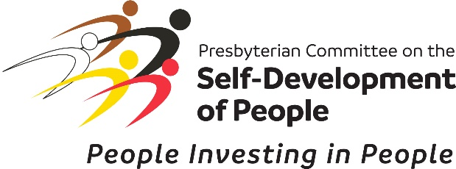
Office use
For Office Use Only

NATIONAL LEVEL PRE – APPLICATION (OPTIONAL)
Submit completed pre-application to Margaret.mwale@pcusa.org and copy sdop@pcusa.org. If an email confirmation is not received, follow up via email or phone at (502) 569-5792 to confirm receipt.
Note: The pre application helps potential applicant groups gain an understanding of the Self-Development of People funding criteria and helps them determine whether their project may be a good match for SDOP funding. It also helps SDOP determine if an applicant's proposed project is in line with SDOP funding criteria prior to submitting a full application. Completion of the Pre-application is optional. Groups may choose to submit a full application without submitting a pre application.

- PROJECT INFORMATION
Name of the Project:
Organization:
Organization Phone Number:
Organization Email:
Physical Mailing Address (No P.O.BOX):
City, State and Zip Code:
Website/social media (if applicable):

PRIMARY CONTACT PERSON

Full Name:
Title:
Cell:
Work Phone:
Home Phone:
Email:

Name of the person who completed this application, if different from above:

PROJECT INFORMATION

- How many members are in the group? (SDOP seeks to partner with communities; it is unusual for a community group of less than 10 people to receive funding).

- When was your group/organization formed?

- How will the group members benefit directly from this project?

- Describe the project and why it is needed

- How do the group members own and control the project?

- ADDITIONAL INFORMATION
- How did the group find out about SDOP? (Please check whichever applies)

Community Workshop (indicate where and when)
Presbyterian Church (USA) event
SDOP Website, another website or social media (indicate)
Local Church (indicate the name and location of the church)
Word of mouth (provide the name and contact information of the person)
SDOP National Committee Member/SDOP National Office (provide the name)
Other

- Please list, and provide contact information, for other grassroots organizations and/or organizations working with these organizations that could help SDOP in our outreach efforts. (These organizations do not need to meet SDOP criteria of being controlled by the direct beneficiaries). Please include organization’s name, contact person, phone, address, city, state, email. Use additional pages if needed.

