The Presbyterian Church, USA is now accepting online payments for invoices!

Access the Payer Express online payment portal at pcusa.org. Register in just a few quick steps:

- Select Payer Express from the menu on the pcusa.org site.

- Select Enroll from the Payer Express home page.
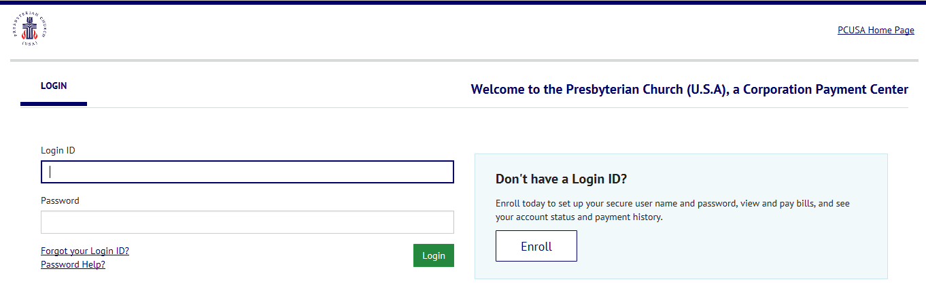

- Enter the Customer ID and Zip Code as they appear on the invoice.
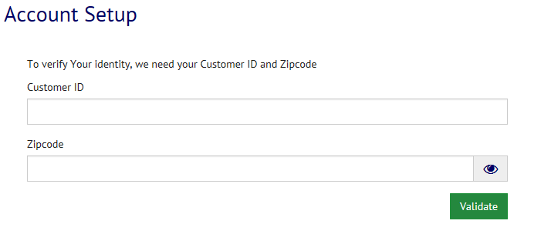

- Complete contact, log-in, and banking information.

- View outstanding invoices and submit online payments!

