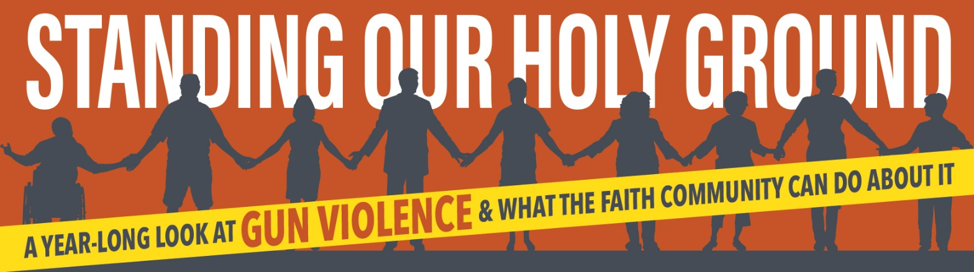

Standing Our Holy Ground Webinar Series
The Ripple Effect of Gun Violence in Urban Contexts
August 2, 2019 at 8:30pm (EST)
Register Here
Twenty percent of all firearm homicides in the U.S. occur in the country’s 25 largest cities, even though they contain just over one-tenth of the U.S. population. The Presbyterian Church (USA)-produced documentary Trigger: The Ripple Effect of Gun Violence examines the ripple effect that one shooting has on a survivor, family, community, and society. The film will screen from 7:30-8:30pm at the Lord Baltimore hotel as part of PC(USA)’S Big Tent Gathering. Following the film, there will be a discussion featuring a panel of Baltimore area residents including clergy, police officers, and activists working to address the gun violence in the city they call home. The discussion is part of a larger webinar-style series, “Standing Our Holy Ground” hosted by the Presbyterian Peacemaking Program, which investigates gun violence and what the faith community can do about it.

Panelist Background
Commissioned Pastor Cleoda Ruth Walker is a dedicated member at Cherry Hill Presbyterian Church and serves under Pastor Keith O. Paige as a Commissioned Pastor. She works unselfishly in social justice to improve the conditions under which many youth and adults in our communities’ struggle.
She is an active participant in numerous organizations geared toward the betterment of the Cherry Hill Community and Baltimore, such as: Chair of the Cherry Hill Public Safety Team, South Baltimore 7 Public Safety Committee, Raising Inner City Youth Board, Youth Resiliency Board, Clergy to Cherry Hill Safe Streets, Cherrydale Guardian Angels and a Baltimore City Police Chaplain.
As a faithful servant, she is persistent when it comes to bringing about transformation, justice and righteousness. She wants to be a change agent for God, changing lives, changing communities, changing hearts, changing minds towards God. Wherever she goes and whatever she does, she prays that she touches the lives of all she meets with a loving and humble spirit. She reminds those she meets “It’s not about me, it’s about God.” I give Him all the glory for the great things He has done!”
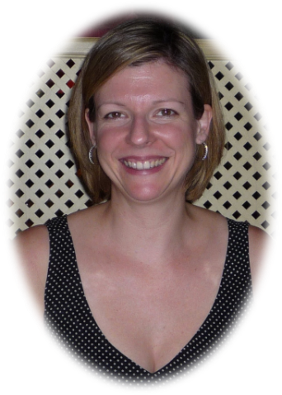
Amy Cress is a leading gun violence prevention activist in Maryland who joined the movement right after the Sandy Hook massacre. She helped plan the March on Washington for Gun Control in January 2013, and is currently Director of Community Engagement for Marylanders to Prevent Gun Violence. Amy is also a gun violence survivor who lost her sister to suicide by gun in 2015.

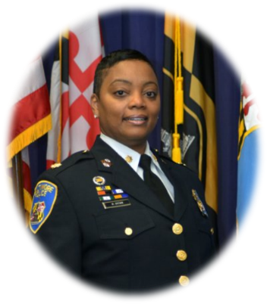
Major Monique Brown joined the Baltimore Police Department in 2000 and is currently the Commanding Officer of the Southern District. Major Brown has been a member of the department for 18 years and served in patrol assignments in the Southwestern, Eastern and Northwestern Districts. She has also served in Neighborhood Services, Command Investigation, the Warrant Apprehension Task Force as a Detective and Sergeant, and Child Abuse, as a Sergeant. She has been honored for her hard work with Unit Citations and Special Commendations.
Major Brown is a native of Baltimore City and grew up in East Baltimore. She is a proud alumnus of Mergenthaler Vocational Technical High School. She is a graduate of the University of Maryland Criminal Justice Leadership program and a graduate of Senior Management Institute for Police, SMIP #74. Currently she attends Strayer University, completing her bachelor’s degree in Criminal Justice. Major Brown served as an Executive Board member of the Vanguard Justice Society, Inc., serves as an Executive Board member for WiLEP (Women in Law Enforcement Professionals) a woman’s professional mentoring group, serves as an Executive Board member of Mentoring Mentors, Inc., serves on the Women in Leadership Committee of the Baltimore City’s Women Commission; and featured in Charm City, a documentary film about Baltimore City and voted as Baltimore’s Homecoming Hero.
Major Brown enjoys serving as a mentor to young girls.
Major Brown is the proud mother of two children and grandmother of two grandchildren.

