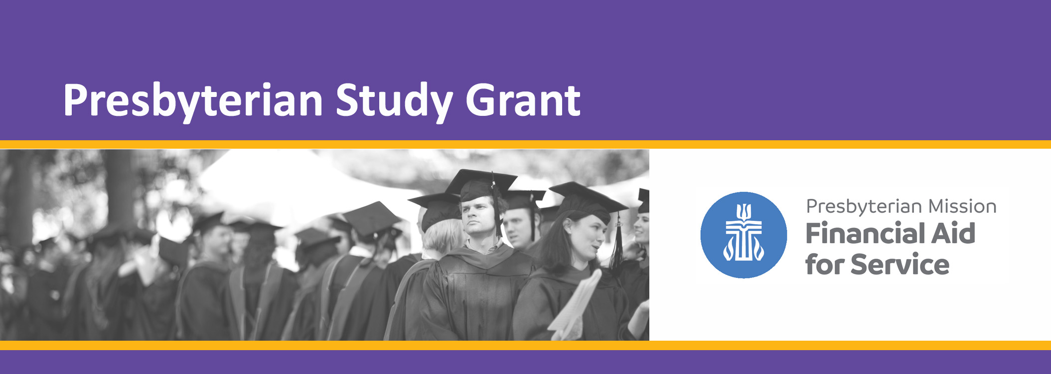

Presbyterian Study Grant (PSG) is the Presbyterian Church (U.S.A.)’s financial aid program for students preparing to lead and serve as a minister or Christian Educator. The Presbyterian Church (U.S.A.) theological grant program includes Presbyterian Study Grant, and supplemental grants intended to promote diversity and relieve poverty. To be designated a Presbyterian Study Grant recipient a student must be:

* A MDiv student seeking ordination as a teaching elder, or
* A MACE student planning to serve as a Christian Educator with the Presbyterian Church (U.S.A.).

The applicant must demonstrate readiness for ministry through practice of spiritual disciplines in seminary life and have displayed to their home church the gifts they bring to congregational leadership. MDiv students must be recommended by the CPM in the Presbytery of care.

No more than 120 students are awarded per academic year. PSG can be awarded up to three times to students who have not completed the first professional degree (required for certification or ordination).

**Eligibility**

Presbyterian Church (USA) members who are:

* MACE students are not required to be Inquirer/Candidate, but must be an active member of a Presbyterian Church (U.S.A.) congregation
  + MDiv (also Dual Degree) students entering years 1 and 2 **must be an Inquirer or Candidate**
  + MDiv (also Dual Degree) students entering year 3 **must be a Candidate**
* Enrolled full time at ATS accredited institution
* Limited to MDiv and/or MACE
* Demonstrate Financial Need

**Range of Award**

$1,000 - $6,000

**Deadline**

*May 15:* Student portion of

on-line application completed

**Awards**

No later than August 30

**The Process at a Glance**

*These steps will be completed by the applicant.*

Visit [https://app.mykaleidoscope.com/scholarship/presbyterianstudygrant](https://nam02.safelinks.protection.outlook.com/?url=https%3A%2F%2Fapp.mykaleidoscope.com%2Fscholarship%2Fpresbyterianstudygrant&data=04%7C01%7CLaura.Bryan%40pcusa.org%7C37fde55a85b04ada560a08d8f5da4d6b%7C99082a1a70af459fa6ac8ad01476a157%7C0%7C1%7C637529665249495320%7CUnknown%7CTWFpbGZsb3d8eyJWIjoiMC4wLjAwMDAiLCJQIjoiV2luMzIiLCJBTiI6Ik1haWwiLCJXVCI6Mn0%3D%7C0&sdata=jMVXqSyklanBnzHX0WvXaDRJOcDkgMQYHsWusgt3dG0%3D&reserved=0)

Complete the FAFSA. Sign up for financial aid at the seminary you plan to attend.

Gather information needed to complete the application.

Complete the remaining application elements in the online application system by May 15th.

*These steps will be completed by the office of Financial Aid for Service*

Financial Aid for Service will evaluate your submission to determine if you are eligible for selection.

Applications are read by a reading committee.

Awardees are selected by the reading committee and notified by August 30th.



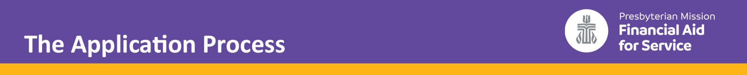

**For the Applicant:**

**Complete the FAFSA. Apply for financial aid at the seminary that you plan to attend.**

Periodically we remind students to complete the FAFSA. When you complete the FAFSA, contact your Financial Aid office to let staff know that you are a Presbyterian Study Grant applicant and you have filed a FAFSA. Information from the FAFSA is sent to your financial aid office. When your application is complete, Financial Aid for Service will ask you to sign a release for the financial information from your seminary.

**Gather the information needed to complete the application.**

* Name and address of the worshiping community you attend
* Name and email address of your pastor or session member
* Name and email address of a faculty member at the seminary or the Director of Admissions (first year students only), or an advisor from a degree program completed by the student
* Name and email address of your liaison, the moderator of the committee/commission on preparation for ministry, or the Stated Clerk of the Presbytery
* Information about where, when, and what you have studied to date.
* General information about your interests and goals.
* The name and email address of your financial aid counselor at the seminary that you plan to attend in the fall.

**Set up an online account. Visit** [https://app.mykaleidoscope.com/scholarship/presbyterianstudygrant](https://nam02.safelinks.protection.outlook.com/?url=https%3A%2F%2Fapp.mykaleidoscope.com%2Fscholarship%2Fpresbyterianstudygrant&data=04%7C01%7CLaura.Bryan%40pcusa.org%7C37fde55a85b04ada560a08d8f5da4d6b%7C99082a1a70af459fa6ac8ad01476a157%7C0%7C1%7C637529665249495320%7CUnknown%7CTWFpbGZsb3d8eyJWIjoiMC4wLjAwMDAiLCJQIjoiV2luMzIiLCJBTiI6Ik1haWwiLCJXVCI6Mn0%3D%7C0&sdata=jMVXqSyklanBnzHX0WvXaDRJOcDkgMQYHsWusgt3dG0%3D&reserved=0)

Start your application here after you have completed the

**Complete the remaining application elements in the online application system by May 15th.**

This includes writing an essay. You can find more details about the essay requirements on the next page of this guide. You will be asked to allow us to contact your endorsers after the essay section of the application. If you do not allow us to contact your endorsers you will be required to collect the paper endorsements on your own. Financial Aid for Service will contact you with more information if you select this option.

**For the Office of Financial Aid for Service**

**Applications are read by a reading committee.**

A reading committee will meet in August to select students for awards. Readers will be instructed to

**Awards announced by August 30.**

Selected students will be eligible for up to $6,000 in funding, dependent on need.



**Resume**

In prior years, students prepared resumes. The application was organized with the resume first, then essay, then endorsements by congregational leader, CPM (if required), and Faculty. Preparing a resume can be helpful to students. It organizes information that you will be asked to submit in the application, and it can be helpful to send to your endorser after you have asked, and the endorser has agreed to write a recommendation for you.

In 2020-2021, in the first year of the online application, readers expressed frustration over the lack of the resume in the online presentation of the application. The critique was that students were simply listing, without any helpful context, activities, interests, and prior employment.

Here are some helpful elements of context that I hope you will consider:

* How much time was committed?
* What was your role?
* What did your learn about yourself, or your gifts?

There is a question about personal commitments. Sometimes students are apprehensive about elements of the application that seek information about interests and activities that they do not have time for due to personal commitments. Readers found the personal commitments prompt helpful last year, and suggested that we give more prominence in this application to sharing personal commitments.

***Essay Topic for First-Time Applicants***

**What do you believe God is calling you to do in ministry?**

***Essay Topic for Renewal Applicants***

Previously awarded students will reflect on the essay that supported their application in the original year of award and write about how their understanding of their call has evolved.

**Essay Guidelines**

The essay accounts for 40% of the overall score for your application and is the single most important document in your application. Composition of reading committees is at the discretion of the Coordinator for Financial Aid, but will normally include recent graduates, and may be supplemented by representation from those engaged in preparation for ministry, education at related schools, and both ruling and teaching elders distinguished by their contributions to and interest in theological education.



**Endorsement Overview**

Students should be mindful that providing an endorsement is not a requirement for the endorser.

Students are responsible for soliciting endorsements. We strongly recommend that students provide endorsers a resume and/or essay and the program guidelines.

Endorsements should never be completed by a person completing another endorsement for you—even if the endorser could be the same person in more than one context. This effectively deprives the student of a third voice supporting their application. Endorsements should not be completed by the student’s parents, spouse, or sibling.

The on-line application will prompt students to provide a name and email address for a congregational leader, and a faculty member or advisor. MDiv students are required to provide an endorsement by CPM moderator or liaison.

**Faculty Endorsement**

May be completed by a faculty member at the seminary or the Director of Admissions (first year students only), or an advisor from a degree program completed by the student. Do not wait until the last minute. Faculty members and Admission Directors write more effusively when they aren’t under intense deadline pressure.

**Congregational Leader Endorsement**

This element of the application can be completed by a pastor, a session member, or in a congregation context other than the student’s home church.

**Committee for Preparation for Ministry Validation & Endorsement**

This is a required element for all MDiv and MDiv/Dual Degree students used to validate status under care as well as to secure an endorsement. Completed by your liaison, the moderator of the committee/commission on preparation for ministry, or the Stated Clerk of the Presbytery, the CPM Form can also be used to document pending eligibility. If the student will be a first or second year MDiv student in the fall, the student must be enrolled by the Presbytery as an Inquirer by September 1. After the student has completed two years of study in an MDiv program, the student must advance to candidacy no later than November 1 of the year of application to be considered for award.

The CPM, and only the CPM, can request a deadline extension for students who have not been enrolled as Inquirers, or students entering third year advancing to Candidacy. This is an accommodation that has limits imposed by our fiscal year and expectations that Financial Aid for Service exhausts the funding available to support student aid. We do not want to interfere with or pressure the CPM to act, and we cannot ignore the eligibility requirements.

We accept requests for extensions for pending Presbytery actions up to the week prior to reading committee. Students with anticipated enrollment dates reported by Presbytery up to September 1, may be selected by the readers, but will not be awarded until the enrollment by Presbytery is reported.

Students advancing to Candidacy with anticipated Presbytery meetings reported by Presbytery up to November 1, may be selected by readers, but will not be awarded until the Presbytery has acted.

Readers will select alternates for students with pending Presbytery actions. Alternate Inquirers advance on the first business day after September 1. Alternate Candidates advance on the first business day after November 1.



**Deadlines & Extensions**

The goal of Financial Aid for Service is to present as many applicants as possible to the PSG reading committee. We consider deadline extensions on a case-by-case basis with the goal of presenting a complete application to the selection committee.



**Mailing Address/Contact Information**

Financial Aid for Service

100 Witherspoon Street

Louisville, KY 40202

Toll Free: 800-728-7228 ext. 5097

Email: finaid@pcusa.org

**Supplement Grants Awarded in Addition to PSG (Based on Need):**

People of Color up to $2000

Native American up to $2000

Immigrants to the United States up to $2000

**Disclaimer**

Grant or scholarship aid provided by the Presbyterian Church (U.S.A.) may not be used for study abroad or internships. PSG and supplemental awards cannot be used to reduce institutional grants or scholarships but may be used to reduce work/study or student loans. PSG and the supplemental grants are restricted to the common requirements for MDiv and MACE degrees.

Aid for international students is managed in consultation with the partner denomination through World Mission.

**Study Abroad**

The Presbyterian Study Grant may not be used for study abroad.

**Confidentiality of Evaluations**

Do not share your user ID/password, or any application links sent to your email after you have started the application.

Information collected to support your application is maintained by the office of Financial Aid for Service. The church membership/pastor endorsement form, work product of the college or university the student attends, and the reading committee are confidential and will not be released to the student and/or parent/guardian. Applications are viewed only by staff members with responsibility for the Presbyterian Mission Agency scholarship program, reading committee members, and financial aid staff at the student’s selected college or university.

**Searching for Student Aid**

A new and exciting feature of the online application powered by Kaleidoscope is that at the end of the application, you may find more scholarship programs offered by other Kaleidoscope partners. You are welcome to apply. This will probably be a feature of greater utility for undergraduates than it will be for seminarians. The more specialized and advanced education is, the harder it becomes to find opportunities for aid. Kaleidoscope will probably be no more, and no less useful than scholarship search engines.

Here are a few suggestions:

* Get a free email account to use for scholarship searches
* Visit fteleaders.org and fteleaders.org/fundfinder
* Enlist the help of friends and family, church and presbytery

You might be thinking: that’s all very specific or incredibly vague. There are a lot of scholarship search engines out there. Only Fund for Theological Education fteleaders.org is theological education-specific. Everything else is just search algorithms or listing services. Give your scholarship search email to search engines. Save *your* email for applications. It will help you prioritize, and it will quarantine spam that is generated by advertiser supported sites.

Never, never, *never* pay for information about scholarships, or pay for anyone to manage your application process.

**Links**

**MDiv Students**

<https://oga.pcusa.org/section/mid-council-ministries/prep4min/>

**Christian Education students**

<https://oga.pcusa.org/section/mid-council-ministries/christianeducators/>

**Church Call System**

<https://oga.pcusa.org/section/mid-council-ministries/clc/>

**Donate!**

Presbyterian Study Grant is entirely supported by donor restricted gifts. We bear grateful witness to the faith of generations of members in the future of the Presbyterian Church. Please pray for our students and give to ECO E052102 as you are able.

*presbyterianmission.org/donate*

