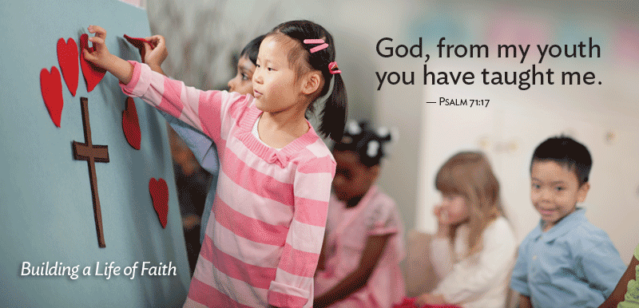
THE PENTECOST OFFERING
HELPS OUR YOUTH BEGIN LIFE WITH A STRONG START—
A SOLID FOUNDATION OF FAITH FORMED IN THE FIRST THIRD OF LIFE,
FROM CHILDHOOD THROUGH YOUNG ADULTHOOD.
Each year on Pentecost Sunday, we celebrate the gift of the Holy Spirit and the birthday of the church. The Holy Spirit remains with us still, connecting us with the church of the past, continuing to inspire the church of today, and pointing us to the church of the future. Each year, this celebration is marked by receiving the Pentecost Offering which nurtures the faith of those who are the church to come — children, youth, and young adults.
Psalm 71 testifies that a foundation of faith established during childhood helps ensure lifelong faith and service. The patterns and lessons established during these formative years continue to bear fruit throughout a person’s life. By giving to the Pentecost Offering, your congregation participates in helping our children, youth, and young adults grow up to proclaim with the Psalmist, “O God, from my youth you have taught me, and I still proclaim your wondrous deeds.”
Since the Pentecost Offering started in 1998, Presbyterians have raised more than $15 million for ministries that benefit younger members of God’s family. We believe we are called to do even more — to support and care for young people as they build a strong foundation of faith. Won’t you join in your support? If we all do a little, it adds up to a lot.

Won’t you join us? If we all do a little, it adds up to a lot.

