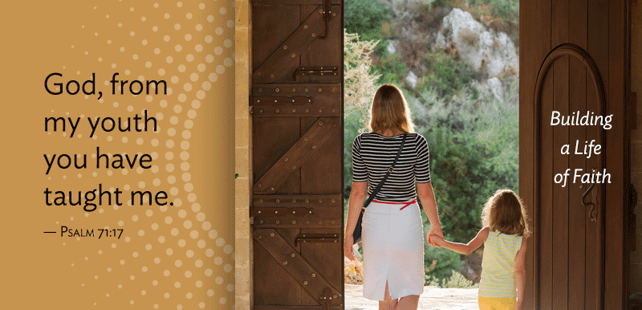
Who was the first person to teach you about Jesus?
Who was the first person to show you how to honor God with your life?
WHO HELPED YOU OPEN THE DOORS
TO NEW UNDERSTANDINGS OF GOD AND FAITH?
When did these things happen? For many of us, they happened during our childhood. They happened at home, at Sunday School, at church, at camp, or, perhaps through mission trips or experiences of service.
We probably don’t need a study to tell us that a foundation of faith established during childhood through young adulthood, the first third of life, helps ensure lifelong faith and service – but yet studies do show this to be true. Psalm 71 testifies to this same truth. Verse 17 says “O God, from my youth you have taught me, and I still proclaim your wondrous deeds.” The patterns and lessons established during these formative years continue to bear fruit throughout a person’s life.
During Pentecost, we celebrate that the Holy Spirit has opened the doors to faith in Jesus Christ. Just as many of us were nurtured in faith during our youth, we give to support these ministries and offer ourselves in service to the faith formation of other youth and young adults. We join with the Spirit and the whole church, so that the generations to come will still proclaim God’s wondrous deeds. Won’t you join in your support? If we all do a little, it adds up to a lot.

Won’t you join us? If we all do a little, it adds up to a lot.

