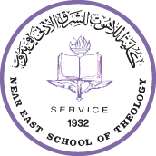
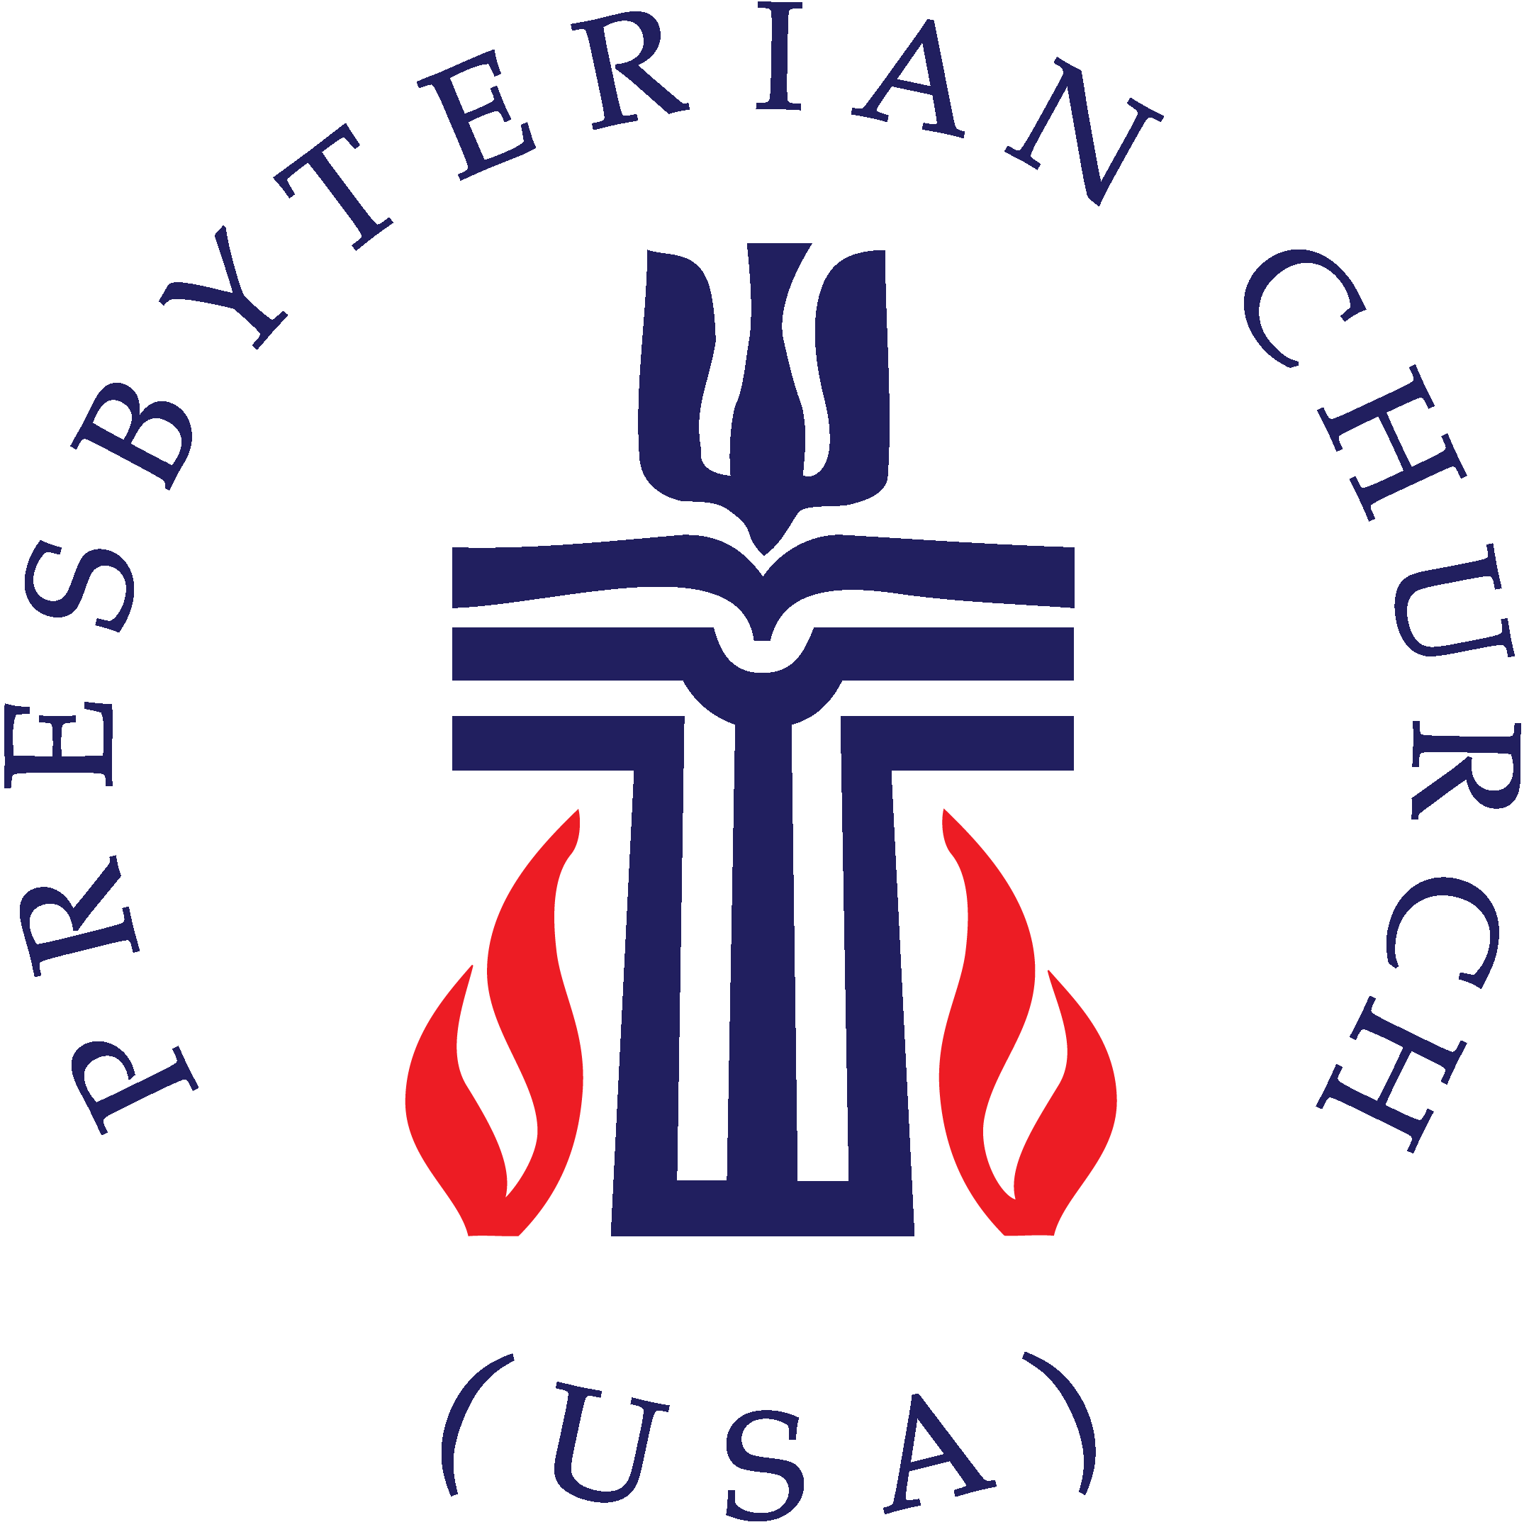

Study Trip for PC(USA) Pastors & Members

Exploring Christian-Muslim Dialogue and Cooperation in Peace-making,
Reconciliation and Civil Society Development

In Collaboration with the Near East School of Theology

Beirut, Lebanon

Background
The Near East School of Theology (NEST) is an inter-confessional Protestant Seminary serving the Protestant churches of the Middle East. It is the oldest Protestant theological school in the Middle East, and the only accredited Protestant Seminary in Lebanon. The primary purpose of NEST is to train pastors and church workers for ministry in the churches and other church organizations in the Middle East.

It is also concerned with continuing theological education of pastors and lay people. NEST welcomes candidates from other Middle Eastern churches, as well as any person seeking to learn about Protestant theology and faith, irrespective of his or her religious affiliation. Students from beyond the Middle East, who have a special interest in Biblical Studies against the cultural background of the Middle East, Islamics or Oriental and Orthodox churches, are also welcome. NEST is a member of the Association of Theological Institutes in the Middle East (ATIME) and cooperates closely with the Fellowship of the Middle East Evangelical Churches (FMEEC) and the Middle East Council of Churches (MECC).

It is also a member of the Encounter of Christian and Islamic Religious Colleges and Institutions in Lebanon.

NEST is located in the western part of Beirut, near major educational and cultural institutions, in a section of the city that has a long history of Christian-Muslim coexistence. It houses a library of 45000 volumes in English, Arabic, Armenian, French, and German.

Study Trip
NEST, in collaboration with Presbyterian World Mission, is offering a special program for PC(USA) Pastors and Leaders who would like to become acquainted with and/or deepen their knowledge of the churches of the Middle East, Islam and Christian-Muslim relations—with particular emphasis on how these relations are impacting current work in Peace-making, Reconciliation, and Civil Society Development in Lebanon and the larger region and an eye towards how insights from the region might impact the work of the church in the USA.

Duration: 2 weeks on the ground plus travel days (17 days total) – departing USA on June 25 to arrive into Beirut June 26 and departing Beirut on July 11, 2018.

Four Major Themes will be explored through lectures, field visits, interviews and encounters with local Christian and Muslim leaders and organizations and NEST Faculty:

Introduction to the Lebanese and Middle Eastern Political and Religious Context

Introduction to the five church families of the Middle East: Assyrian, Eastern Orthodox, Catholic, Oriental Orthodox, and Protestant.

Introduction to the different strands of the Middle Eastern Islamic Scene

Introduction to Christian-Muslim Dialogue and Relations in the Contemporary Period, including shared work in Peace-making, Reconciliation, and Civil-Society Development.

Prerequisites
- Completed Application Form and Acceptance into the Study Program.
- Completion of pre-Study Trip reading and reflection assignments

Costs
- Ground Costs: $2,137 This includes room and board, tuition, internet, accident insurance, and transportation for field trips.
- International Airfare and travel insurance are additional costs.

Trip is limited to 10 participants. Apply early! Application due by 12/31/17.

For Application and Information

Philip Woods, PC(USA) Area Coordinator for the Middle East and Europe
philip.woods@pcusa.org

Elmarie Parker, PC(USA) Regional Liaison to Iraq, Syria, and Lebanon
elmarie.parker@pcusa.org

