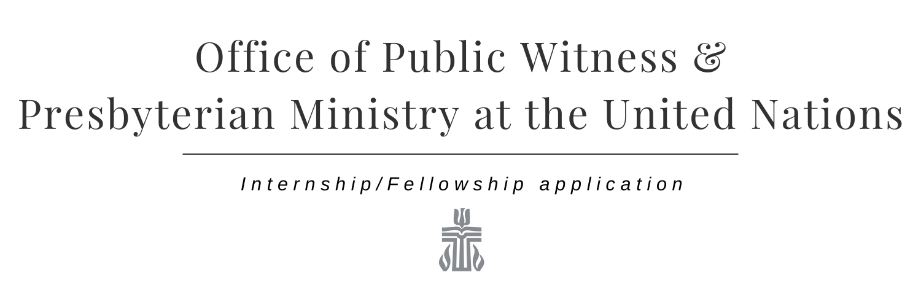

Purpose:
The Office of Public Witness and Presbyterian Ministry at the United Nations believes that formation of servant leaders and advocates is vital to the public policy ministry and witness of the Presbyterian Church (U.S.A.). The Internship seeks to provide substantive, formative work and guidance for persons seeking experiential learning and vocational discernment in the church and in the public square.

Goal:
Interns will receive a broad experience of the ministry of Public Witness and will explore the connections between the Presbyterian Church (U.S.A.)’s ethical teachings and political and social realities in the world and United States today.

Personal Information:

Full Name: ______________________________________________________________________
(Last) (First) (MI)

Current Address: Permanent Address (if different from current):

________________________________ ______________________________________

________________________________ ______________________________________

________________________________ ______________________________________

Phone Number: Cell/Mobile Number:
________________________________ _______________________________________

Email Address: ________________________________________________________________

Denomination: __________________ Are you Ordained? yes no under care
still discerning
If yes, you are Teaching Elder Ruling Elder Deacon Other ____________________

Seeking to be inclusive, please describe your gender and racial/ethnic background (optional):
______________________________________________________________________________
Please check the age bracket to which you belong (optional): Under 35 36-55 Over 55

Education Information:

Are you currently enrolled at an educational Institution? yes no

If yes, Institution Name: ________________________________________________________

Degree: _____ Major/Specialty: __________________ Graduation Expected: ________

Internship / Fellowship Information:
Identify your ideal term and hours of service, in light of other commitments. Note: Summer Fellowships are full time.

Term of Service (eg. Spring 2019; Summer 2019): ____________________________________

Hours of Service (eg. Full-time; Part-time 20 hrs/week): ______________________________

List three issue areas of interest (eg. International, domestic, health, Middle East, eco-justice, gun violence, etc.):

1)_______________________ 2)_______________________ 3)_______________________

How did you find out about the Internship / Fellowship for Public Witness?
- Website Email from ________________ Conversation with _________________
- Facebook Field Ed or Internship Office at __________________________
- Other ___________________________

Application Packet:

Please include in your application packet the following:
- This application form
- Cover letter
- Resume
- Names and contact information for three references

I certify that the information contained on this form and in my application packet is true and complete to the best of my knowledge.

__________________________________________ _______________________
Signature Date

Please return your application packet electronically to the email address below.

PC(USA) Office of Public Witness
Subject: Internship Application (your name)
ga_washington_office@pcusa.org

Questions? Please email us at ga_washington_office@pcusa.org or call at (502) 297-3985.

