We can make a Display! Or Bulletin Board! Or (fill in the blank!)
The best place to begin when creating a Special Offering display/bulletin board/etc. is to go to http://specialofferings.pcusa.org/ and click on the Offering you are working with. Browse the Resources section by scrolling down.
Great idea-starters from the Resources section could be:
- Poster
- Bulletin Inserts
- Minutes for Mission
- Promotional Images
- PowerPoint slides

OGHS Display (2019 – 70th Anniversary)
Presbyterian Church (U.S.A.) display case
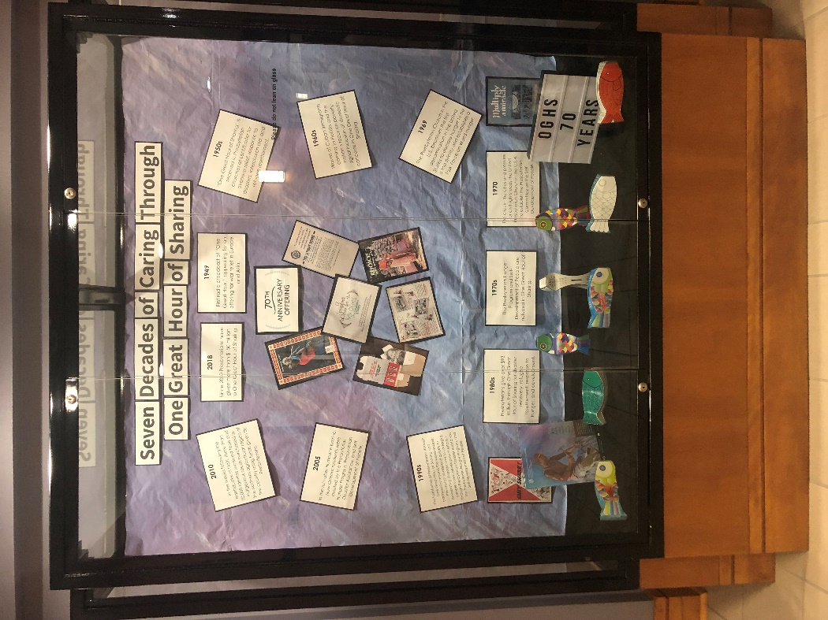

Once you choose a theme:
- Measure the display area (case, bulletin board, window, etc.)
- Make a list of materials you will need
- Purchase/Gather needed materials. (see “Shopping/Gathering list” below)
- Select and print offering-related promotional images at: https://www.presbyterianmission.org/resource/2019-one-great-hour-of-sharing-promotional-images/
- or the PowerPoint slides:
  - https://drive.google.com/file/d/1L_N6YGLM_d4dgFA-6d4vtR9sHg55T0l9/view
  - https://drive.google.com/file/d/19-eGocZM1qGHF1ERp3plIEG9IKETOFLd/view
- or choose images from another source of your choice

For 2019 OGHS 70th Anniversary display, we recreated the 70th anniversary timeline:
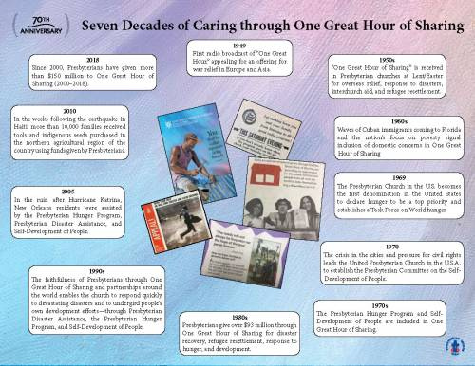
- https://www.presbyterianmission.org/resource/seven-decades-of-caring-through-one-great-hour-of-sharing/
To recreate “Seven Decades of Caring through One Great Hour of Sharing”:
- Type “Seven Decades of Caring through One Great Hour of Sharing” into a Word document. Enlarge to an easily readable size for display. Print, trim, and mount to colored paper (we used black).
- Copy the 70th Anniversary logo into a Word document. Cut and adhere to colored paper. We used black, but another color may work better for your background/display area.
- Type the timeline pieces into a Word document, with each one on a separate page. Print out, trim, and adhere to black paper.
- Print out images of old OGHS resources (found here: https://www.presbyterianmission.org/resource/oghs-through-the-years/). Trim and adhere to black paper.

Basic Steps of the Process:
- Create background for display. You may have a neutral background already, or you may need to use large sheets of paper. We recreated the purple/blue background effect from the timeline by painting white bulletin board paper.
- Adhere wording and 70th Anniversary logo to back of display at top.
- If you have a display case, add a coordinating fabric on the bottom.
- Add OGHS resource samples or other related materials to bottom of display or table (if applicable). We used old fish banks from previous years of OGHS.

Shopping/Gathering List:
- For bottom of display case:
  - Black fabric
  - Tape
  - OGHS Resources
  - Other elements if desired
- For display wall:
  - Bulletin board paper (if needed)
    - Paint/paint brushes (if needed)
  - Printed and prepped wording and images
    - Printed pages
    - Black (or other color) cardstock/construction paper
  - Stapler
  - Tape
  - Scissors
Not using a display case?
- This project will translate well onto a basic bulletin board. You will need to mount any additional materials that would be in the bottom of a display case, or use the floor space in front of the board.
***If you find another way to create an OGHS display for your congregation, please share images with us so we can share on our social media! Email pictures to special.offerings@pcusa.org.

