Niger Mission Trip
Please contact Don Dawson for the dates
(

PURPOSE
This trip is sponsored by the Niger Mission Network (NMN) in order to know and grow together with the Evangelical Church in the Republic of Niger (EERN) and PCUSA co-workers in Niger. Our desire is to partner with the EERN as invited and in response to the identified needs. Our goals for this journey are to build face-to-face relationships with our brothers and sisters in Christ and to learn from and about the EERN and the country it serves. Our team will visit churches, projects and both primary and Bible schools, and listen to their pastors, evangelists, and leaders as they share the joys and challenges of ministry in a country which is 95% Muslim. We will pray as we go and discern how we can come alongside and encourage and support their work. President Mai-aike Kadade and Honorable Issaka Moussa, Secretary for Partner Relationships, will interpret God’s work in their midst and join us. Mission co-workers Jim (water and sanitation) and Jodi (nursing and public health) McGill will introduce us to the work they do to assist the EERN. Michael and Rachel Ludwig will explain the CHE (Community Health Evangelism) approach they help facilitate for the EERN, show a student housing center, and give us a glimpse of their witness in their neighborhood. Participants will be inspired and transformed by this view of what God is doing in Niger.

EXPECTATIONS
- Participate fully in every aspect of the trip, including.
  - Two Orientation Meetings – TBD
  - Two Post-trip Debriefing Meetings - TBD
- Prepare yourself through prayer, reading, and by learning some basic language phrases.
- Keep a journal.
- Become ambassadors for the EERN and PCUSA co-workers, sharing the story of God’s work with individuals, churches, and presbyteries

FINANCES
The $2,400 (approximately, depending on airfare) trip cost includes airfare, visa fees, food, housing and all in-country transportation. The cost may vary depending on where your flight originates. Participants are responsible for paying passport fees, any additional luggage charges, and immunizations. A $200 deposit is due with your application and commits you to the cost of airfare. The remainder is due in equal payments on September 1st and November 1st. Participants are encouraged to seek financial and prayer support from their home churches, families and friends and commit to share their story after the trip.

APPLICATION

Apply by submitting an email to Don Dawson – dawsondonj@gmail.com with your name address, and phone number. Include a brief summary of your service to the church along with a brief statement of why you want to participate and how you hope to contribute and grow. The application and deposit ($200) deadline is July 1, 2018. Make your check payable to Hampton Presbyterian Church and send to 2942 East Hardies Road, Gibsonia 15044. The trip is limited to 6 participants.

QUESTIONS?
Contact Rev. Dr. Don Dawson (dawsondonj@gmail.com or 724-494-0915)

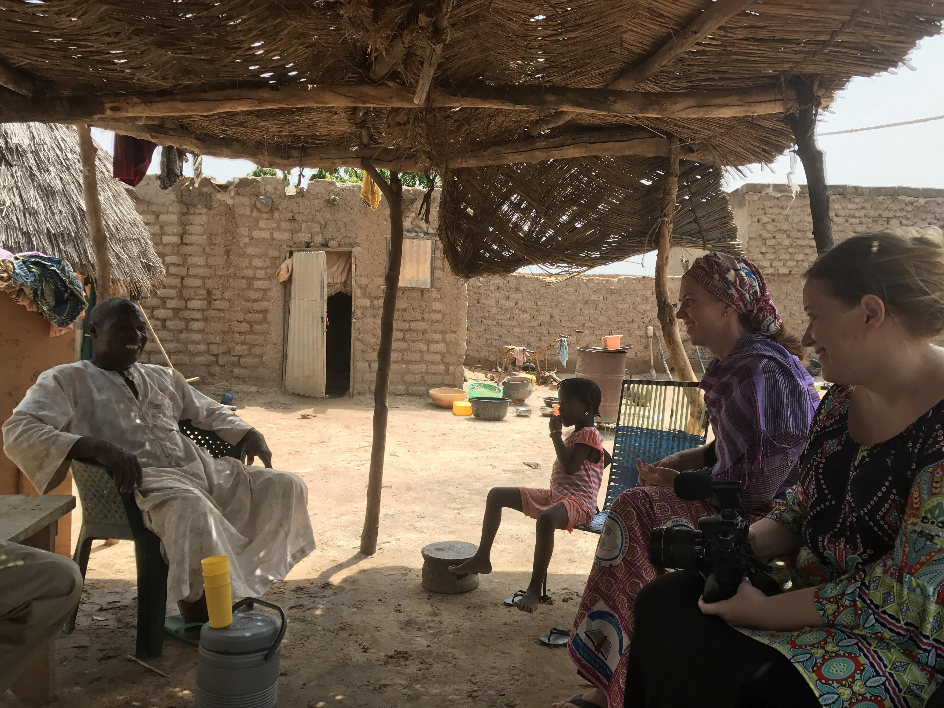

Tentative Itinerary

Day 1 Afternoon/evening departure

Day 2 Late afternoon arrive in Niamey, Niger – Stay at EERN guesthouse

Day 3 Sunday worship with one or more EERN congregations in Niamey
Meet with Issaka Moussa and other EERN Bureau leaders

Day 4 Jodi McGill will introduce the group to the EERN’s School of Nursing and how she assists

Day 5 Happy New Year! Our hosts will help us learn about the culture and country as we visit around Niamey

Day 6 Jim McGill will introduce our group to the EERN’s WaSH (Water, Sanitation and Hygiene) project

Day 7 Visit WaSH project in Dogon Dutchi school on the way to Maradi – Stay at EERN guesthouse

Day 8 Visit Bible school (agriculture incorporated in curriculum), primary school, and student housing site

Day 9 Meet with President Kadade and EERN Bureau, and join a gathering of Muslim neighbors at the Ludwigs

Day 10 Worship with one or more congregations in Maradi and dinner with President Kadade and EERN Bureau

Day 11 Visit CHE (Community Health Evangelism) evangelists on the way to Niamey – EERN guesthouse in Niamey

Day 12 Final day in Niamey to visit Artesian shops and dinner with Issaka Moussa and EERN Bureau
Flight leaves at midnight

Day 13 Arrive home

