Final Narrative Report:
Final: 15/08/2018_______ Reference Number: _SI 13001
Mission Statement: Narrative and Financial report

Contact Person _SEMARINGA Innocent

- Indicate the time period this report covers. If the report is late please explain why.
This report covers the period from December2017to September 2018
The report is presented by late due to the unexpected service leave that I took for family reasons

- Providing information on how funding these projects assist your Organization in achieving its mission.
In its mission, the EPR wants that people have an abundant life (spiritual and bodily). It is in this context that apart from evangelization, the EPR initiates the development projects in favor of community.
This fund from SDOP has enabled us to support 10 new savings and credit groups, to keep track of these savings and credit groups and others that already existed.
Apart from this economic aspect, this fund has also contributed to the reconciliation of human relations or the social aspect. This fund has also helped us to design a manual handbook for savings and loans groups in order to have our own tool. Briefly, this project has allowed us to concretize our mission. We have manifested love by helping the poor people without discrimination. This project reminded us and beneficiaries about the love that we should have as God’s children.

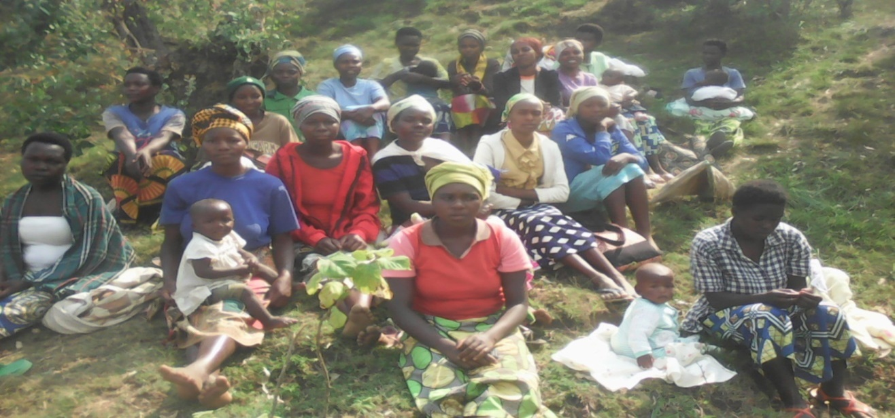
This picture is for the member of saving and credit group during a meeting

- Describe each project funded (and amount funded)

This fund was used to support 10 new saving and credit groups composed of 234 members.
Number of Saving and credit Groups | Number of group members | Man | Woman | Activity funded
10 | 234 | 88 | 146 | Supporting the funds created by saving and credit groups in order to allow the group members to get the small credits.

In this period we focused in West province precisely in Karongi and Rusizi Districts.

Name of Saving and Credit groups supported | Number of group member | Amount received in Rwf | Amount in USD
DUSASIRANE | 24 | 200.000 | 235.294
DUSHAKEIBISUBIZO | 20 | 200.000 | 235.294
TERIMBERE | 15 | 200.000 | 235.294
DUKOMERE | 26 | 200.000 | 235.294
DUFASHANYE A | 24 | 200.000 | 235.294
KWISUNGANA | 27 | 200.000 | 235.294
DUFASHANYE B | 27 | 200.000 | 235.294
KANGUKUKORE | 28 | 200.000 | 235.294
DUTERIMBERE | 30 | 200.000 | 235.294
TWIZIGAMIRE | 23 | 200.000 | 235.294
Total | 234 | 2,000,000 | 2,352.94

We supported the saving and credit groups and not the individual projects. By supporting the funds created by saving and credit groups, this means that the capacity granting of credits is strengthened to provide credit to a large number of members who want these small credits.
As mentioned above, this fund was used as following:
-Supporting 10 new saving and credit groups
-Doing monitoring
-Trainings
- Designing a manual handbook for savings and loans groups which will be used as our own tool.

Project | Amount in Rwf
Supporting 10 SHG | 2,000,000
Trainings | 1,875,350
Materials | 1,756,320
Designing a handbook | 751,450
Monitoring | 2,106,880

- What was the overall goal of each project funded? Did they achieve their goal? If not, why not? If so, provide highlights from each project that enabled them to achieve the goal

This project has an overall goal which is to create strong and permanent funds that enable saving and credit groups to support their members for its sustainability. Most of the group members were not able to take loan in the micro-finance institution due to the lack of guarantee/co-lateral. Then the amount from SDOP is used for reinforcement of funds created by small saving done by the group members in order to initiate the small business. At the beginning of the creation of a saving and credit group, each member presents its own objectives to be attained during a year.

- What resulted from the groups achieving their goal? If they did not achieve their goal what was the result and what are their future plans?
The objective of this project is to help the people to have a permanent fund which the members can use in case these group members want the small credits to initiate their own business or resolving other social issue. This project is achieving its main objectives. In the future this project aims to continue to monitor the activities in the field and to encourage the savings and credit group members to expand their revenue-generating projects.

After supporting these 10 saving and credit groups, some of their members have initiated the following projects:

Domains | Number of project funded
Breeding | 35
Agriculture | 24
Commerce | 16
Construction and rehabilitation of houses | 12
Health insurance and school fees | 143
Total

6. How were the people involved in identifying, addressing and achieving the goal for their specific project?

Beneficiaries are involved in all levels of the project means in designing, implementation, monitoring and evaluation.
The Church plays the role as a catalyzer by training beneficiaries at all levels of the project. For example the Church sensitizes the people about the importance of saving and credit groups and after they can create the group of saving and credit. For the projects identification, the implementation, monitoring etc., the church trains beneficiaries. So the role of the church is limited only at increasing awareness of people, trainings, and monitoring.

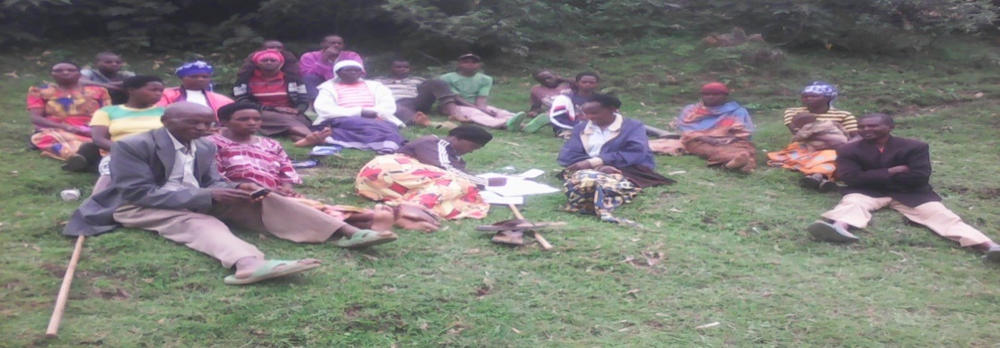
This picture shows that after trainings the saving and credit group members can themselves manage their SHG.

7. How many people in each group benefitted as a result of their goal being achieved?

-All saving and credit group members access to the support given to their saving and credit group because this fund allows the member to take the loans.
-The trainings done have been benefitted by all savings and credit members.
- The interests given by those who take credits are benefited by all the members

- Attach a financial report indicating exactly how Self-Development of People funds were used.

Activity | Unity cost | Number | Cost in Rwf | Cost in USD
Supporting 10 new Saving and credit groups | 2,000,000 | 10 | 2,000,000 | 2,353
Elaboration of a Manuel handbook | 751,450 | 1 | 751,450 | 884
Providing the basic tools of saving and credit groups to 10 new Saving and Credit Groups | 1,756,320 | 1 | 1,756,320 | 2,066
Trainings | 1,875,350 |  | 1,875,350 | 2,206
Monitoring | 2,106,880 | 1 | 2,106,880 | 2,479
Total | 8,490,000 |  |  | 9,988

9. Other comments.

“Stories and clear pictures are greatly appreciated – pictures separated preferably in electronic files”

Munyempanzi Theogene is a member of Dushakibisubizo Saving and credit group. He took a loan of 50,000 Rwf and he bought a pig
Now his pig has given birth to 8 piglets. These piglets were sold at 1,000Rwf for each. After selling some of the piglets he has now 3 pigs. The mother-pig is currently pregnant.
Apart these piglets, he also got organic manure to fertilize his field. He said now the agriculture production is increased.

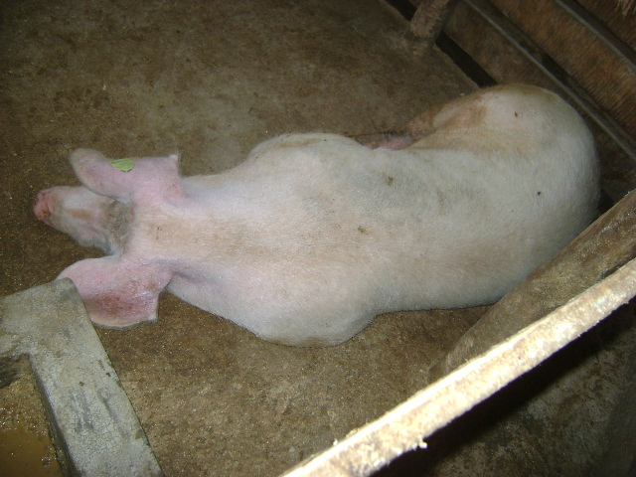

2. Bimenyimana Fidele is member of Twizigame Saving and Credit Group. He has taken a loan from his group in order to start a business. After being trained about entrepreneurship, he decided to start a small business of small shop. Now due to a good service that he gave to the customers, many of people have become his customers. He said that he is able to pay school fees for his children , paying medical insurance and other basic needs.

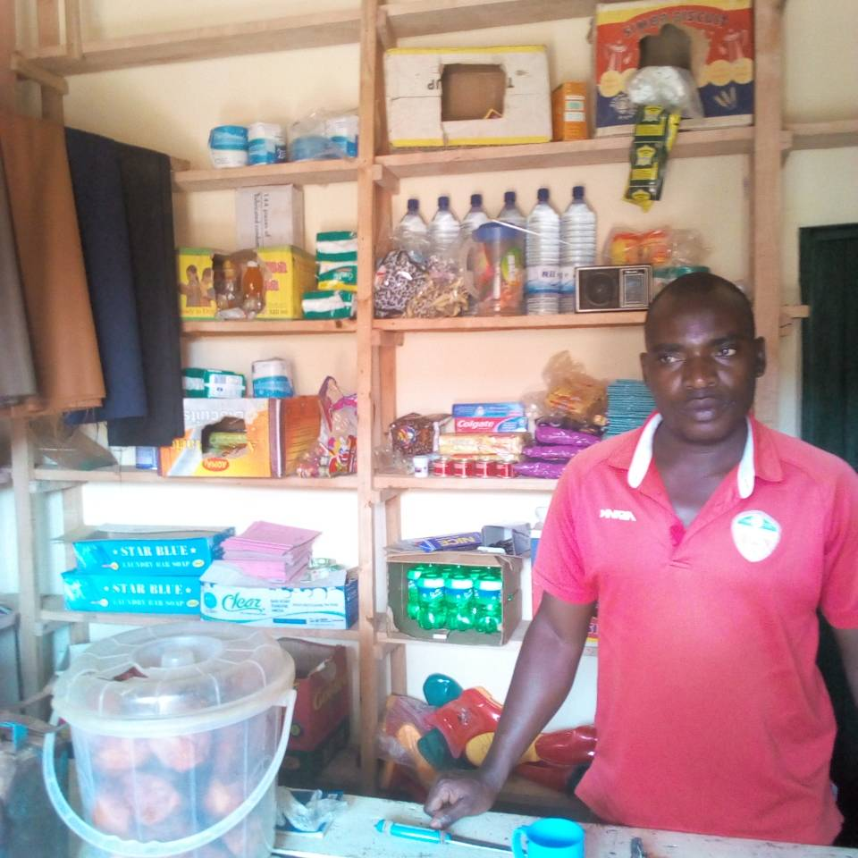
3. Nyiraturatsinze Donatha is a mother of 5 children. She started this initiative before being supported by SDOP fund. She had a small shop with a few articles/items. But within time their fund increased due to the support from SDOP and their own weekly saving, he took a loan to increase her business. Now she is happy for being member of her saving and credit group.

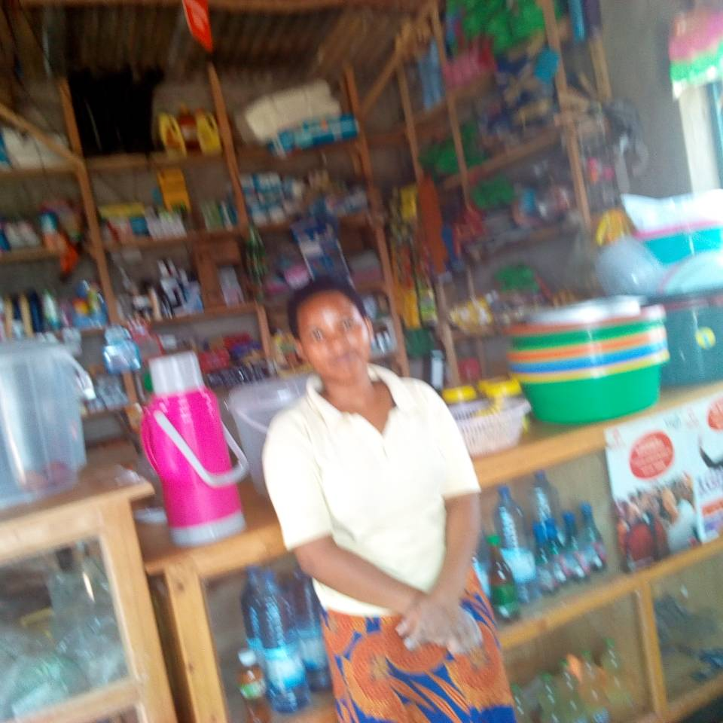

N.B This report describes the activities carried out by the fund obtained in December 2017 but as we have continued to follow the projects that have been carried out in the past, we want to share another success story.

UMUCYO is a saving and Credit Group based in Karongi District, precisely in the Murundi sector, it started in 2010 and has been supported in 2012 by SDOP fund. This saving and Credit Group is composed by 15 members. These members committed to buy a cow for every member of their saving and Credit Group. During our regular visit we meet some of them like:

MUJAWIYERA Eugenie: is member of UMUCYO saving and credit group. Her saving and credit group was created in 2010. She has taken loan many times for solving the family problems.
As all the members are farmers, they decided to have one cow for every member. This cow could produce milk to solve malnutrition problems and also produce organic manure in order to increase the agriculture production.
Now this cow has a calf, produces manure and milk for the family. She said that some milk is sold. She said apart this cow, she sells the local drinks.

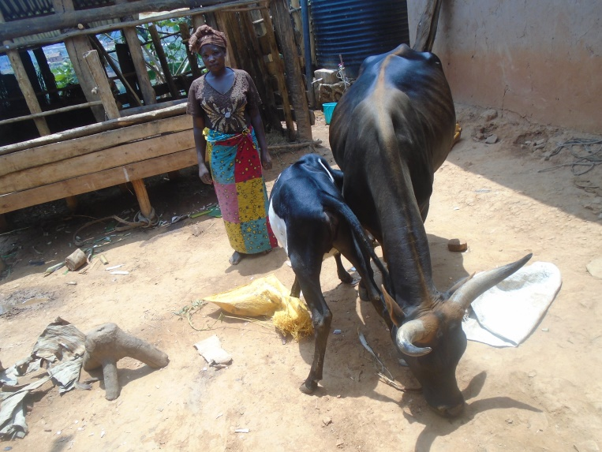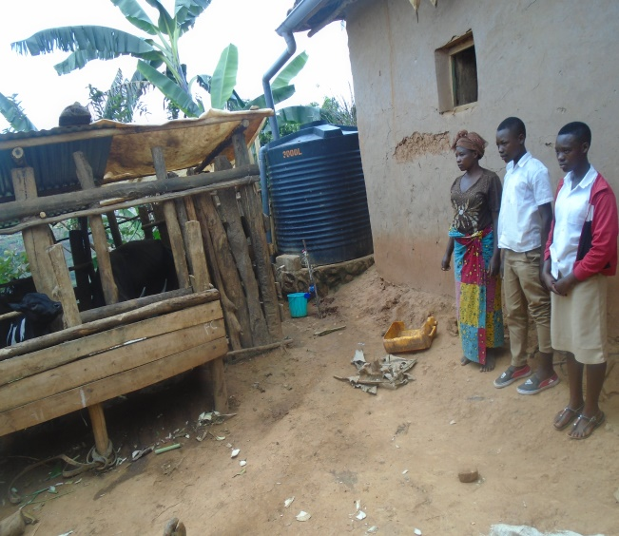

Mukagahima Madeleine,is President of Umucyo Saving and Credit Group. She has taken a loan of 60,000Rwf and she has sold two of the goats that she had in order to have 100,000Rwf for buying a cow. Now her cow has cattle and produces the milk and organic manure.
She said that there is increase of agricultural production.

