PRESBYTERIAN MEN
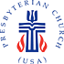

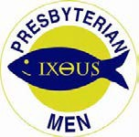

Presbyterian Church (U.S.A.)
Church Man of the Year Award

_____________________________________________________________________________________________
(Name of Church)

Named

as Church Man of the Year for the following reasons:

(Please use reverse side or attach a sheet of paper if more space is needed)

Date_______________________________________

Signed,

(Clerk of Session) or (Pastor)

Church Address:

City/State/Zip:

Church Phone Church Fax

Church E-Mail Address

Church Web Site

Please keep a copy of this form and send the original with a $25.00 check payable to Presbyterian Men addressed to:
National Presbyterian Men SE06002
P. O. Box 643765
Pittsburgh, PA 15264-3765

If you wish to pay by Credit Card fill in the following lines:
American Express Discover Visa Master Card

Number: Expiration Date /

Name on Card (Print)

Signature

National Council of Presbyterian Men, Inc., 100 Witherspoon Street, Louisville, KY 40202

Revised 5/14, 3/24/18

PRESBYTERIAN MEN

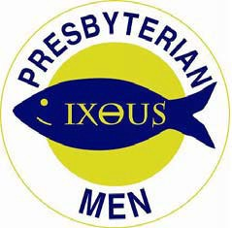

Presbyterian Church (U.S.A.)

Qualifications for the Church Man of the Year Award

- Any man in the Presbyterian Church (U.S.A.) is eligible for the award.

- He must have the endorsement of the Session of the church of which he is a member.

- The reason(s) for his selection shall be noted on the Church Man of the Year form.

- The reasons will ordinarily include exceptional demonstration of his Christian faith and outstanding service to the Church and/or Community.

- To award the Church Man of the Year pin and Certificate, the chapter must be a registered member of the national Presbyterian Men’s organization.

- The recipient should be recognized by a presentation in worship in the church of which he is a member.

- The purpose of the award is to encourage others, by their example, to stir up the gift of God within them and to bring such a vitality of inspiration and motivation for the Gospel that many will become active followers of Christ.

National Council of Presbyterian Men, Inc., 100 Witherspoon Street, Louisville, KY 40202

Revised 4/30/14, 3/24/18

