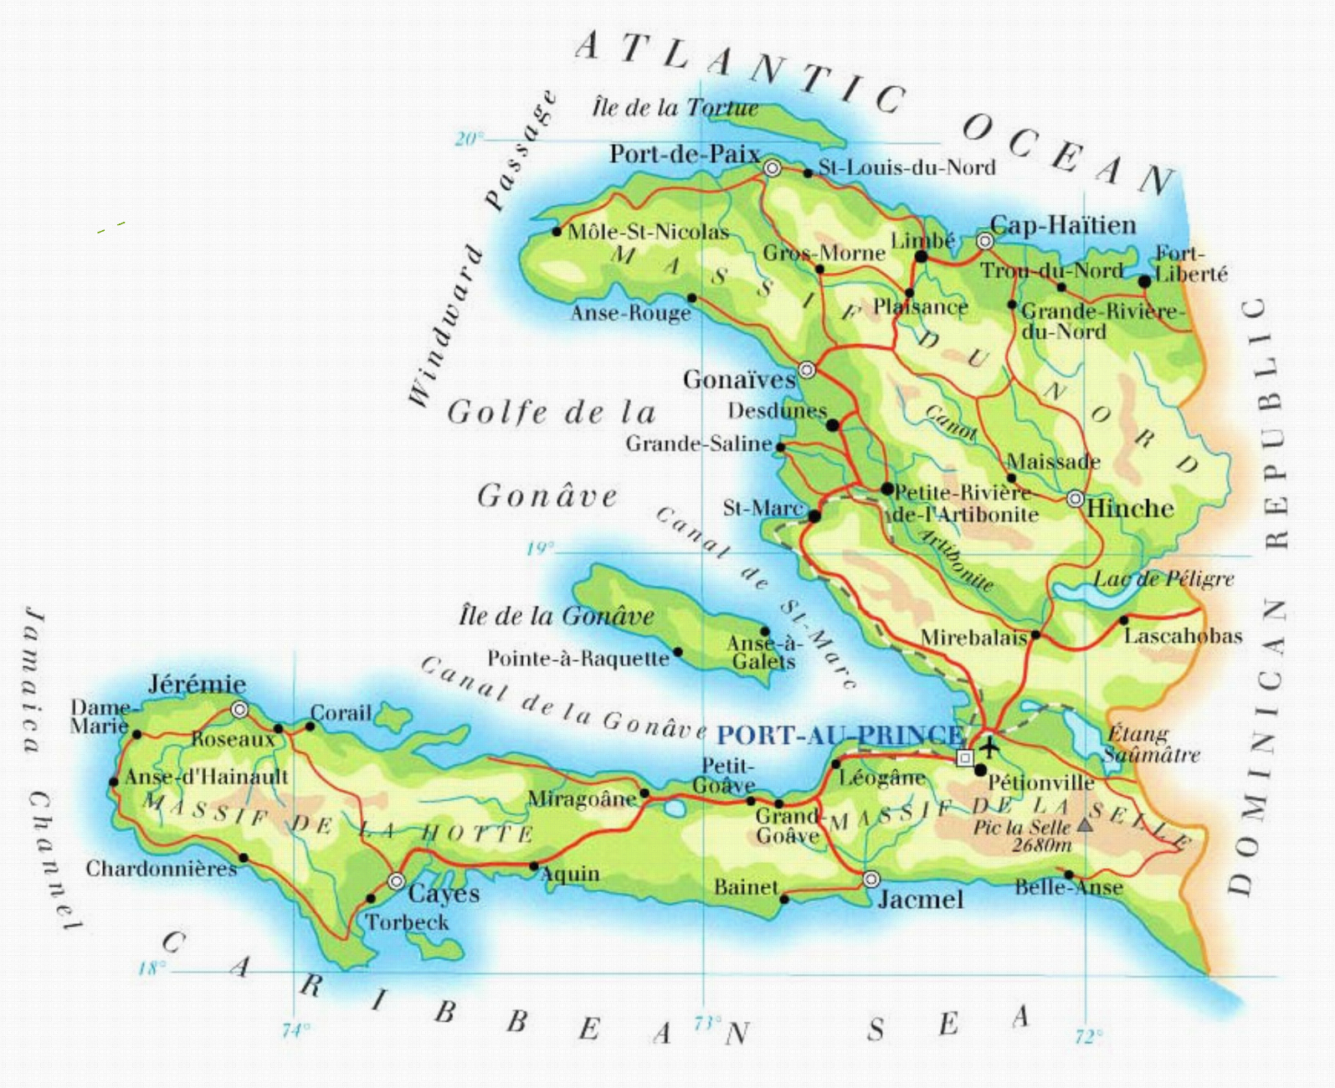
Haiti

“And the king will answer them, ‘Truly I tell you, just as you did it to one of the least of these who are members of my family,
you did it to me.’”
Matthew 25:40

Introduction

As we accept the great commission and journey to a place God calls us, we can use devotionals and prayer to remind us of the spiritual journey we are called to as well. Scripture reminds us and questions for reflection can encourage us to be mindful of how God is with us, of how God loves us and those we serve, of how we are part of Christ’s body. Scripture and reflection questions linking the Bible with our lived experience can help us see more clearly why God has called us, of the relationships God builds, of how God renews our strength, of how the Spirit transforms us, and of how God uses us. We will use the scripture, reflections, and prayers to guide our morning and evening devotions.

You can use the Journaling/Doodling/Questioning pages in whatever way you want. They are a space for you to express, reflect, gather, wander, or just be.

You can also create your own conclusion to this devotional. In the Take Aways section, include what you have felt, learned, and experienced during your time in Haiti. Also, reflect on how that will affect your life when you return.

God has called us and will support us. 1 Thessalonians 5:24 says, “The one who calls you is faithful, and he will do this.”

In response to God’s goodness, we answer the call. We join in the work God has already begun! Others support us in this journey, so now we begin!

Day One: Morning Reflection
God is With Us
“The Lord went in front of them in a pillar of cloud by day, to lead them along the way, and in a pillar of fire by night, to give them light, so that they might travel by day and by night.”
Exodus 13:21

As the Israelites wandered the desert far from the home they knew, God was with them. They were led by God—they were never alone. God’s presence was always visible to them.
During our journey to Haiti, far from home and familiar things, look for God’s presence.
- Look for God’s presence to guide today’s physical journey
- Look for God’s presence to help you care for the people of Haiti
- Look for God’s presence in the people of Haiti as they participate with you and care for you
- Look for God’s presence to encourage you in daily tasks
- Look for God’s presence to help you say, “Yes! This is why we are here!”
Prayer: Heavenly Creator, guide our journey. Help us to arrive safely to do your work. Let us greet enthusiastically this wonderful opportunity to serve you. Help us to love our neighbors and to receive love from our neighbors. In the powerful name of Jesus, we pray. Amen.

(Journaling / Doodling / Questioning)

Day One: Evening Reflection
God is With Us
“[God] divided the sea and let them pass through it, and made the waters stand like a heap. In the daytime he led them with a cloud, and all night long with a fiery light. He split rocks open in the wilderness, and gave them drink abundantly as from the deep. He made streams come out of the rock, and caused waters to flow down like rivers.”
Psalm 78:13-16

What a long journey for the Israelites. What a long time they wandered. What a long time they had the cloud and fiery light to show that God was with them!

What a long time we prepared for this mission trip. What a long trip for us today: the flight, customs, the bus to our mission site. What a long time to reflect on what God is calling us to.

What a long time our Haitian brothers and sisters have prepared for our visit. We get to join them in a partnership, but they’ve already been in partnership with God so we respect that.

What a long time to thank God for that presence that guides all of us.

Let us pray that God’s Spirit unites our journey with the journey of those we meet this week.

Prayer: Thank you, dearest Lord Jesus, for our safe arrival here. Thank you for guiding us, not only on our trip today, but in our decision to come to Haiti to serve you and to discover where your Holy Spirit is already at work. We are excited about experiencing your presence with us this week. Amen.
(Journaling / Doodling / Questioning)

Day Two: Morning Reflection
God is Love
“He answered, ‘You shall love the Lord your God with all your heart, and with all your soul, and with all your strength, and with all your mind; and your neighbor as yourself.’”
Luke 10:27
Here we are. After much prayer, patience, and preparation, we have finally made it! It’s okay to have questions, even many doubts or fears, along with the excitement and expectation. Our time together will be deeper and more meaningful if we work through our feelings and experiences together. Risk being open.

Start by looking at Jesus—the perfect volunteer. He lived and worked on the margins. God came down to be with us—to suffer, to cry, and to experience joy with us. And, ultimately, amazingly, to die for us—for the community around us, for our team, for you.

- What motivated you to participate in this trip? Did you come for adventure? Were you looking for a change in your life? Are you here to live out your faith? Maybe you felt compelled to help. Perhaps something else motivated you. Talk about those motivations.

- How do you think you might be used here? How might your experiences change you?

- Now that you are here, what are your first impressions of Haiti and of the mission trip you volunteered to join?

Prayer: Thank you, O God, for using us to witness to your great message of love here in Haiti. We pray that you will help our group to be open to the Haitians’ witness to us. We praise and thank you for blessing us with the opportunity to serve and partner in ministry. In the holy name of Jesus. Amen.

(Journaling / Doodling / Questioning)

Day Two: Evening Reflection
God is Love
“For God’s foolishness is wiser than human wisdom, and God’s weakness is stronger than human strength.”
1 Corinthians 1:25

Jesus can bring healing, change, and renewal. He can bring hope into any place and situation. Jesus volunteered his life and love—that was his holy motivation. And that should be the place for us to start too. No matter what happens—what our group does, does not do, experiences, does not experience—we should pray to be motivated by love for God and God’s creation.

Love is the cornerstone of all good change: change in heart, change in community, change in relationships. Not only are we called to love all people, we are called to be that love. Loving your neighbor as yourself is second only to loving God with everything you have and are. God will use us in surprising ways if we submit, or perhaps surrender, ourselves to God. God may surprise us by showing us love through new Haitian friends and strangers.

- What is one thing you could do this week to show Jesus’ love more clearly?

- What are some ways you can keep your heart open to receiving Jesus’ love through others?

Prayer: Loving God, help us to surrender ourselves to your love, to love others with our whole hearts, and to keep our hearts open wide to the love we can receive from those around us. In the name of Jesus, our teacher and redeemer we pray. Amen.
(Journaling / Doodling / Questioning)

Day Three: Morning Reflection
The Body of Christ
“Now concerning spiritual gifts, brothers and sisters, I do not want you to be uninformed. Now there are varieties of gifts, but the same Spirit; and there are varieties of services, but the same Lord; and there are varieties of activities, but it is the same God who activates all of them in everyone. For just as the body is one and has many members, and all the members of the body, though many, are one body, so it is with Christ.”
1 Corinthians 12:1, 4-6, 12, 27

Today is a significant serving day! We begin serving as the hands and feet of Jesus in another country. No matter what role we play or what task we do, we are using the gifts God gave us to love and serve together. What an amazing team!

But how does this “hands on” work relate to the volunteer assignment of Jesus on earth? Jesus’ hands, during his ministry, were incredible communicators of what he was really about. His hands communicated blessing, healing, and reconciliation. They created community. At the end of his life, Jesus committed his spirit into the hands of God. In so doing, he effected the most powerful reconciliation of all: the healing of the people’s relationship with their Maker. Jesus enfolded us into his family.

That is a lot to live up to. Yet, as you serve others today by using your hands, you are using your hands to form community. Your touch communicates the love of Christ to those around you. Expect to find God because where community and love are, God is, too!

As you work today, think about ways you communicate God’s love to those whom you encounter. Be mindful of how God is showing God’s love to you through a touch, a smile, a conversation with Haitians or with our team members. And pray for each person with whom you interact today!

Let’s hold each other’s hands, literally and figuratively, as we pray for and with one another.

Prayer: Dear God, excite us as we prepare to serve you today. Jesus Christ, our Savior, help us to be a witness as we live out our faith and receive the loving witness of others around us. Amen.

(Journaling / Doodling / Questioning)

Day Three: Evening Reflection
The Body of Christ
“Jesus, knowing that the Father had given all things into his hands, and that he had come from God and was going to God, got up from the table, took off his outer robe, and tied a towel around himself. Then he poured water into a basin and began to wash the disciples’ feet and to wipe them with the towel that was tied around him.”
John 13:3-5

Today might have been your first glimpse of poverty—of people, families, and communities in real need. And even if it was not your first glimpse, seeing people living in poverty probably has an impact on you. How do you sort through these emotions? How do you make sense of this experience? For what purpose, exactly, are we here?

We were not only the hands of Christ today, but also the feet. Who wants to be like feet—especially feet like our group’s feet right now? The working-all-day, sweaty, not-so-well-showered kind of feet. Well, Jesus’ feet were probably not so different. He spent his days walking around in a hot and dusty place. Dirty feet were normal in those days, and a servant would often wash the feet of dinner guests before a meal.

Can you even imagine the Son of God kneeling before you and washing your smelly, dirty feet? That was the work of the lowest servant. However, Jesus tells his disciples that without receiving this act of service, his dear and loved friends have no part with him.

Jesus was connecting physical washing with spiritual cleansing, pointing toward Calvary. He wants to connect with you in humility, too, for your benefit and the benefit of others.

Foot washing needed to be done in Jesus’ day because feet became dirty and dusty again right after they were washed. Similarly, we are washed by Jesus’ blood, but we still become dirty. Have you gone through a cleansing today? Maybe you made mistakes. In new and different environments, avoiding mistakes is not always easy. This is a different culture with different ways of understanding and different ways of doing.

Jesus washed our feet in love at Calvary. So, seek God first. Walk with washed feet. And then eagerly and humbly follow in Jesus’ footsteps, knowing the Holy Spirit will guide you.

- What are your first impressions of the community we visited today?
- Talk about some of the innovative things that the community does. What do you admire about their lives?
- What does it mean to you to wash another’s feet?
- How can our team be “foot washers” in the communities we serve?
- What would it mean for our team to allow ourselves to have our feet washed – literally or figuratively – by our Haitian brothers and sisters?

Prayer: Creator God, thank you for your presence with us today, giving us the strength to do your work. Calm our tired bodies and grant us a refreshing night’s rest. Thank you for showing us how to be part of your body—the Church in action. In Jesus’ name. Amen.

(Journaling / Doodling / Questioning)

Day Four: Morning Reflection
Why are We Here?
“As it is written, ‘He scatters abroad, he gives to the poor; his righteousness endures forever.’ He who supplies seed to the sower and bread for food will supply and multiply your seed for sowing and increase the harvest of your righteousness. You will be enriched in every way for your great generosity, which will produce thanksgiving to God through us; for the rendering of this ministry not only supplies the needs of the saints but also overflows with many thanksgivings to God. Through the testing of this ministry you glorify God by your obedience to the confession of the gospel of Christ and by the generosity of your sharing with them and with all others, while they long for you and pray for you because of the surpassing grace of God that he has given you. Thanks be to God for his indescribable gift!”
2 Corinthians 9:9-15

While this refers to giving money, we well know that it takes more than money to build the Church—the body of Christ.

Yesterday, we talked about how our different gifts work together to serve those in need. The gift of service—the gift that we are giving—is the essence of a mission trip and is just as important in building the body of Christ as material donations.

You who have come on this trip have responded to the gospel of Christ, and you obeyed it by sharing generously with God’s people. You are a blessing to the ones you are helping. Today, look not only for ways you can be a blessing, but ways you are blessed in this serving, and ways other people who are serving are a blessing.
Look for the ways in which our Haitian brothers and sisters have shared their gifts with us individually and as a team, even as they have received us during this trip.

“Do unto others as you would have them do to you.”

Prayer: Dear God, thank you for giving us this opportunity to be a generous, giving people. Thank you for the chance to give of ourselves and to receive the gifts of others. As we offer our gifts of service, and as we receive the gifts of others who work in service to and with us. We thank you for your many indescribable blessings. In Jesus’ name. Amen.

Day Four: Evening Reflection
Why are We Here?
“I therefore, the prisoner in the Lord, beg you to lead a life worthy of the calling to which you have been called, with all humility and gentleness, with patience, bearing with one another in love, making every effort to maintain the unity of the Spirit in the bond of peace. There is one body and one Spirit, just as you were called to the one hope of your calling, one Lord, one faith, one baptism, one God and Father of all, who is above all and through all and in all. But each of us was given grace according to the measure of Christ’s gift.”
Ephesians 4:1-7
We are far from home, volunteering, taking time away from family and work. What are we hoping to do? Are we hoping to make a difference in the lives of those around us? How and where do we see Haitians around us trying to make a difference as described in the passage above?

Ephesians 4 talks about unity in the body of Christ. It talks about walking in a manner worthy of the calling to which we have been called: “bearing with one another in love” and maintaining the unity of the Spirit. We are called to these actions.

Although we have these shared expectations, each one of us is different. We are each uniquely gifted. God gave us these unique gifts for God’s own reason, so we should avoid jealousy of others’ gifts because God knows best. We all have something to contribute, wherever we are and whoever we are.

We must live together as children of God, for that is who we are! We must walk and work as God’s children, using the gifts, skills, resources, and power that God has given each of us.

We are called to be stewards of the gifts God has given us. Stewardship is a way of living in God’s creation as God’s created people. A steward in Jesus’ day was a servant entrusted with the management of his master’s land or resources. Stewardship requires us to be wise and fair as we manage and care for our gifts and resources; it also requires us to share the beauty and wealth of this world in which God has placed us. Stewardship is an important part of our vocation. And it will give glory and praise to God!

- What do you see as your true vocation: Your job? Your family? Your church and service? How does vocation fit in with what you are experiencing here?
- What do you feel is your contribution to this trip? Which of your gifts have contributed to the team, the community, or the trip in general? How have you felt stretched?
- Does God still hold us to our vocation and calling when life is full of chaos or adverse circumstances? Share a time when your life was full of chaos, trouble, or difficulty. How did you handle it? How did you regain control? How did God fit in?

Prayer: Transform my heart, mind, and soul to be sensitive to the needs of Haitians...the needs of the team...my own needs…the needs of neighbors back home. Use me, O God, this day. Take all of me and do as you please, like a potter with his clay. Amen.

(Journaling / Doodling / Questioning)

Day Five: Morning Reflection
Relationships
“Do nothing from selfish ambition or conceit, but in humility regard others as better than yourselves. Do all things without murmuring and arguing, so that you may be blameless and innocent, children of God without blemish in the midst of a crooked and perverse generation, in which you shine like stars in the world. It is by your holding fast to the word of life that I can boast on the day of Christ that I did not run in vain or labor in vain.”
Philippians 2:3, 14-16

We are children of God. Whether in Africa, Asia, Europe, the Americas, or the Caribbean, we are made in the image of God. Our neighbor, too, is a child of God and made in God’s image.
At the most basic and important level, this is what defines our identities. We were made to bring glory to God. We were created to take care of the world and be productive in the world. The same is true of our neighbor. We need to work together, to live on this earth in a way that, ultimately, will point to Christ.

Paul’s letter to the Philippians reminds us to do everything with humility. To do everything without arguing and grumbling, even when everything is different: what we eat, where we sleep, what we do, with whom we interact. Are we shining like stars?

We may wonder what we can do in such a short time here. Well, not much, if the emphasis is on us. But it shouldn’t be. It is all about the Holy Spirit.

Praise God that Jesus is still here among us in the person of the Holy Spirit! Through his incomparable power, relationships are created and strengthened and deepened and made beautiful.

Our Brief Statement of Faith says, “The Spirit…sets us free to accept ourselves and to love God and neighbor, and binds us together with all believers in the one body of Christ, the Church.”

Today, think about how God is present in our relationships. Give thanks to God for all our brothers and sisters in Christ.

Prayer: Thank you, God, for this day in which you have allowed us to serve in the name of your Son, Jesus Christ. May your will be done on earth as it is in heaven. Amen.

Day Five: Evening Reflection
Relationships
“Now when Jesus heard this, he withdrew from there in a boat to a deserted place by himself. But when the crowds heard it, they followed him on foot from the towns. When he went ashore, he saw a great crowd; and he had compassion for them and cured their sick. When it was evening, the disciples came to him and said, “This is a deserted place, and the hour is now late; send the crowds away so that they may go into the villages and buy food for themselves.” Jesus said to them, “They need not go away; you give them something to eat.” They replied, “We have nothing here but five loaves and two fish.” And he said, “Bring them here to me.” Then he ordered the crowds to sit down on the grass. Taking the five loaves and the two fish, he looked up to heaven, and blessed and broke the loaves, and gave them to the disciples, and the disciples gave them to the crowds. And all ate and were filled; and they took up what was left over of the broken pieces, twelve baskets full. And those who ate were about five thousand men, besides women and children.”

Matthew 14:13-21

Have you felt like a servant today? Like a willing servant? You probably have been a blessing to those with whom you had contact. You probably have received blessings, too. The wonderful, nearly incomprehensible, marvelous thing about service and blessings given and received in the name of Jesus is that they seem to multiply. The five loaves and two fish fed a large crowd.

Who would have thought? The church grew because of twelve rather ordinary people who lived out their belief in Jesus Christ, who told others of the Good News! The church continues to grow because of the service and blessings that keep multiplying. Giving and receiving, serving and being served, blessing and being blessed are part of the Christian community. That is how the body of Christ continues to grow. Each one of us is a part of this!

- What is the relationship among members of our team? Have we grown closer? If so, what is it that has brought us closer together? If not, what has kept us from developing a closer relationship? Envision and pray that we come together as one for the glory of God.
- There are people who feel that short-term mission trips do not provide the opportunity to establish relationships. What do you think? Is there anyone here in Haiti with whom you share a special connection or friendship?

Prayer: Heavenly Creator, how blessed we are to be in relationship with you. Let us take a few moments to silently pray for someone with whom we have begun to establish a friendship on this trip.

Thank you for hearing our prayers. Please continue to strengthen and deepen those relationships. In the name of Jesus, we pray. Amen.

(Journaling / Doodling / Questioning)
Day Six: Morning Reflection
Renewing our Strength
“Have you not known? Have you not heard? The Lord is the everlasting God, the Creator of the ends of the earth.
He does not faint or grow weary; his understanding is unsearchable. He gives power to the faint, and strengthens the powerless. Even youths will faint and be weary, and the young will fall exhausted; but those who wait for the Lord shall renew their strength, they shall mount up with wings like eagles,
they shall run and not be weary, they shall walk and not faint.
Isaiah 40:28-31

These beautiful words of scripture were written to bring hope to a people who were in exile, far from home. God promised to lift them up and carry them. God promised them strength for their journey, so they could run with energy and walk with perseverance.

As we prepare to start a new day, are we rested and filled with energy or still stiff and sore from a tough week? Do we in some way feel “in exile,” far from home and anxious to return? Remember that God is with us today, lifting us up, encouraging us, renewing our strength. Walk on. Be strong. Soar like an eagle. Pray for those on our team and for our Haitian brothers and sisters.

Prayer: Lift us up on eagle’s wings, Lord Jesus. Let our spirits be ever aware of your support and presence. Amen.

(Journaling / Doodling / Questioning)
Day Six: Evening Reflection
Renewing our Strength
“But now thus says the Lord, he who created you, O Jacob, he who formed you, O Israel: Do not fear, for I have redeemed you;
I have called you by name, you are mine. When you pass through the waters, I will be with you; and through the rivers, they shall not overwhelm you; when you walk through fire you shall not be burned, and the flame shall not consume you. For I am the Lord your God, the Holy One of Israel, your Savior.”
Isaiah 43:1-3a

This evening’s scripture, also from Isaiah, honestly names troubles that Israel will have when returning from exile to its homeland. The Israelites will have to cross rivers and burning deserts, but they will succeed because it is God who saves them.

Imagine having to cross a river in high water. Sometimes we can’t fly over our problems on eagle’s wings, we plod through them. Yet it is God who provides a way through, God who offers us fullness of life, and God who gives us the strength to go on. Let us thank the Lord our God for being present with us today.

- What’s been your experience with rivers and river beds in Haiti?
- What difficulties did you experience today?
- How were you aware of receiving strength from the Lord today? How were you encouraged? For whom might you intercede to lift out of trouble?

Prayer: We lift up our difficulties, pains, and sorrows to you, O God. Receive them. Help us sleep well, trusting in your love and closeness to each one of us. Amen.

(Journaling / Doodling / Questioning)

Day Seven: Morning Reflection
The Spirit of It
“But, as it is written, ‘What no eye has seen, nor ear heard, nor the human heart conceived, what God has prepared for those who love him–these things God has revealed to us through the Spirit; for the Spirit searches everything, even the depths of God.”
1 Corinthians 2:9-10
The Spirit knows the thoughts of God and through the Spirit, hearts are changed. The Spirit gives us the conviction to be agents of change in the hearts of others and opens our hearts so others can be agents of change in us. The Spirit sends us out to do the work, but it is the Spirit alone that is able to do the changing. In fact, the Holy Spirit is central to what is happening here in Haiti, and the Holy Spirit will be at the center of changes in our lives as we are transformed by our experiences here.

As we go out today, let us remember that the Holy Spirit will initiate, guide and produce a response among Haitians and do the same within us and in our community at home. The Holy Spirit will make the difference in all of us. We may never know what gesture, what smile, what participation, what relationship, what action God will use. We may not see it now, but God will—in God’s time and through the power of the Holy Spirit—do amazing work with the little things we do today and the little things we have done all week. God will use Haitians we have met and with whom we have served to make a difference among their own people and in our lives.

Prayer: Creator God, how humbled we are to be your creation, created in Christ Jesus to do good works, which you prepared in advance for us to do. Be with us this day. Amen.

(Journaling / Doodling / Questioning)

Day Seven: Evening Reflection
The Spirit of It
“And the king will answer them, ‘Truly I tell you, just as you did it to one of the least of these who are members of my family, you did it to me.’”
Matthew 25:40
Through his hands, feet, and heart, Jesus Christ embodies perfect servanthood and love, providing the model for volunteering. God also gives us direction for furthering God’s Kingdom on earth. God gives us purpose by providing us with relationships through which we can find our identity in Jesus and vocation in the world. The Holy Spirit helps us to go out and apply Jesus’ model of servanthood—building relationships and furthering God’s Kingdom. And God the Creator will make it stick!

- What have you learned during your time here? What will you miss?
- Do you think you have changed while being in Haiti? How?
- How will you talk about your experiences when we get home? Surely, we will talk about the importance of the work and what was accomplished, as well as moments of communion and fellowship with Haitians and among our team members. What else?
- How can we talk about this experience in a way that is positive, God-honoring, and respects the dignity and humanity of the people of Haiti?

Prayer: Lord Jesus, we give you thanks and praise for being
with us always, for giving us strength and courage this week, and for using us and our Haitian brothers and sisters to do the work necessary for you to do amazing things in all of us. Amen.

Take-Aways

Day Eight: Morning Reflection
Being Used for God’s Glory

“Let the favor of the Lord our God be upon us, and prosper for us the work of our hands—O prosper the work of our hands!”
Psalm 90:17

Praise the Lord, O my soul. Praise the Lord.

Think of what our team has accomplished, or rather, what the Holy Spirit has accomplished through us and our Haitian partners this week! Some results may be immediate and visible, while other accomplishments will happen slowly and be seen over time. Undoubtedly, our Triune God has used us and our mission partners for God’s glory, despite our sins and failings. God even takes our best and makes it infinitely better.

Praise God for this experience! Let us pray with the Psalmist, “Prosper for us the work of our hands—O prosper the work of our hands!”

Well done, good and faithful servant!

Prayer (from O Worship the King): “Your bountiful care, what tongue can recite? It breathes in the air, it shines in the light; it streams from the hills, it descends to the plains, and sweetly distills in the dew and the rain.”

May your tender mercies guide and surround us today as we complete our journey home, and may they guide and surround our Haitian brothers and sisters as they remain here in their homeland. Help us all to continue seeking your will. Amen.

Names you want to remember

