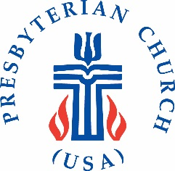
CONGREGATION REMITTANCE FORM
For use with PC(USA) Special Offerings

Date: PIN:
Church Name:
Address:
City: St: Zip:

AMOUNT
One Great Hour of Sharing $____________
(100% of funds to Presbyterian Mission Agency (PMA))
Pentecost Offering $____________
(40% of funds kept by the congregation, 60% to the PMA)
Peace & Global Witness Offering $____________
(25% of funds kept by congregation; 25% of funds to mid council; 50% to the PMA)
Christmas Joy Offering $____________
(100% of funds to the PMA)
Other:
Presbyterian Giving Catalog $____________

INSTRUCTIONS:
You may remit through your normal receiving agency (usually the presbytery) or you may send directly to the Presbyterian Mission Agency:
Presbyterian Church (U.S.A.)
PO Box 643700
Pittsburgh PA 15264-3700

Submitted by: __________________________________ Date: ______________

