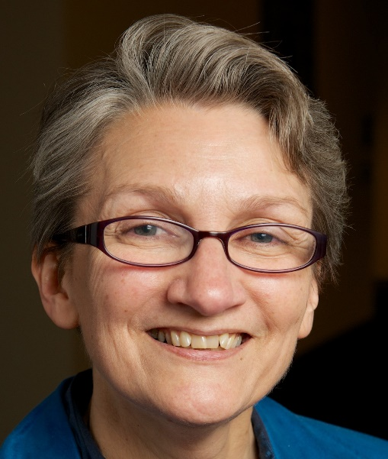

Tricia Dykers Koenig
502-569-8360/502-322-0903
tricia.dykers-koenig@pcusa.org

Tricia is an Associate Stated Clerk serving as Associate Director for Mid Council Relations for the Office of the General Assembly, a position she began in September 2017.
She is a graduate of Duke University and McCormick Theological Seminary and a member of the Presbytery of the Western Reserve (Northeast Ohio). She was a candidate for ministry under care of Hanover Presbytery (PCUS), ordained by the Presbytery of Des Moines (UPCUSA). After ordination in 1980 Tricia served congregations as co-pastor with her spouse, Mark Koenig – 5 years at the United Church of Diagonal, Arispe United Methodist, and Shannon City United Methodist (Iowa) and 15 at Noble Road Presbyterian in Cleveland Heights, Ohio.
Mark held several positions with the Presbyterian Mission Agency over 17 years, and is currently Advocate for Justice Ministries in the Presbytery of New York City and interim pastor of First Presbyterian Church of Whitestone in Queens. Tricia was national organizer for the Covenant Network of Presbyterians from 2000-2017.
Tricia and Mark share a passion for justice. They have two sons: Sean Koenig works for the New York City Health and Hospitals Corporation and lives with their grand-dog Henrik; Rev. Eric Koenig-Reinke and his wife, Essie, serve First Presbyterian Church of Ann Arbor and live with grand-dog Bentley. Tricia is thrilled to be a member of J. Herbert Nelson’s OGA team working for the health of the PCUSA and our faithful witness in the world.

