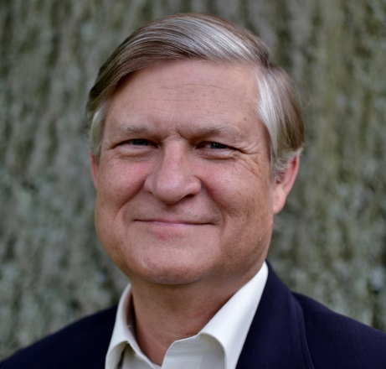
THOMAS D. HAY
Phone: (888) 728-7228 x5500
E-mail: thomas.hay@pcusa.org

Tom is an Associate Stated Clerk and Director of Assembly Operations at the Office of the General Assembly in Louisville. He has been with the OGA since January of 2009. Before coming to work at the OGA, he served as the General Presbyter for Shenandoah Presbytery in western Virginia and portions of West Virginia.
Ordained in 1979 in the PCUS, Tom has served pastorates in Buchanan (VA), Wallace (NC) and Bristol (VA). He is a graduate of St. Andrews Presbyterian College (BA) and Union Presbyterian Seminary (D.Min.). Tom is a third-generation Presbyterian pastor with deep roots in the church and the ministry. He brings this history into the current imperative to discover the unfolding future of Christ’s work in the world.
He is married to Dawn Biggs of Winchester, VA and together they have four children ages 19 to 35, two granddaughters, six chickens, and a dog.

