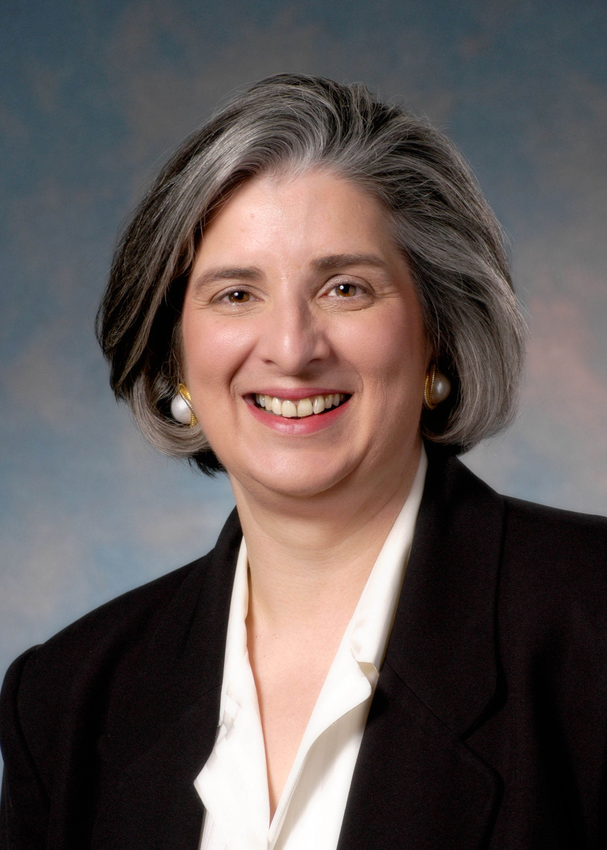

Rev. Rosemary Catalano Mitchell, CFRE
Phone: (888) 728-7228 x5628
E-mail: rosemary.mitchell@pcusa.org

The Reverend Rosemary C. Mitchell, CFRE, is Senior Director for Mission Engagement and Support for the Presbyterian Mission Agency, Presbyterian Church, U.S.A. In that role she leads a team responsible for increasing engagement in the mission of our church including financial support.

Previously she served as Vice President for Seminary Relations at Princeton Theological Seminary and as the Executive Director of the Women's Foundation of Genesee Valley in Rochester, New York. She is a graduate of SUNY at Cortland, New York and Princeton Theological Seminary. She was ordained by Susquehanna Valley Presbytery and served as a pastor at New York Avenue Presbyterian Church, Washington, DC and Downtown United Presbyterian Church, Rochester, New York.

Rosemary’s article “Nurturing Faithful Stewards: 11 Things to Remember” was published in Presbyterians Today, April, 2015 issue as part of a spiritual and practical guide to fundraising. She is co-author of two books: Birthings and Blessings (Vol. 1 and Vol 2) published by Crossroads Press. She produced and hosted, Women and the Word on WWWG Radio, Rochester, New York. She is married to Attorney Joseph E. Mitchell and they have three adult children.

