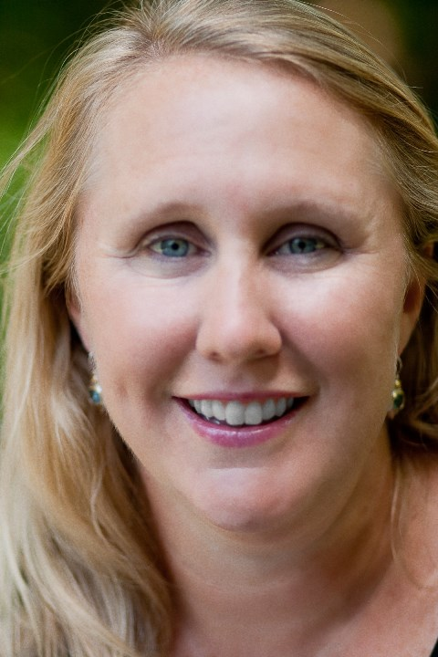

Nikki Collins

Phone: 502.693.4653
E-mail: Nikki.Collins@pcusa.org

Nikki Collins began serving as the Coordinator for 1001 New Worshiping Communities in June 2018. Previously she served Cherokee Presbytery as Stated Clerk and Mission Coordinator and, before that, as the founder of Bare Bulb Coffee, a rich brew of full-service coffee shop, music and arts venue, and home to a diverse group of disciples committed to shedding light in the world.

She graduated with a degree in psychology and religion from Wesleyan College in Macon, Georgia and earned her M.Div at Union Presbyterian Seminary in Richmond, Virginia.

Nikki makes her home in Chattanooga, TN and is the mother of two teenaged sons and the shepherd of a herd of spirited dogs and a lazy cat. She loves to plan a great college football tailgate, paddle a kayak, swing a tennis racket, and dig in the dirt.

