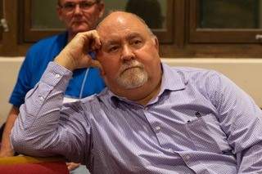

Kerry Rice
Phone: (888) 728-7228 x5412
E-mail: Kerry.rice@pcusa.org

Kerry Rice has served the Office of the General Assembly as Deputy Stated Clerk since June of 2017. Among other duties, the Deputy Stated Clerk is responsible for strategic planning, for coordination of meetings of the Committee on the Office of the General Assembly (COGA), for leadership team meetings, and for providing leadership and administrative oversight for all programs and services of the OGA.

Rice, a ruling elder and long-time employee of the national church, has served in the Office of the General Assembly since September of 2007 – in the areas of General Assembly Meeting Service and Ordered Ministry and Certification in Mid Council Ministries. Rice is married to teaching elder Cindy Cushman, a member of Ohio Valley Presbytery. Rice is a member of Henryville Presbyterian Church in Henryville, IN.

