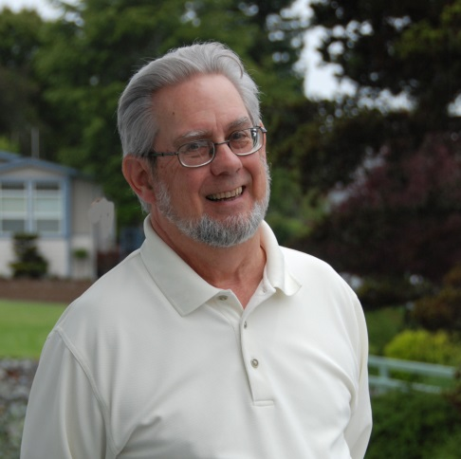
Edd Breeden
Phone: (831) 239-6817
E-mail: edd@breeden.us

Edd graduated from the University of California in Santa Barbara with a Bachelor’s degree in Mathematics. His plan at the time was to go into the field of training teachers in Math. God changed the direction of Edd’s life with a call to Seminary and the Pastorate. While at seminary he taught Greek and Hebrew language classes as well as worked in a cabinet shop in Pasadena as a draftsman.

Edd graduated from Fuller Theological Seminary in June of 1974 and with his wife, Linda, and two children they drove to St. Cloud, Minn. to serve as an Associate Pastor at the First Presbyterian Church. After 4 years of ministry and the addition of two more kids, the family made their way back to California as Edd received a call to the Presbyterian Church of Woodlake. Another 7 years and the next move was to Santa Cruz, CA where he served for 12 years. Edd took a short break from the pastorate and worked for Merrill Lynch as a Financial Consultant for 5 years. Returning to what he thought would be the beginning of interim pastoring, Edd started as designated pastor at the San Martin Church and ended up staying for 13 years. He retired in December of 2014.

He continues as the Treasurer of the Presbytery of San Jose, has 80 clients in his Tax Preparation business and enjoys having more free time and playing more golf. He guest preaches from time to time and teaches a regular men’s Bible Study.

He has authored ten books; commentaries on Galatians, Ephesians, Philippians and Revelations, and books on Prayer, Discipleship, Worship and Peer Counseling. He recently finished Volumes One and Two of Generous Living; Looking at Jesus’ Teachings on Generosity in Matthew. He loves to write, teach, read, play golf, help others with questions in his areas of expertise and listen to Country Western Music where they still love Jesus and support America.

Edd married in 1968, and currently enjoys his family of 19: wife, four children, spouses and 9 grand-children ages 7-24.

