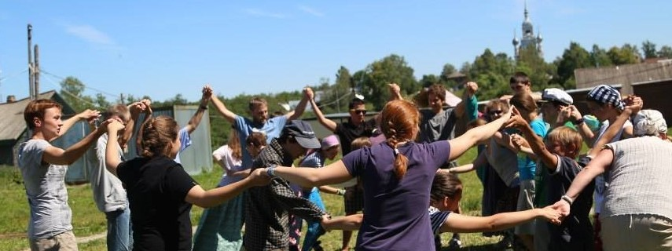
BURM Network Virtual Conference Agenda
Belarus, Ukraine, and Russia Mission (BURM) Network, formerly the Russia Mission Network
October 28-30, 2021

THURSDAY, October 28, 2021
11:00 am EDT (GMT-4) | Opening Session (1 hour)
12:00 pm EDT (GMT-4) | Break (15 minutes)
1:15 pm EDT (GMT-4) | Connecting with One Another (45 min)
2:00 pm EDT (GMT-4) | Break (15 minutes)
2:15 pm EDT (GMT-4) | Breakouts: (45 minutes; choose a breakout)  - Re-Energizing Your Partnership  - Developing a New Partnership
3:00 pm EDT (GMT-4) | Sessions end
Moderators: Ralph Clingan, pastor of Good Shepherd Presbyterian Church, St. George, UT, Karen Morey, Presbyterian Church of the Cross, Omaha, NE, Ellen Smith, Mission Co-Worker, Linda Speck, Russia Mission Team Chair, First Presbyterian Church, Ann Arbor, MI, Nancy McLean, White Memorial Presbyterian Church, Raleigh, NC, Olga Mitskevich, Smolensk Baptist Church, Smolensk Russia, Sergey Grokhotov, Word of Life Evangelical Baptist Church, Dorogobuzh, Russia

FRIDAY, October 29, 2021
11:00 am EDT (GMT-4) | Belarus, including migration issues (90 min.)
12:30 pm EDT (GMT-4) | Break (15 minutes)
12:45 pm EDT (GMT-4) | Q&A with the speakers (30 min.)
1:15 pm EDT (GMT-4) | Sessions end
Speakers: Michal Jablonski, pastor of Warsaw congregation of the Reformed Church of Poland, Natia Tsintsadze, Executive Director of World Student Christian Federation (WSCF) – Europe plus one additional speaker from WSCF-Europe, Moderator: Ellen Smith, Mission Co-Worker

SATURDAY, October 30, 2021
11:00 am EDT (GMT-4) | Trauma of Children in Migration (90 minutes)
12:30 pm EDT (GMT-4) | Break (15 minutes)
12:45 pm EDT (GMT-4) | Questions and Answers with speakers: (45 minutes)
1:30 pm EDT (GMT-4) | Closing Session (45 minutes)
2:15 pm EDT (GMT-4) | Conference ends
Speakers: Alla Soroka, Project Manager for This Child Here, Daniel Ekat, Director of Moscow Protestant Chaplaincy (MPC), Jessica Derise, MPC Chaplain, Susan Krehbiel, Presbyterian Mission Agency, Marni Newell, Lutheran Family Services of Nebraska, Moderators: Connie Weaver, Pastor of Hebron Presbyterian Church, Manakin-Sabot, VA, and Ralph Clingan, Pastor of Good Shepherd Presbyterian Church, St. George, UT

