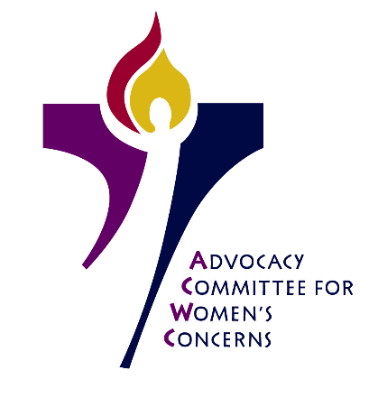
Advocacy Committee for Women’s Concerns (ACWC)
January 7-9, 2019
Louisville, KY

- Began meeting with worship, meeting covenant creation, sharing joys and concerns

- Reviewed and discussed Racial Implicit Bias test results; renewed commitment to addressing gender justice intersectionally

- Heard presentation of journal exercise by the ACWC dismantling white supremacy
working group

- Connected with many members of Presbyterian Mission Agency and Office of the General Assembly staff, including Rev. Dr. Diane Givens Moffett and Rev. Dr. J. Herbert Nelson

- Received greetings from 223rd General Assembly (2018) Co-Moderator, Rev. Cindy Kohlmann

- Discussed gender bias at all levels in the PC(USA), making multiple follow-up action plans

- Reviewed gender justice issues in the current news

- Met in working groups: Gender & Leadership; Sexual Justice, Dismantling White Supremacy and created next-step plans for continued work

