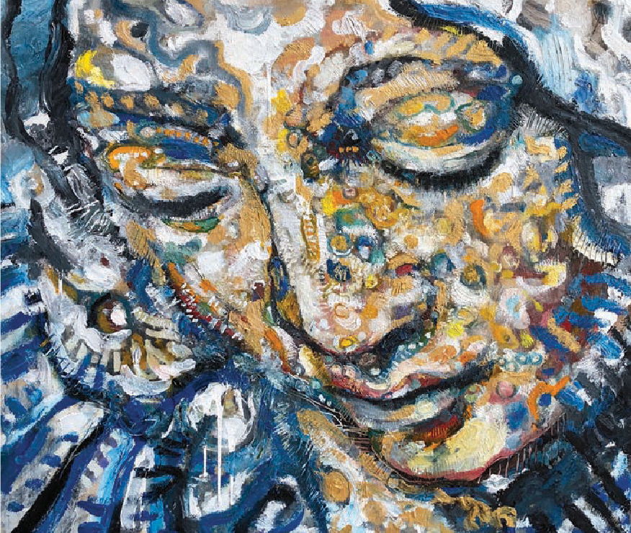
Celebrate the Gifts of Women Sunday • March 5, 2023
Adoration, Daniel Bonnell

Favorecida
Luke 1:45–56

hen I think about Mary, the mother of Jesus, Michelangelo Buonar-
W
roti’s sculpture, La Pietà always comes to mind. I had the opportu- nity to see the work of art when I visited St. Peter’s Basilica in the Vat- ican City as part of a college trip to Europe. What impressed me the most was the sculpture’s realism— especially Mary’s expression as she looks down at the lifeless body of her son in her lap. Looking at the marble statue, I wondered about Mary, a mother holding her child, and her thoughts in that moment.
BY VILMARIE CINTRÓN-OLIVIERI

Hymns, writing and art (like La Pietà) honor the mother of Jesus and speak to her importance in history and the life of the church. But how much do we consider who this young woman was and who she represented beyond the traditions surrounding her? This liturgy is an invitation to focus on the person of Mary, partic- ularly on both her vulnerability and her strength.

Mary, the teenager. Mary was pregnant and unmarried; most proba- bly, she was a teenager, poor and from a small town. She had no apparent

status or power. It is in this context that an angel visits her and gives her life-changing news: that she would conceive and bear the “Son of the Most High” (Lk. 1:32). In reading Luke 1, what stayed with me was the conviction and trust at the heart of her response to such an outrageous announcement, and at such a young age. “And blessed is she who believed that there would be a fulfillment of what was spoken to her by the Lord” (v. 45). Blessed indeed.

Mary’s prayerful song. In a con- text where the voices of women were

rarely heard, this song—known tra- ditionally as “The Magnificat”—is important. Mary raises her voice in praise and pronounces prophetic words of blessings to all generations. Scholar R.T. France says, “. . . it can also be a liberating experience . . . to be reminded that Luke introduces it as the personal response of a village girl to the overwhelming grace of God in her own life and calling, to be made to read it through her eyes and to reflect on how its universal princi- ples were to apply to her future expe- rience and to the mission of her promised son.”1 When thinking about Jesus’ life, it seems to me we tend to place more emphasis on his divine nature than on his humanity. Much of Mary’s wisdom and teach- ings shaped Jesus’ life and teachings.
Much of who Mary was became lived out in Jesus’ life and ministry.

The Sisterhood of Mary and Elizabeth. Mary and Elizabeth, for all their differences, had much in common. Both were pregnant under questionable circumstances, with chil- dren whose particular significance would become known much later.
Both women were poor, their worth in society rooted in their ability to procreate and tend house. They had protection only from the men in their lives and lacked any real decision- making standing in the community. Mary could have been killed as an unwed, pregnant young woman, and Elizabeth’s miraculous pregnancy both amazed and frightened her com- munity. Regardless of their individual, difficult positions, they supported
each other. I imagine the three months they spent together were empowering and necessary. What lay ahead for them would be challenging at best, frightening and dangerous at worst. Their sisterhood sustained them and prepared them for what was to come.
What inspires you most from Mary’s story and testimony? I invite you today to reflect on Mary’s response to “the overwhelming grace of God in her own life and calling”2 and on her prayerful song of praise and promise. As we reflect and cele- brate, let us consider the ways in which we are also called, individually and collectively. May the ways in which we respond magnify God in word and in deeds.
May it be so. Que así sea.

A Service for the Worship of God

Call to Worship
(Based on Ps. 34: 1–4, 7–8, 14)
One: I will bless the Lord at all times;

All: God’s praise shall continually be in my mouth.
One: My soul makes its boast in the Lord;

All: let the humble hear and be glad.
One: O magnify the Lord with me,
All: and let us exalt God’s name together. One: I sought the Lord and was answered. All: God delivered me from all my fears. One: The angel of the Lord encamps

All: around those who fear God and delivers them.
One: O taste and see that the Lord is good;

All: happy are those who take refuge in God.
One: Depart from evil, and do good;
All: seek peace and pursue it.

Suggested Hymns³
Salmo 34—Bendeciré al Señor (HP, 418)
“Heaven Is Singing for Joy”/El Cielo Canta Alegría
(GtG, 382)
“Canticle of the Turning” (GtG, 100) “Sing Out, My Soul” (GtG, 646)

Call to Confession
(From Ps. 139:23–24)
Search us, O God, and know our hearts; test us and know our thoughts.
See if there is any hurtful way in us, and lead us in the way everlasting.

Litany of Confession
(Based on Lk. 1:46–55)
One: Creator God, Mighty One,

All: Have mercy on us.
One: Jesus, Christ and Redeemer,

Have mercy on us.
One: Holy Spirit, Counselor and Sustainer,

Have mercy on us.
One: Our God and Savior,
You have looked upon us with favor, and we have been blessed:
Your mercy has found us. Your strength has sustained us. Your love has redeemed us.
Yet we stray from your way.

All: Have mercy on us.
One: We confess, we don’t always recognize nor show your mercy.
We confess, we believe the strength that sustains us is our own.
We confess, we take your love for granted.

All: Have mercy on us.
One: We are misled by our prejudices, fear and pride.
We cling to power and wealth for our own beneﬁt.
We confess that our love for others wavers and we become indiﬀerent towards the vulnerable, ignoring the hungry and rejecting the poor.

All: Have mercy on us.
One: You came to the aid of your children, and, through Jesus, became one of us, showed us the way.
Through Jesus we came to know true mercy, strength, and love.

All: Forgive us . . .
One: That we may recognize your mercies and, in turn, practice mercy.

All: Help us . . .
One: To love as you have loved us, and to ﬁnd strength in courage, humility and service.

All: Restore us . . .
One: That we may walk in your favor and magnify you in words and deeds.
All: Por Cristo, Amén.

Assurance of Pardon
One: Sisters, siblings, believe the good news of the gospel: In Jesus Christ we are forgiven.
All: Thanks be to God. Amen.

Scripture Readings
Luke 1:45–56

Complementary Texts
Psalms 34 and 98, 1 Samuel 2:1–10

Sermon Starter
In preparation to preach, prayerfully read Luke 1, paying spe- cial attention to verses 45–56. Thinking about God’s call to Mary and her response, reﬂect on the elements of the text that stand out to you. Also consider the context in which the gospel was written—when, where and to whom. Early Christianity was forming, and reﬂected the familial and socie- tal structures of the times that included patriarchy, enslave- ment and expectations of women being submissive. Liberating words shine through the text, though, including Mary’s song.

Jane D. Schaberg and Sharon H. Ringe state, “[Luke] is often called ‘the Gospel of the poor,’ just as it is called ‘the Gospel of women,’ meaning that Luke’s concern for the marginalized and
oppressed is apparent. It is important to analyze the link between these concerns, since most of the poor in every age are women and the children who are dependent on them. In this Gospel the economically destitute are called ‘blessed’ (6:20; cf. 4:18), and a reversal of their situation by God is expected (1:53; 16:19–31).”4

Who are the ones considered truly blessed and strong in this text? Liberating, empowering words are spoken to people on the margins of society: “the lowly” or “the humble,” the poor, the hungry, and, in line with Schaberg and Ringe’s commen- tary, also women and children.

Consider the points presented in the introduction: who Mary is, her prayerful song and the sisterhood between Mary and Elizabeth. Mary had little to no inﬂuence in her world, yet the angel called her “favored” (Lk. 1:28), favorecida. Consider scholar Lynn Japinga’s insight into this Luke passage: “Mary is not passive or submissive here. She talks back and asks ques- tions. She is willing to say yes to God even though she does not fully understand what she is in for. She is not merely a passive womb or food source for Jesus. God does not force her, or assume she will say yes, but takes her seriously as a partner in the process of giving birth to Jesus.”5

We have been called—individually and collectively—to be partners in the building of God’s kin-dom,6 that Jesus pro- claimed. While we may encounter biases, preconceptions or misconceptions about gender, identity, race, age and personal or physical conditions, we know that God calls and empowers us to minister in our families, communities and the world.

Through it all, we are not alone. We are supported by a sister- hood, a siblinghood, that surrounds us—beginning with the Holy Spirit in us, our foremothers whose witness is before us, and our familia (by blood and by faith) that journeys with us. Like Mary, we might not fully understand what we’re in for, yet the example of determination and strength of this young woman and the circle of support that surrounded her can inspire us all.

Litany of Gratitude and Celebration
(Multiple people may alternate reading “One.”)
One: Today we celebrate the blessing of God calling women at all stages in life, from diverse ages, languages, cultures, races, backgrounds and in all circumstances. We cele- brate God’s gifts bestowed upon us, a variety of gifts and services for the common good “activated by one and the same Spirit” (1 Cor. 12:11). We are grateful . . .
One: For women of all ages who serve God and neighbor in committees and on boards, as members, elders and deacons, as mid-council leaders and beyond.
For young women, tweens and teens who serve in manifold ways and for the advisors who mentor, listen and hold space for their growth in wisdom and grace. For nominating committees that recognize potential and

promise, hearing the voice of the Holy Spirit in all voices, regardless of age.

All: We celebrate and give thanks to God!
One: For women who work toward a more just world, one free of biases, discrimination, food insecurity and poverty.
For women entrepreneurs, homemakers, students and volunteers who partner and lead, who sit on decision- making boards, who head micro-enterprises, small businesses, nonproﬁts, corporations, churches and ecclesiastical bodies.

All: We celebrate and give thanks to God!
One: For congregations, faith-based organizations and women’s rights organizations advocating for and empowering women and girls.
For those who work in refugee camps and border ministries.
For those who work in helplines and call centers, who provide healthcare and counseling, pastoral care and accompaniment to women and families.
For those who oﬀer welcome, aﬃrmation, safety and care.

All: We give thanks to God for your service and love in action!
One: For foremothers, trailblazers, role models, mentors, activists, educators, reformers, innovators, peacemakers, motivators, advocates, coaches and preachers.

All: We celebrate and give thanks to God!
One: We celebrate you and we celebrate the blessing of God’s call! We give thanks for the gifts this rich diversity brings to building God’s kin-dom. We pray in gratitude and joy, magnifying God for God’s favor!
All: Alleluia! Thanks be to God.

Charge and Blessing
One: Go forth and be blessed, favored ones.

All: God is indeed with us as we live by faith, stand in hope and share love.
One: Let us witness to God’s abundant grace and mercy from generation to generation.
All: Amén.

Postlude/Suggested Hymns
“The Lord Now Sends Us Forth”/Enviada soy de Dios
(GtG, 747)
“Give Thanks” (GtG, 647)

Vilmarie Cintrón-Olivieri is regional liaison for the Caribbean with Presbyterian World Mission along with her husband José Manuel Capella-Pratts. An educator and a Presbyterian elder, she served as a co-moderator of the 223rd General Assembly (2018).

Notes
- R.T. France, We Proclaim the Word of Life: Preaching the New Testament Today. Ian Paul & David Wenham, eds. (Downers Grove, IL: InterVarsity, 2013), 43.
- Ibid.
- GtG indicates Glory to God! The Presbyterian Hymnal (Louisville, KY: Geneva, 2013). HP indicates El Himnario Presbiteriano (Louisville, KY: Geneva, 1999).
- Jane D. Schaberg and Sharon H. Ringe, Women’s Bible Commentary, Third Edition: Revised and Updated, Carol A. Newsom, Sharon H. Ringe, & Jacqueline E. Lapsley, eds. (Louisville, KY: Westminster John Knox, 2012), 496.
- Lynn Japinga, From Daughters to Disciples: Women’s Stories from the New Testament (Louisville, KY: Westminster John Knox, 2021), 10.
- Ada María Isasi-Díaz’s word to define the “interconnected community, seeing God’s movement emerge from la familia, the family God makes . . .” quoted by Melissa Florer-Bixler in “The Kin-dom of Christ,” Sojourners, Nov. 20, 2018; sojo.net/articles/kin-dom-christ.

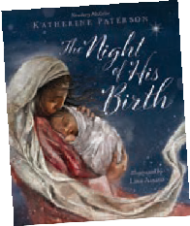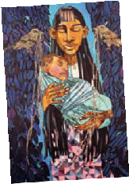A Additional Resources and Suggestions
Flyaway Books’ The Night of His Birth, written by Katherine Paterson and illustrated by Lisa Aisato, is an award- winning children’s book presenting an interpretation of the story of the birth of Jesus imagining the thoughts Mary could have had that night. Beautifully illustrated with engaging words, a
reading of the book could be included in the sermon or children’s sermon. Learn more at flyawaybooks.com/book/the-night-of-his-birth.

Mary is the focus of Lessons 7 and 8 of the PW/Horizons Bible Study, What My Grandmothers Taught Me: Learning from the Women in Matthew’s Genealogy of Jesus by Merryl Blair, with suggestions for leaders by Magdalena I. García. Use
these lessons to complement the liturgy and as preparation for your sermon.
Activities could be planned using the resources at presbyterianwomen.org/matthew.

