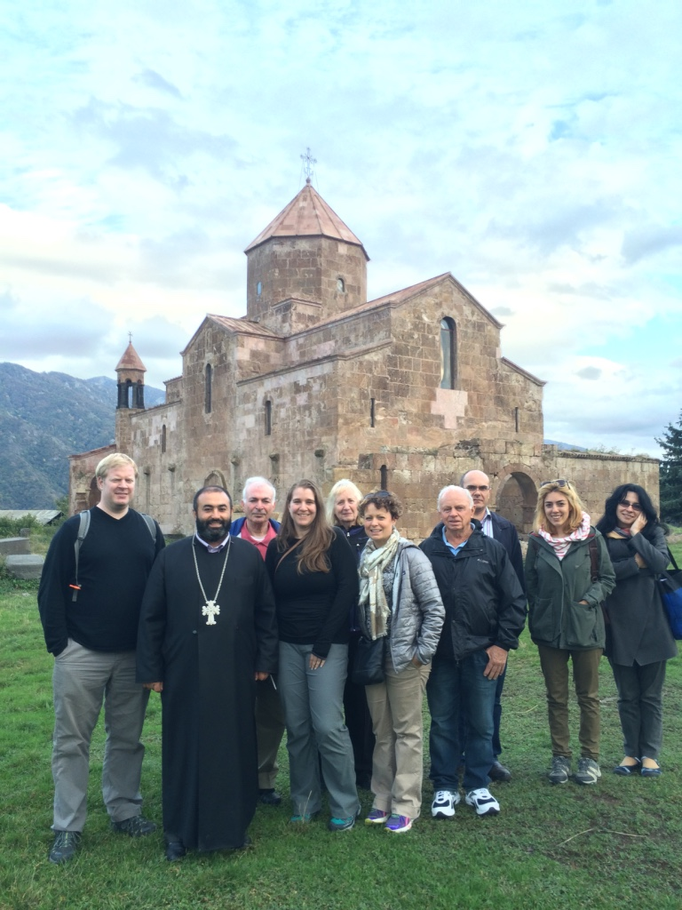  - October 2017  Armenia tour  JMP 50th Anniversary Mission Encounter  Journey to this beautiful, ancient Christian homeland with a focus on history, culture, outreach and faith. Enjoy warm hospitality, amazing historical sites and encounters with ecumenical church partners – Apostolic, Catholic and Evangelical. Through personal visits to faith-based community development projects, farming coops and student leadership groups, learn about the challenges and hopes of this post-Soviet republic. Don’t miss this rare, powerful experience to discover what God is doing in Armenia! Discounts available for JMP donors and retired staff.  “My favorite part was watching Jinishian work in person and interacting with the students and farmers who are succeeding with help from Jinishian’s programs. They treated us as honored guests, but we were the ones who were awed and impressed by their ingenuity and dedication” Tanya Karimi (http://armenianadventurewithwmi.tumblr.com/archive)  “All I can say is, Go… and let the people, their faith and the landscapes draw you into their embrace.” Rev. Charlie Hammil, Pittsburgh, PA |  | Discover Armenia’s ancient Christian heritage and growing faith  Visit with village families, farmers & student leaders  Celebrate JMP’s 50 years of mission  Pilgrimage to the Genocide Memorial  Explore beautiful Yerevan, vistas of Mount Ararat & more!  Contact us Today!  Jinishian Memorial Program  381 Park Avenue South, #617  New York, NY 10016  jinishian@pcusa.org  1-800-728-7228 x 5317

Jinishian Memorial Program 50th Anniversary Tour to Armenia
Tentative Itinerary
(All trips subjected to change in itinerary and/or cancellation)

DATE | ACTIVITY | DETAILS
Day 1, Oct 6  Friday | Arrival to Yerevan International Airport  Check in at the Ani Hotel or apartments
Day 2, Oct 7  Saturday | 8:00-9:00 am Breakfast  9:30am Coordination meeting  11:00am Visit to Matenadaran  12:30 pm Lunch  2:00pm Visit to the Genocide Museum  6:00 pm Dinner in Yerevan  Yerevan City Tour | Yerevan is the capital of Armenia situated on the Hrazdan River, north-east of the Ararat plain. The population of Yerevan is estimated to be about one million people. The history of Yerevan dates back to the 8th century BC. Yerevan is a city of Christian cathedrals, theatres and museums, universities and academies, parks and research labs, squares and industrial sites. The Genocide Museum is a powerful exhibition and memorial to the first genocide of the 20th century.  The Matenadaran is both a museum of ancient manuscripts and a scientific research institute. The Matenadaran is a major center with a unique and exceptionally rich manuscript collection. It is named after Mesrop Mashtots, who is credited with the creation of the Armenian alphabet in 405 AD.
Day 3, Oct 8  Sunday | 8:00-9:00 am Breakfast  10:00am Trip to Echmiadzin city and vocational education project at Cross of Armenian Unity Art Center NGO.  Tour of the Holy Echmiadzin, Liturgy Service Visit to the Church Museum  Meeting with local spiritual leaders  12:00 pm Lunch at the Art Center NGO  1:30-4:00pm Zvartnots Cathedral sightseeing  6:00 pm Dinner in Yerevan | The district of the Holy Echmiadzin (one hour drive from Yerevan) is the “Vatican City” of Armenia as the center of the Armenian Apostolic Church. It is the seat of the Catholicos of All Armenians and the most populous city in Armavir province, about 20 km west of Yerevan. The original cathedral was founded in 301 and is one of the first churches in the Christian world.  Zvartnots Cathedral, famous for its unique design, was built between 643 and 652 AD by Catholicos Nerses III (nicknamed “The Builder”). In 930 AD the church was ruined by an earthquake and remained buried until its rediscovery in the early 20th century.
Day 4, Oct 9  Monday | 8:00-9:00 am Breakfast  10:00am Trip to Lukashin village of Armavir Region. Visit to micro-lending projects supporting economic development of farming communities.  12:00 pm Lunch with the farmers. Enjoy fresh, ecologically clean fruits and vegetables from the gardens.  3:00pm Armenian Evangelical Church visit  Meeting with JMP Students  6:00 pm Dinner | JMF Micro-lending Project provides affordable loans to farmer cooperatives to support small farmers and agricultural development. Nearly 50% of Armenian’s workforce is involved in agriculture.
Day 5, Oct 10  Tuesday | 8:00-9:00 am Breakfast  10:00am Trip to Shirak region, Gyumri city (2 hour drive)  Gyumri city tour  Visit to the Lady of Armenian Convent, orphanage and vocational school  12:00 pm Lunch at the Convent  Celebrate JMP 50th Anniversary in Gyumri city  Meeting with the Civic Dialogue and Actions project activists  6:00 pm Dinner in Gyumri city  Back to Yerevan city | Gyumri (2 hour drive from Yerevan) is the second city of Armenia and one of the oldest cities in the world. The earliest settlement dates back 2500 years and is known as the center of traditional Armenian architecture, science, and tourism. The inhabitants have gained the reputation of hospitality and a rich sense of humor.  Civic Dialogue and Action project encourages university students to become active citizens in their communities by empowering them to identify problems and implement creative solutions  The Congregation of the Armenian Sisters of the Immaculate Conception is a religious order of nuns established in 1847 in Constantinople for the purpose of educating the Armenian youth.
Day 6, Oct 11  Wednesday | 8:00-9:00 am Breakfast  9:00 Visit to Khor Virab Monastery and Noravanq Monastery  12:00 pm Lunch in Noravanq  Trip to Goris city (2 hour drive)  Goris city tour  6:00 pm Dinner  Overnight stay in Mirhav hotel | Khor Virap (1 hour drive from Yerevan) is a place of pilgrimage for Armenians all over the world, where Armenian pagan king Trdat imprisoned Saint Gregory the Illuminator for refusing to acknowledge the Goddess Anahit. From here one can enjoy the majestic view of Mount Ararat.  Noravanq Monastery (1.5 hour drive from Yerevan), situated on a ledge over Arpa River gorge surrounded by fantastic red rocks, was founded in the place of an ancient monastery and took on special significance as a cultural and religious center in the 13-14th centuries. On the territory of the complex there are several khachkars (cross stones) of original design the most valuable of which is a khachkar by Momik dating to 1308 AD.
Day 7, Oct 12  Thursday | 8:00-9:00 am Breakfast  10:00am Visit to Tatev Monastery (30 min drive)  Wings of Tatev cableway  12:00 pm Lunch in Tatev village  Drive back to Yerevan (3 hours drive)  6:00 pm Dinner in Yerevan | Tatev Monastery is a masterpiece of confluence of ingenious medieval architecture and fabulous natural beauty of Armenia. It is one of the most spectacular attractions and famous spiritual and education centers of the Middle Ages.  Wings of Tatev is the longest reversible aerial tramway (3.5 mi) that holds the record for Longest non-stop double track cable car.
Day 8, Oct 13  Friday | 8:00-9:00 am Breakfast  9:00am Trip to Odzun village and meeting with Father Vrtanes  12:00 pm Lunch at the priest’s house with his family  Sightseeing at Odzun and other monasteries in the region  Dinner | This magnificent 7th century Odzum church is situated in the north of Armenia in the village of Odzun (3 hours from Yerevan) built by Catholicos Hovhannes of Odzun. According to a legend, when Hovhannes was at prayer, two dragons fell upon his residence. Hovhannes made the sign of the Cross before them and the two dragons instantly turned into stone. These stone dragons exist today.
Day 9, Oct 14  Saturday | 8:00-9:00 am Breakfast  10:00 Visit to Lake Sevan and  Sevanavank Monastery  12:00 pm Lunch  2:00 – 2:30 Visit to the Youth Engaged in Society project in the regional school of Armenia. Participate in school debates on the hot topics concerning Armenia and learn student opinions.  7:00 pm JMP 50th Celebration Dinner in Yerevan | Sevanavank is a monastic complex located on a peninsula at the northwestern shore of Lake Sevan in the Gegharkunik Province of Armenia, not far from the town of Sevan. According to an inscription in one of the churches, the monastery of Sevanavank was founded in 874 AD by Princess Mariam, the daughter of Ashot I (who became a king a decade later).  The Youth Engaged in Society project is aimed at fostering democracy and developing civically responsible citizens through the establishment of debate clubs in Armenia. The project began in 2005 and is active in more than 100 schools of Armenian regions.
Day 10, Oct 15  Sunday | 8:00-9:00 am Breakfast  9:00am Visit to Geghar Monastery (1 hour drive)  Visit to Garni Pagan temple  12:00 pm Lunch in Garni village  3:00pm Vernissage (Open Air handicraft market)  Free time/Dinner on your own  7:00pm JMP 50th Anniversary cultural event/concert | Garni Pagan Temple was built in the first century and devoted to one of the Armenian Pagan Gods – Mitra. It is the only example of the Hellenistic culture in the territory of the whole Caucasus. The fortress is situated in a picturesque mountain locality and commands a broad panorama of orchards, fields and mountain slopes covered with motley carpets of varicolored grasses, of the jagged and precipitous canyon of the Azat river.  The Monastery of Geghard (the Lance) is located 40 km southeast of the city of Yerevan in the mountainous region of Kotayk. Inscriptive and documentary references to the monastery, also known as Ayrivanq, date from the 7th and 10th centuries, respectively. It is famous for its rock-carved chapel of St. Astvatsatsin.  Vernissage (walking distance from the city center) is an open air market of local handicraft jewelries, carpets, art work, carved wood ornaments, etc.
Day 11, Oct 16  Monday | Departures  Snack boxes

Jinishian Memorial Program Study Tour to Armenia

Application Form

Due: July 15, 2017

BASIC INFORMATION: (Please fill in all fields)

Name (First, Middle, Last)
Address ___________________________ City __________________State _____ Zip _____________
Phone: daytime ____________________evening _________________ mobile
E-mail ___________________________ Passport Number: ______________Date of Expiration: _______
Do you have any health or dietary restrictions: _______________________________________________
D.O.B. ______________________ (mm/dd/yy) Gender ______________________________
Present Occupation
Armenian? No Yes If yes, please specify fluency: _________________________________
Please provide two emergency contacts:
Name #1 __ Relationship to you_________________ Known Years
Phone ______________________ City __________________________ State ____
Name #2 __ Relationship to you_________________ Known Years
Phone __________________________ City _____________________________ State ____ ______

FINANCES: The $1,900 trip cost per person is LAND ONLY (includes food, housing and all in-country transportation) and does not include air travel or paying passport fees. Participants are encouraged to seek financial and prayer support from their home churches, families and friends. Final payment is due 30 days before departure or space will be cancelled. Payments may be made online or by check payable to “Jinishian Memorial Program” with “Study tour 2017” in the memo area. Total trip price will be refunded for any cancellation within 60 days of departure.

APPLICATION: Submit your completed application by email or mail along with a $500 deposit (refundable up to 60 days before departure). The deadline is July 15, 2017:
Jinishian Memorial Program, 381 Park Avenue South, Suite 617, New York, NY 10016

QUESTIONS? Contact us at jinishian@pcusa.org or 1-800-728-7228 x 5317

AIRLINE TICKETS: Once airline tickets have been purchased and issued, they are typically non-refundable and airline rules apply, even in the event of a JMP change or cancellation. For this reason, we encourage all participants to purchase travel insurance. Cancellation and a variety of travel supplementary protections are available from a variety of vendors.

JMP CHANGES/CANCELLATION: All trips are subject to change of itinerary and/or cancellation.

The Study Tour may travel to remote areas reached by long rides over bumpy roads, so participants should be physically independent. A “Waiver and Release” form will be sent for you to sign before departure. Please initial here to verify that you have read the preceding statements: _______

Participant Signature:______________________________________________Date:______________________

