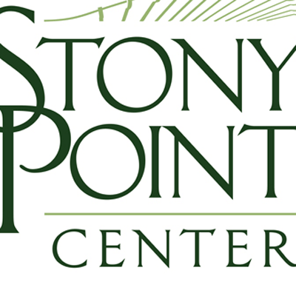
Hi Friends,
I’m excited to share that Stony Point Center will be launching our new “Overbrook Conversation” series June 8 and 9 and you are invited to join remotely!
Join us online for one or both Hybrid Sessions:
Thursday June 8 - 4:00-5:00 PM EST - Climate impact on Under-resourced Communities
https://zoom.us/j/98937896811
Friday June 9 - 11:00-12:00 Noon EST - Repair through Church Property Transfer
https://zoom.us/j/98937896811
What is this?
An Overbrook Conversation is a hybrid blend of an in-person retreat for thought leaders with online engagement opportunities for PC(USA) leaders nationwide. This June Sneak Peak is designed to give us a flavor of what can be and how we can use this tool of the PMA (our retreat center at Stony Point) to further Matthew 25. For this “sneak peak” you will join us for a conversation with a few PMA staff who are in-person at Stony Point Center engaging with nonprofit leaders in the area who have partnered with the PMA to support immigrant recovery from a hurricane and native population that received land returned from church use.
The in-person leaders will be wrestling with these M25 issues and you are invited into that dialog. This is a very modified version. Future versions will bring in multiple leaders from outside of the PMA for in-person experiences and will engage online participants with small groups, resources, hybrid conversations and ongoing cohorts.
Why Join?
You’ll gain two things by joining. 1 - Knowledge of two vibrant Matthew 25 ministries supported by the PMA AND 2 - you’ll be joining us on the ground floor as we build a new way to use Stony Point Center to engage the WHOLE church nationally and internationally!
By joining you will not only hear about these active Matthew 25 experiences, you’ll be helping us form an innovative retreat tool for Stony Point Center to reach all leaders in the PC(USA) regardless of distance, size or resources with high level and innovative conversations. What would it look like if we at the PMA could offer the church real-time engagement with current opportunities and challenges related to Matthew 25? What if we re-envisioned a retreat center to be a space we can gather together – but not necessarily in person? You will be on the ground floor of this innovative dreaming and you may find inspiration on how you too can reach the whole church in real time either through Stony Point Center or on your own.
What can I expect?
For the June 8 Sneak Peak, you will join online into a conversation with leaders of nonprofits working to support immigrants devastated by Hurricane Sandy. Hear how they created Proyecto Faro, a multi-faceted immigrant support agency – disaster leading to long term sustainability. And much more.
For the June 9 Sneak Peak, you will hear from those who turned a previous PC(USA) Church that was returned to the local native population into an Indigenous Embassy. Stony Point Center (and through it, the PMA) continue to participate in this ministry through hosting guests and sharing land. You’ll hear more on our zoom.
No need to register. Just click the Zoom link above and join us.
Want more information? Have questions? Have another idea on how we can/should use Stony Point Center? Please email me at brian.frick@pcusa.org. My goal is to be the “concierge” to support the PMA’s utilization of Stony Point Center.
See you in June!!
Peace,
Brian Frick
Director of PMA Camp and Retreat Ministries

